Load Test Report

## Load Details

stack: S1

stack_url: https://jupiter.uptycs.net/

sprint: 138

build: 138888

load_type: SingleCustomer

load_time: 10 hrs

load_start_time_ist: 2023-08-12 23:08

load_end_time_ist: 2023-08-13 09:08

## Disk Usages

### KAFKA disk space usage

|  |  |  |  |  |
| --- | --- | --- | --- | --- |
| Node | KAFKA total space configured(TB) | KAFKA disk used % before load | KAFKA disk used % after load | KAFKA used space during load (GB) |

### HDFS disk space usage

|  |  |  |  |  |
| --- | --- | --- | --- | --- |
| Node | HDFS total space configured(TB) | HDFS disk used % before load | HDFS disk used % after load | HDFS used space during load (GB) |

### PG disk space usage

|  |  |  |
| --- | --- | --- |
| partition | master configdb node | standby configdb node |
| /pg | 115M | 4.6G |
| /data | 4.1G | 28G |

### Kafka topics

|  |
| --- |
| 138888 |
| Summary : No new topics added |
| New Topics : |
| Old Topics : __consumer_offsets __debezium-heartbeat.cdc __debezium-heartbeat.statedb agentghquery agentkubequery agentlesslog agentlesslogdecorator agentoktaquery agentosquery alert alert_replay api asset-capability assetgroup1 audit auto-exception az_events_blob bulk_replay cdc.public.alerts cdc.public.asset_cloud_infos cdc.public.asset_tags cdc.public.assets cdc.public.cloud_accounts cdc.public.customer_database cdc.public.customers cdc.public.incidents cdc.public.object_groups cdc.public.user_object_groups cdc.public.users cloudconnectorsink cloudqueryVuln cloudqueryevents cloudqueryinventory cloudtrail_objects compliance compliance_summary containers cqazevents cqcloudtrail cqcloudtrail_data_sink cqcloudtrail_ro_sink debezium_configs debezium_offsets debezium_statedb_configs debezium_statedb_offsets debezium_statedb_status_storage debezium_status_storage decorators detection ephermalresources epsink event event_cloud event_replay gcp_cloudlog_objects managedavtables notifications op osquery_cli_tags prestoquerylogs querypack realtimequery registryevent reportschedule1 scan_summary sidequerydecorator slackuser1 state statedb.public.containers_current statedb.public.kubernetes_nodes_current statedb.public.kubernetes_pods_containers_current statedb.public.kubernetes_pods_current statedb.public.vulnerabilities_scanned_images tag1 threat_indicators unified_dashboard uptycs-cloud-remediation vulnerabilities vulntickets |

## Charts

### Live assets

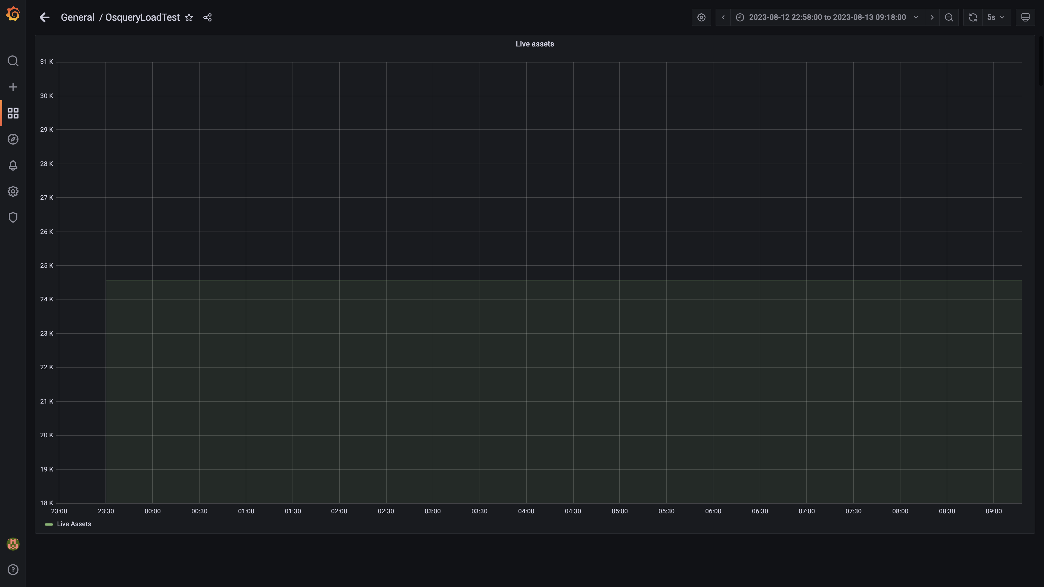

### Kafka lag for all groups

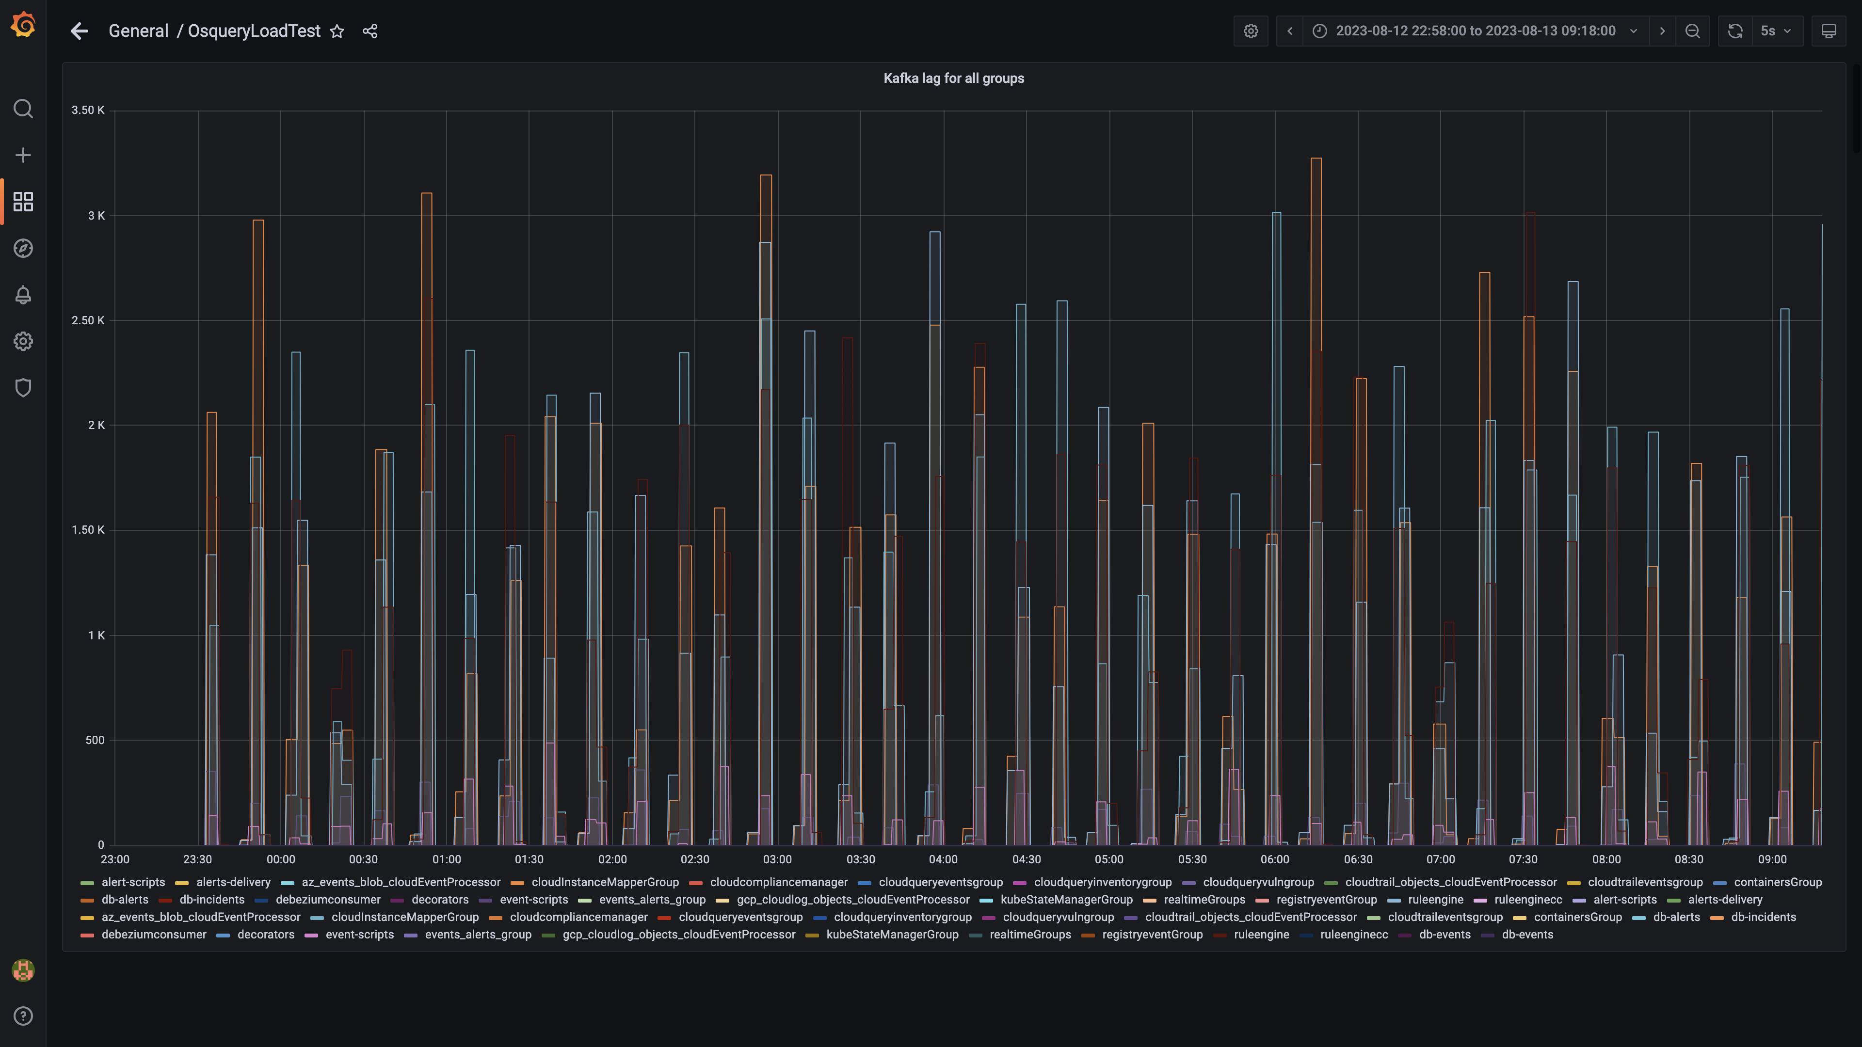

### Process node ram used percent

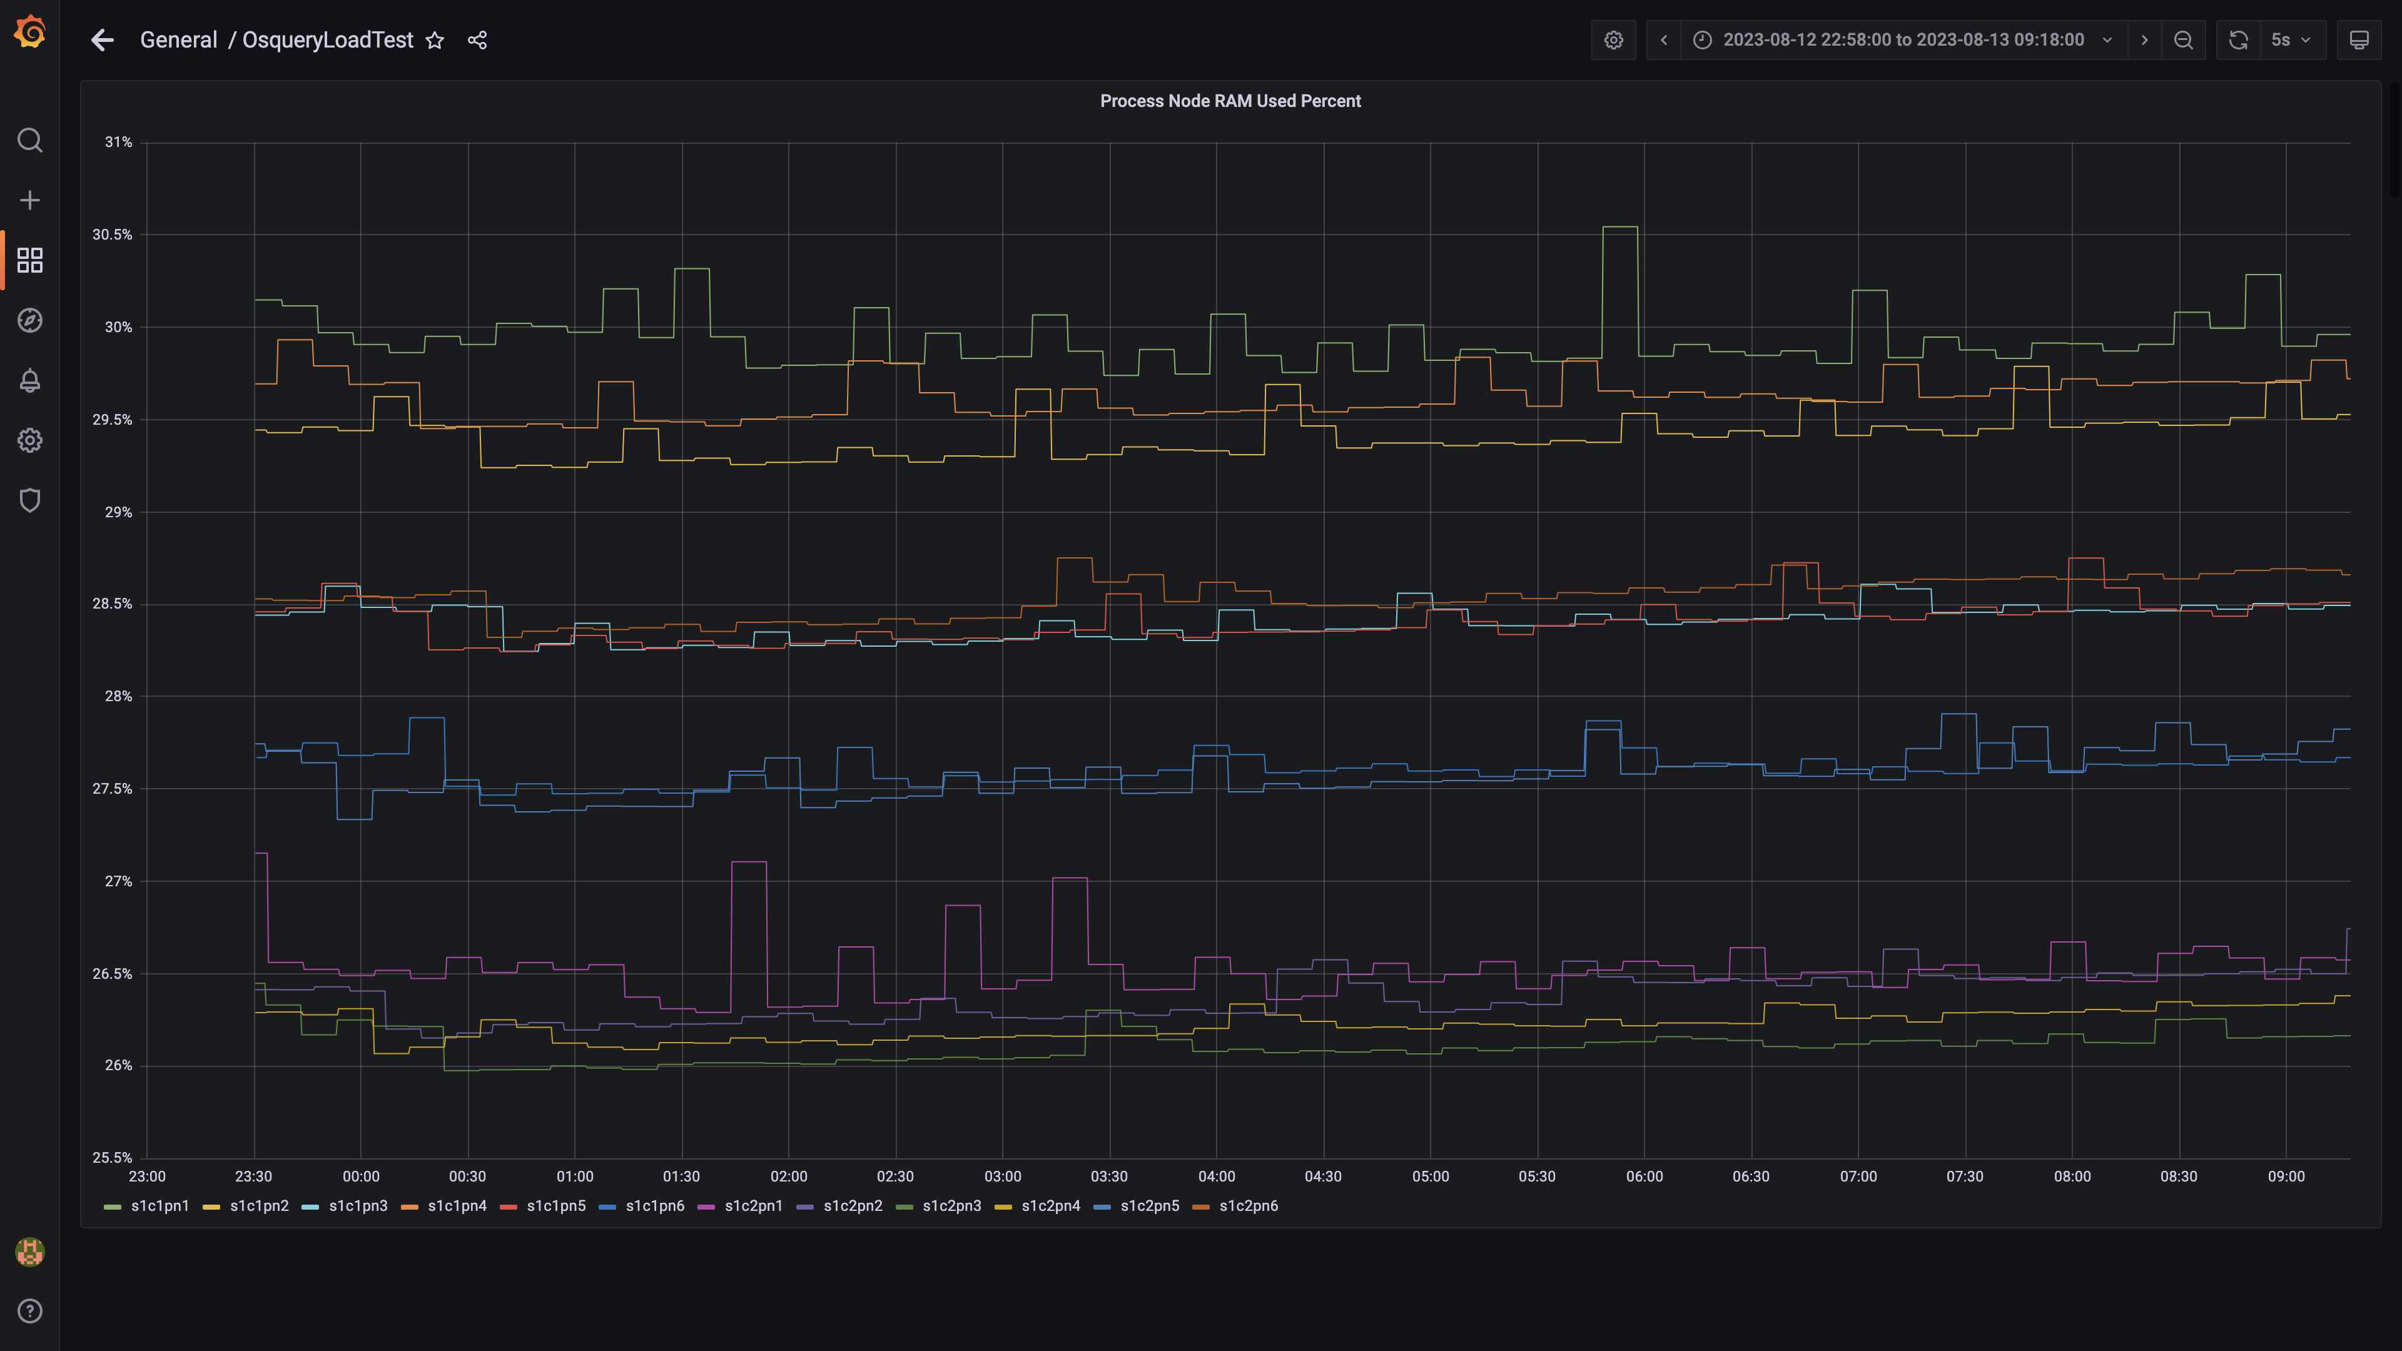

### Data node ram used percent

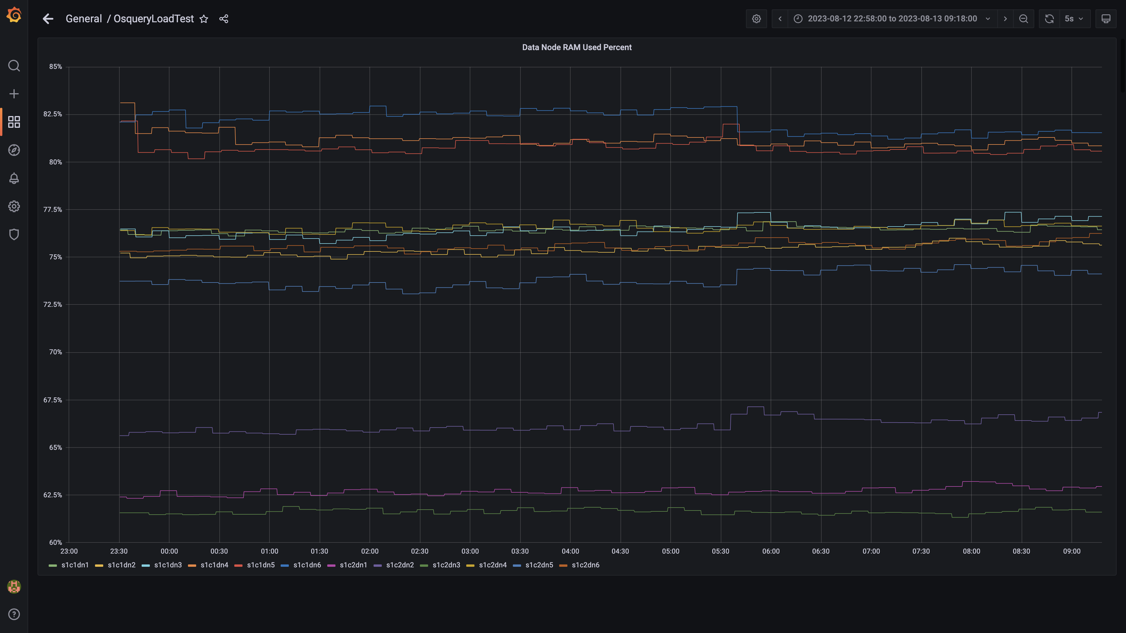

### Postgres node ram used percentage

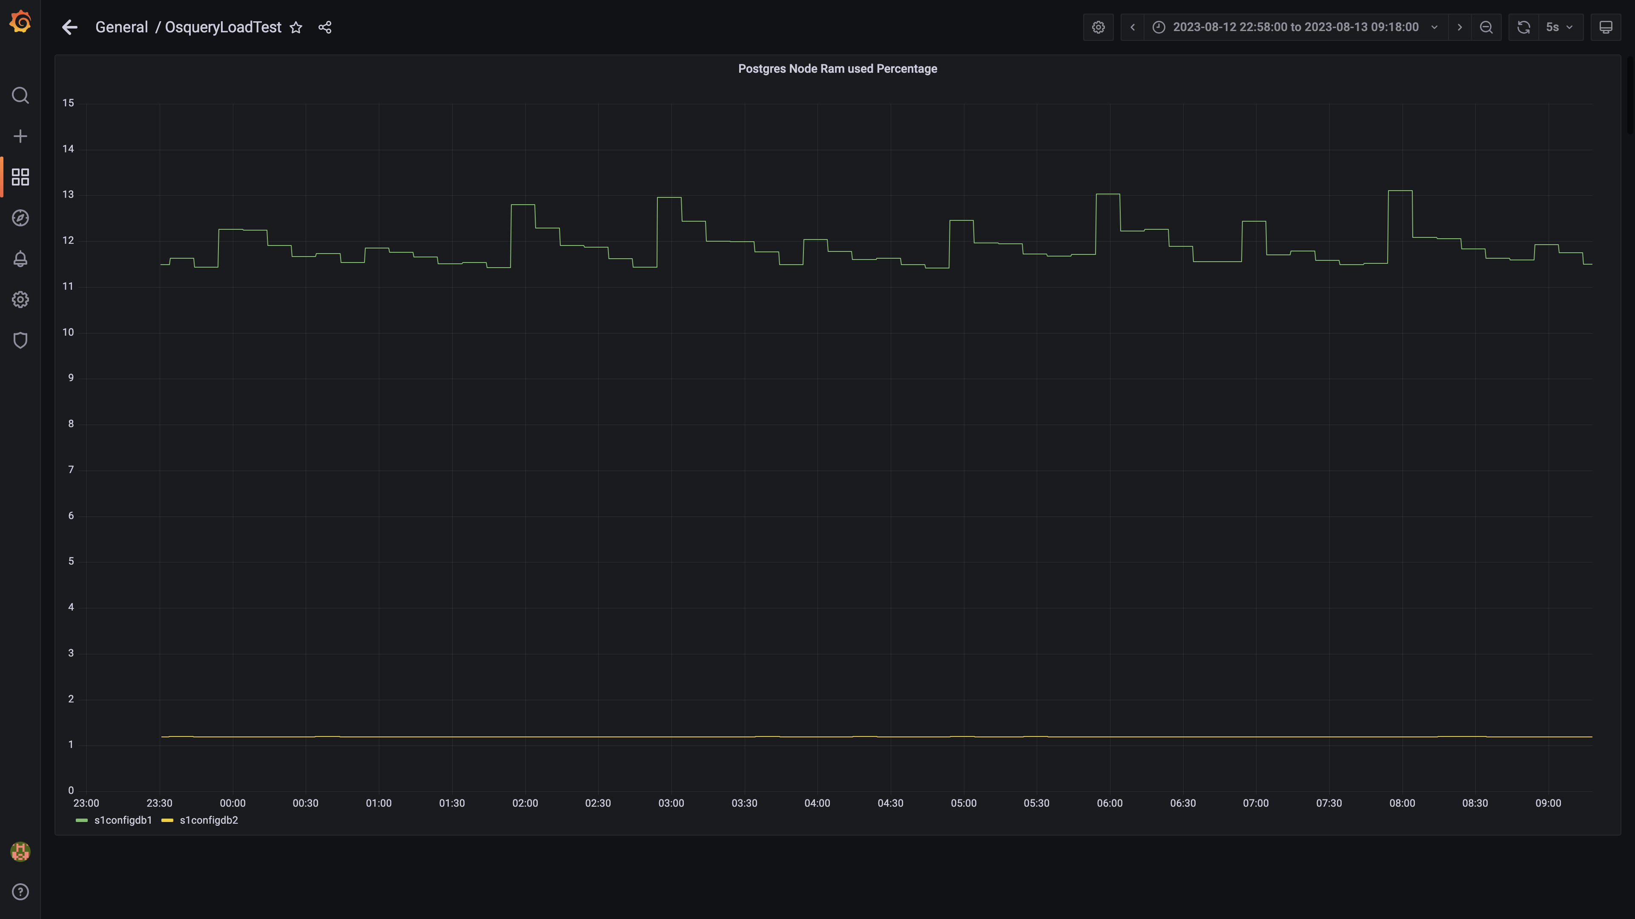

### Memory consumed by eventsdbingestion

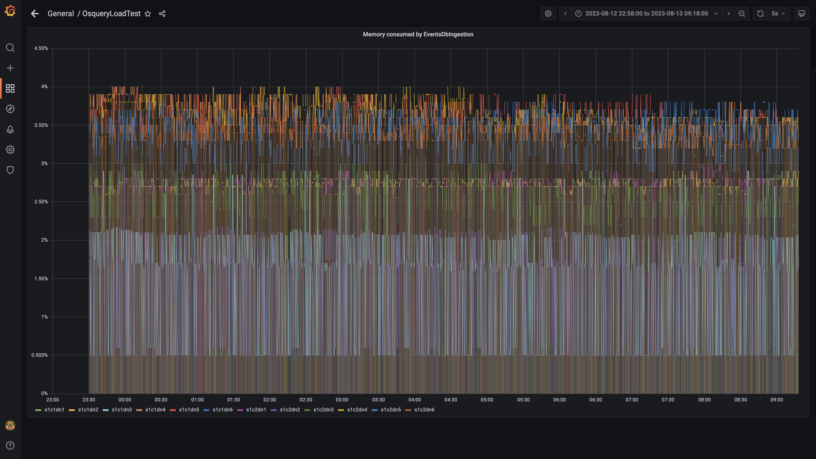

### Kafka disk used percentage

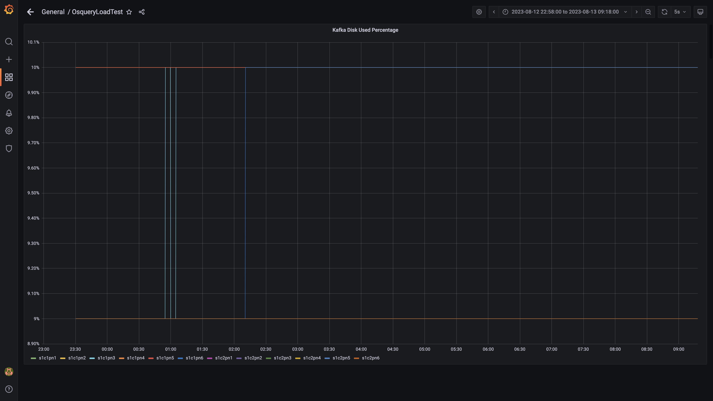

### Memory consumed by orc-compaction

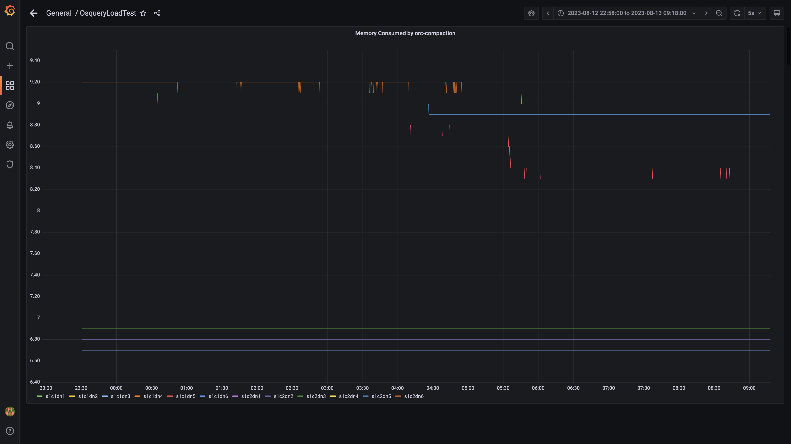

### Compliance summary consumer memory consumption

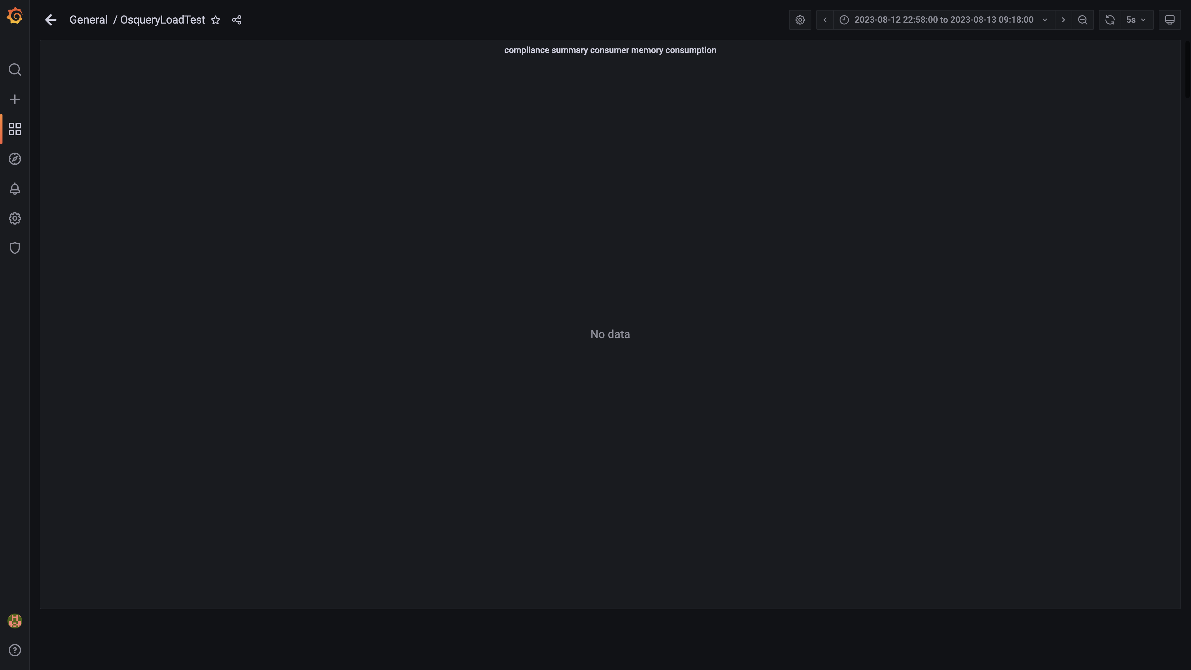

### Memory consumed by logger

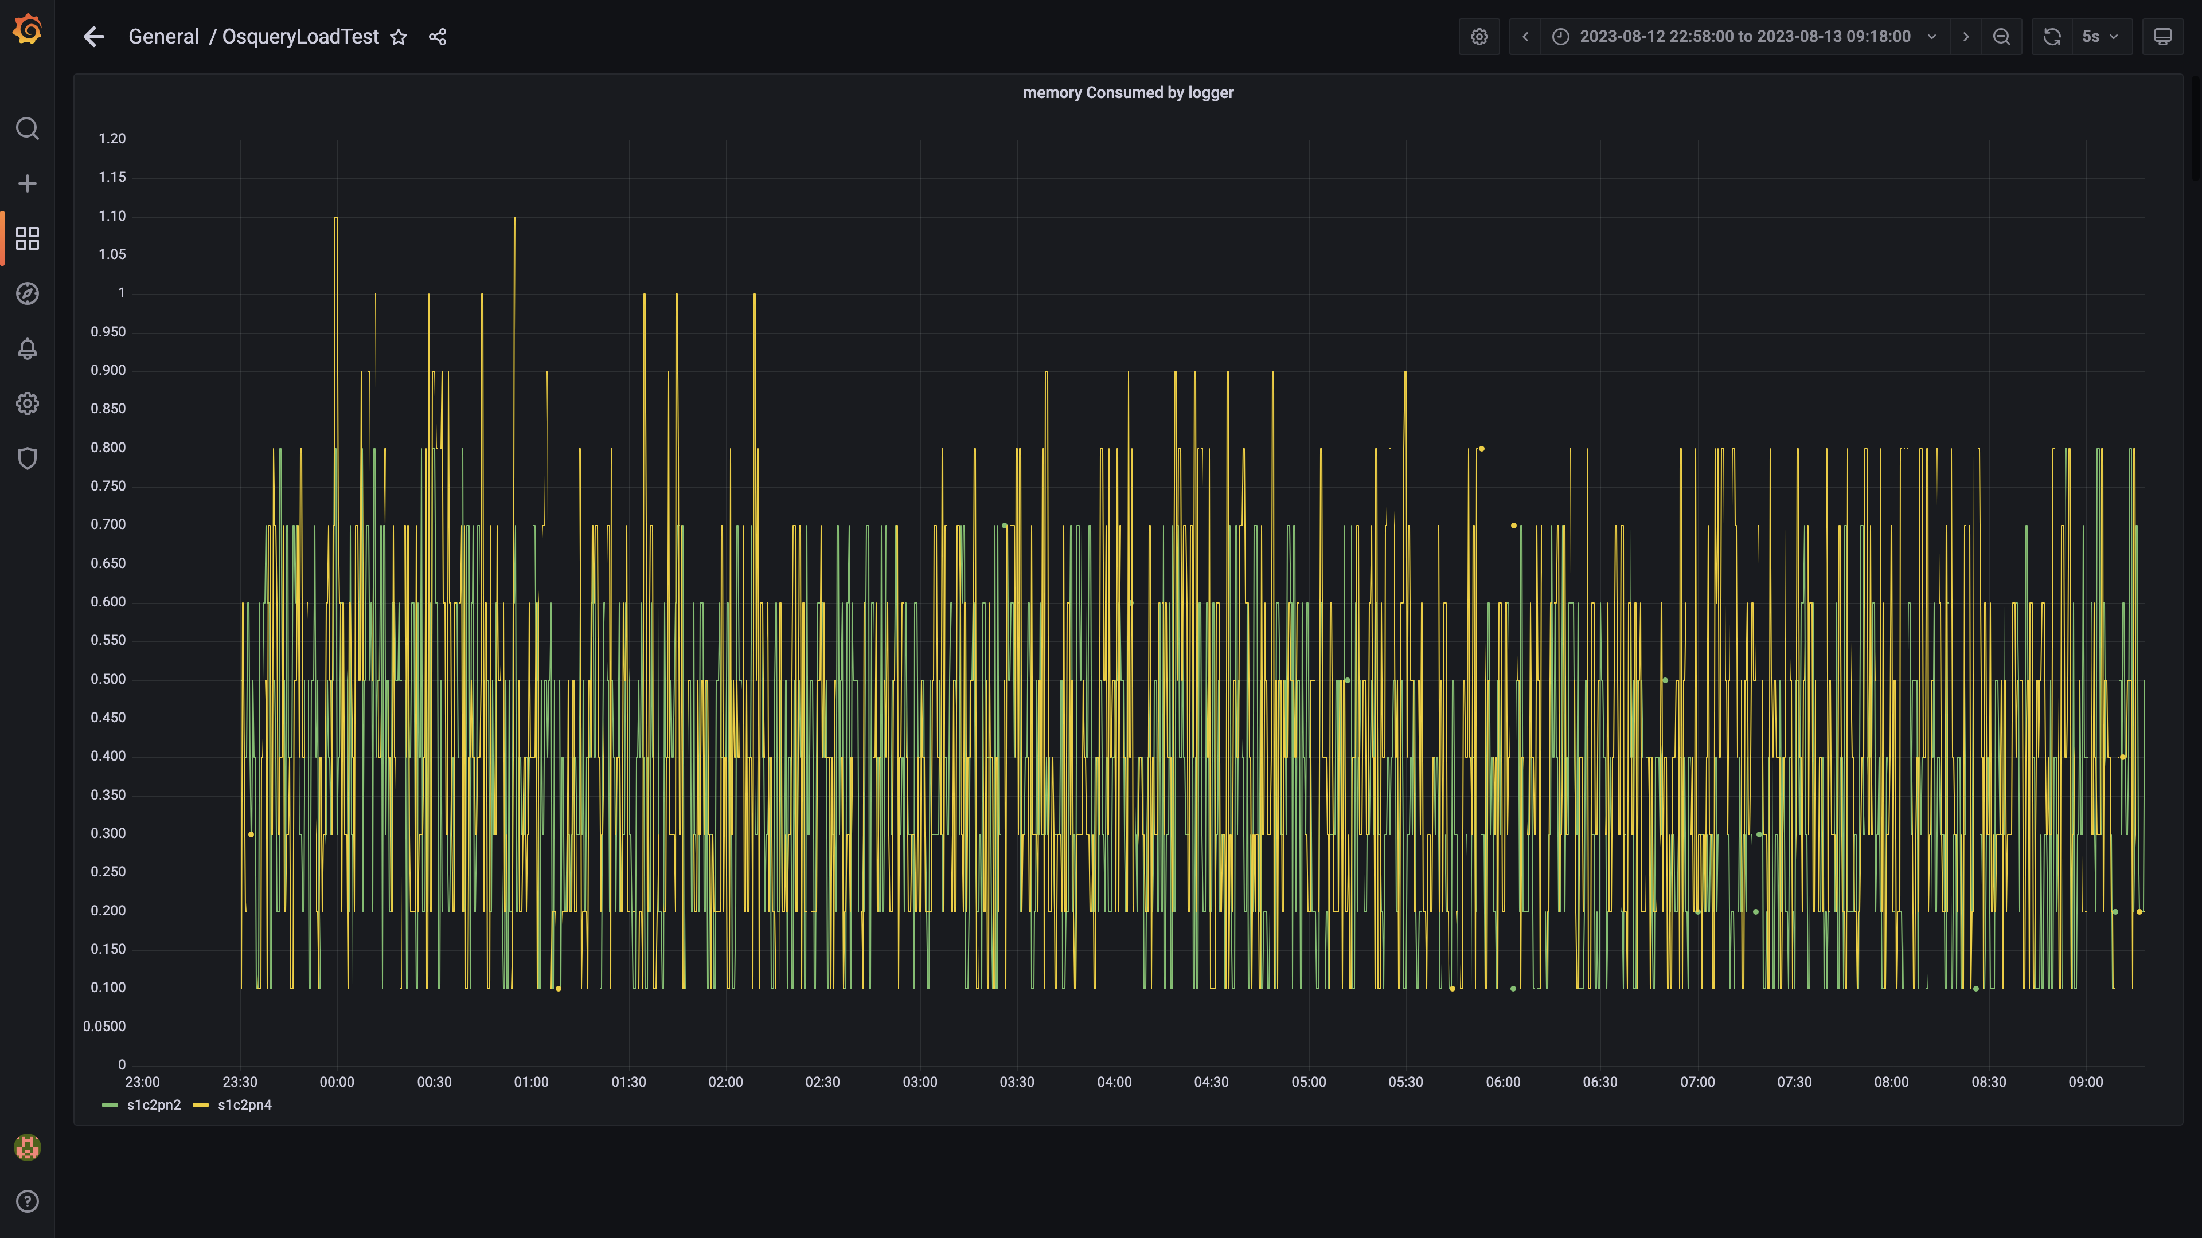

### Kafka memory used percentage

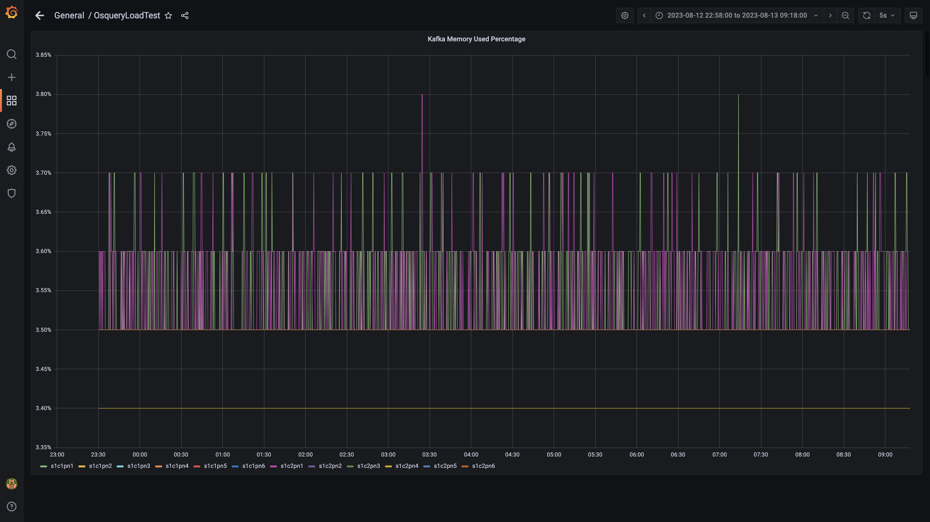

### Memory consumed by trino

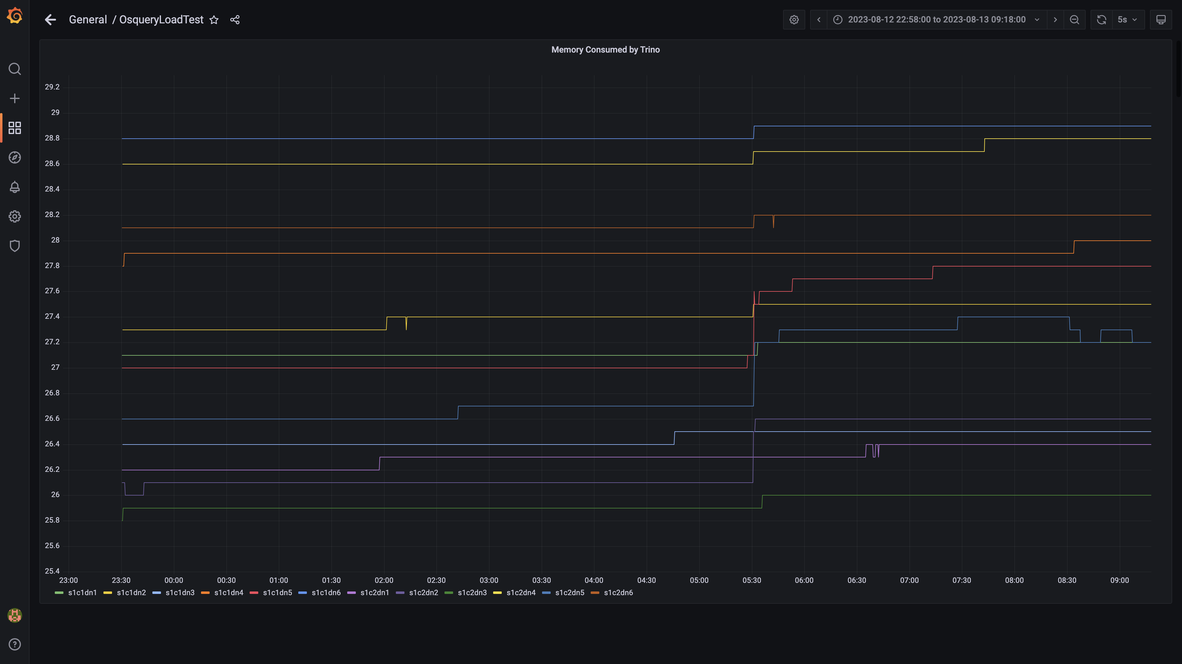

### Memory consumed by osqueryingestion

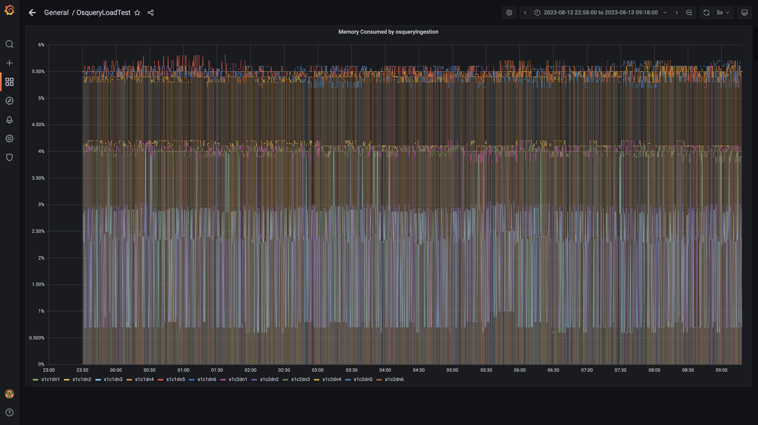

### Memory consumed by spark-worker

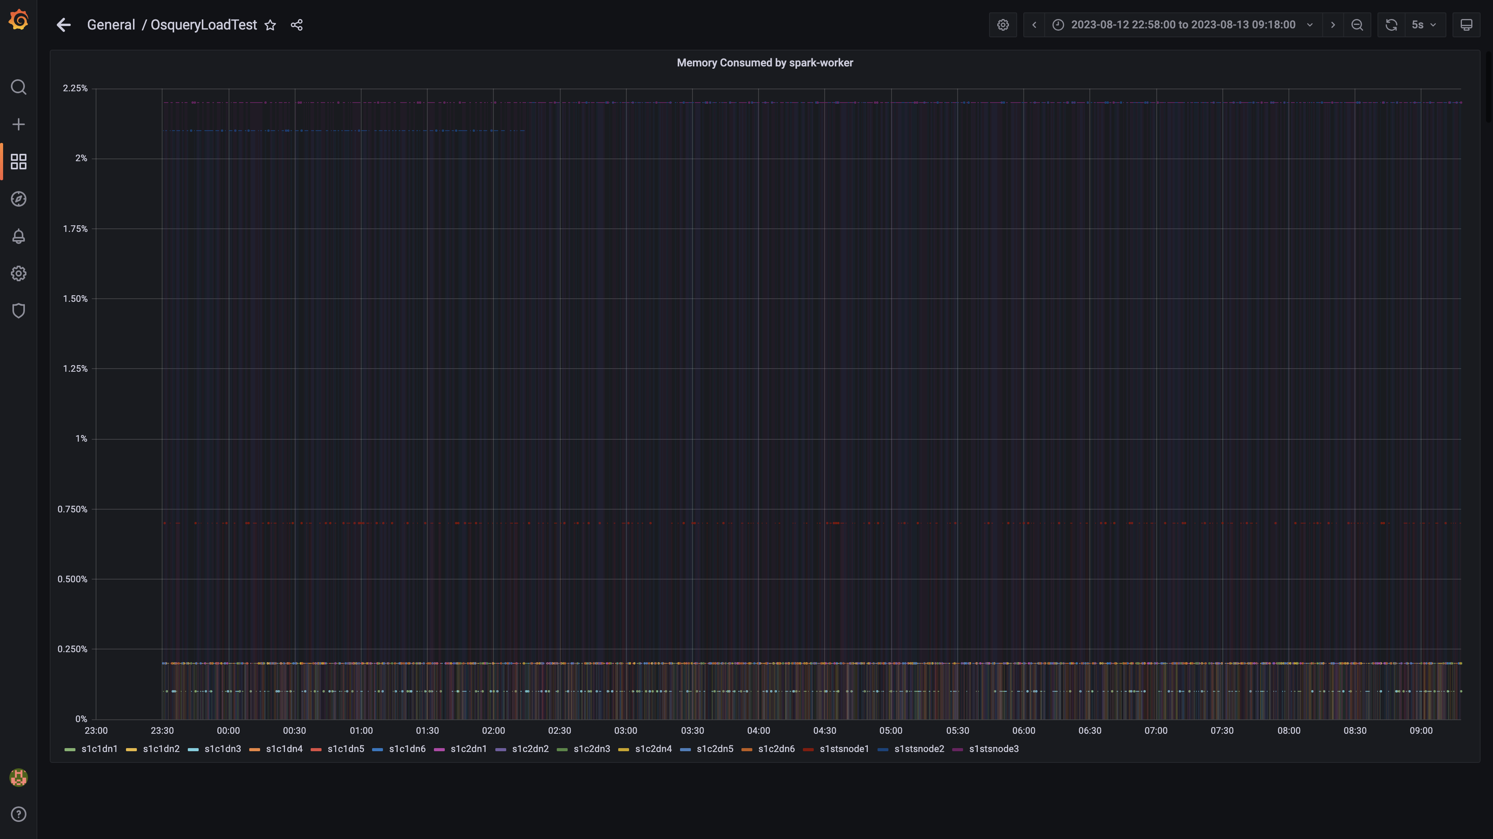

### Memory consumed by ruleengine

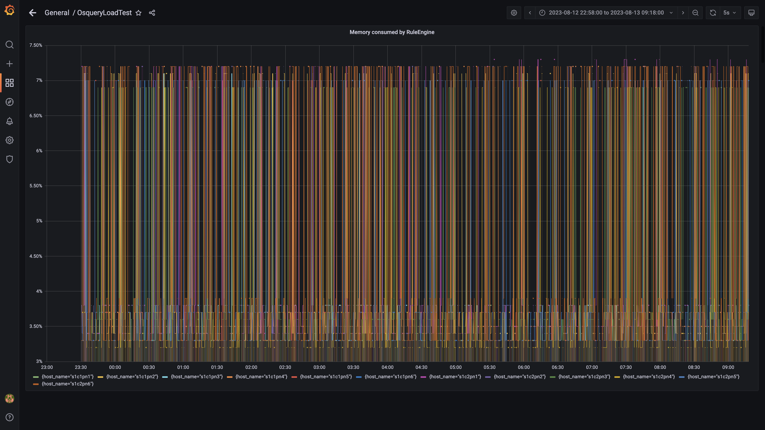

### Memory consumed by configdb

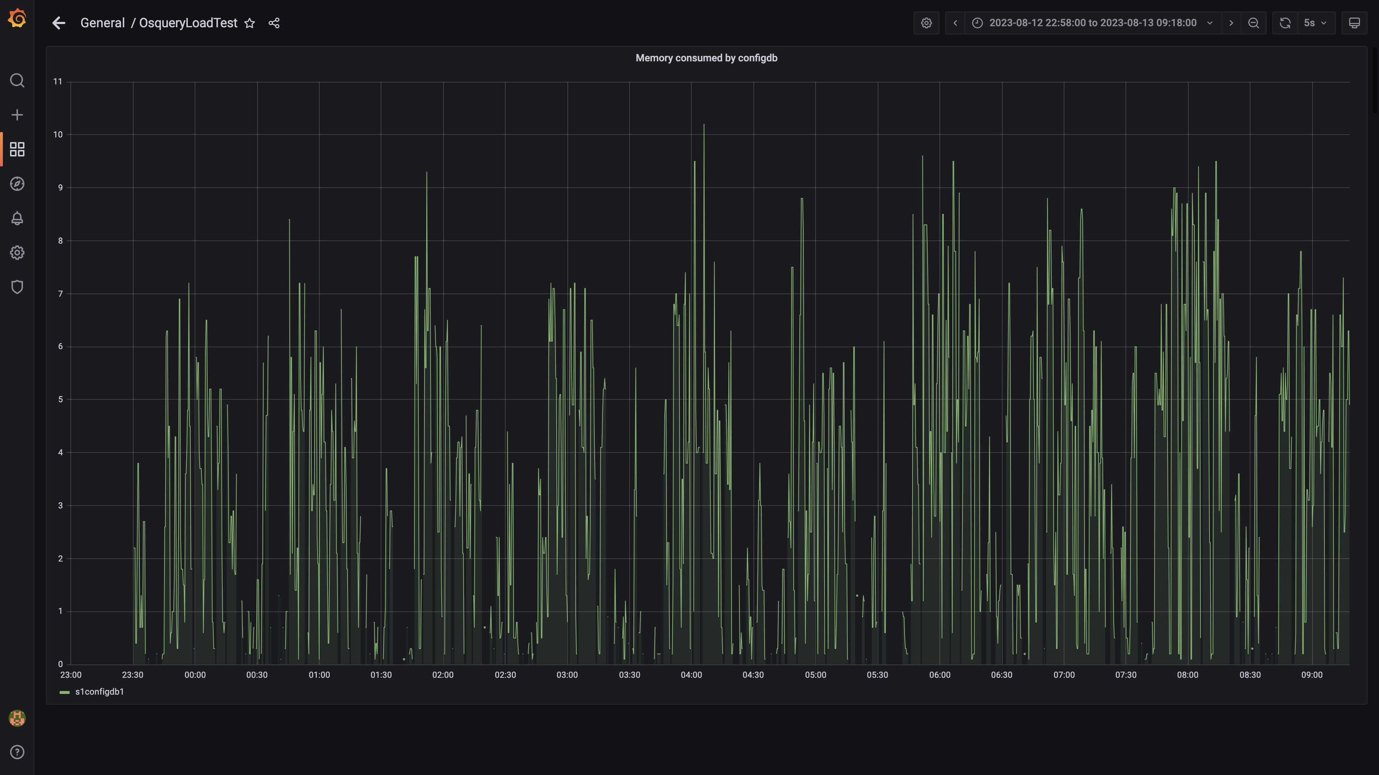

### Memory consumed by data archival

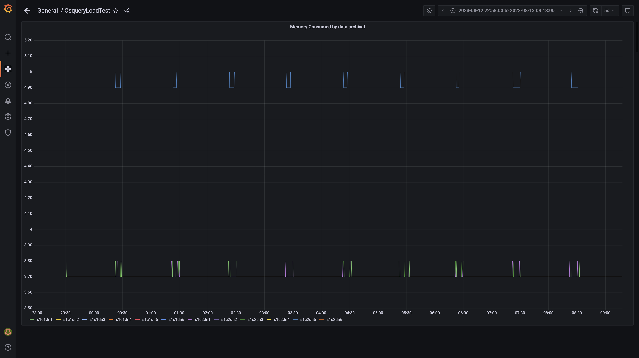

### Debezium memory usage

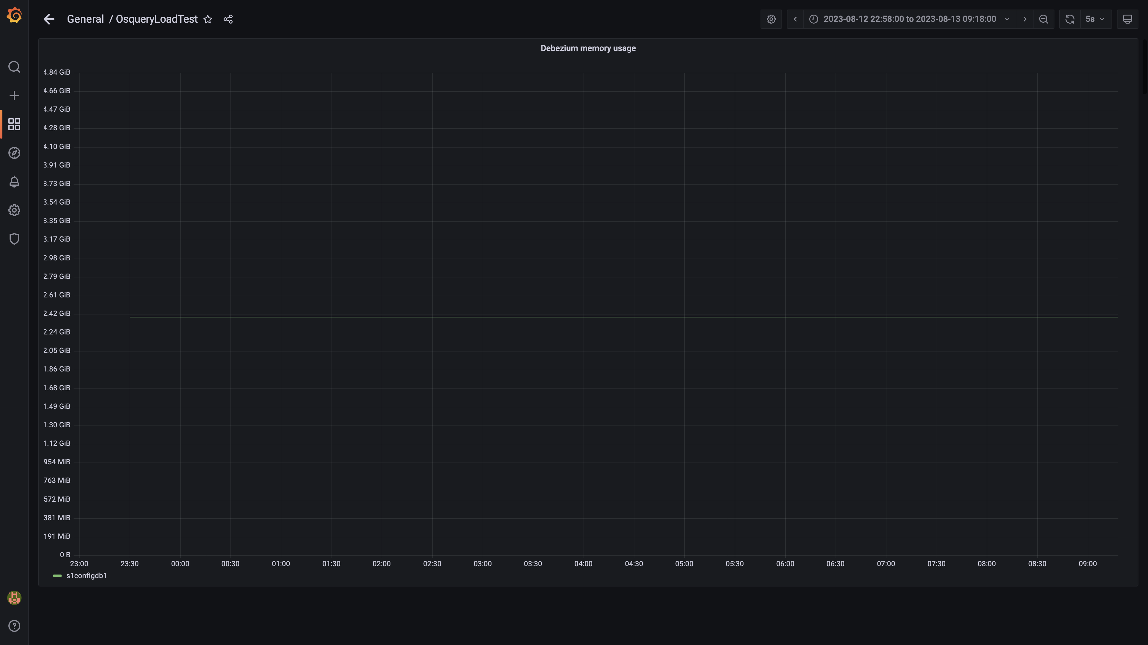

### Memory consumed by redis server

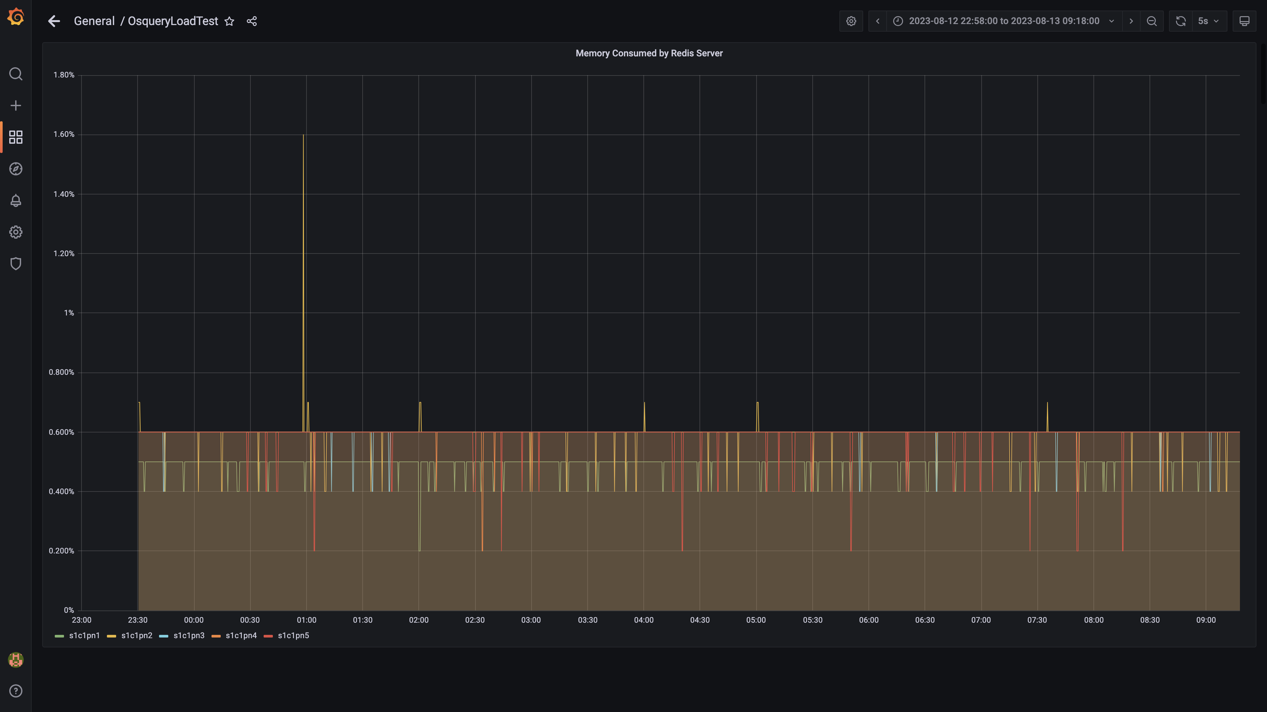

### Memory consumed by tls

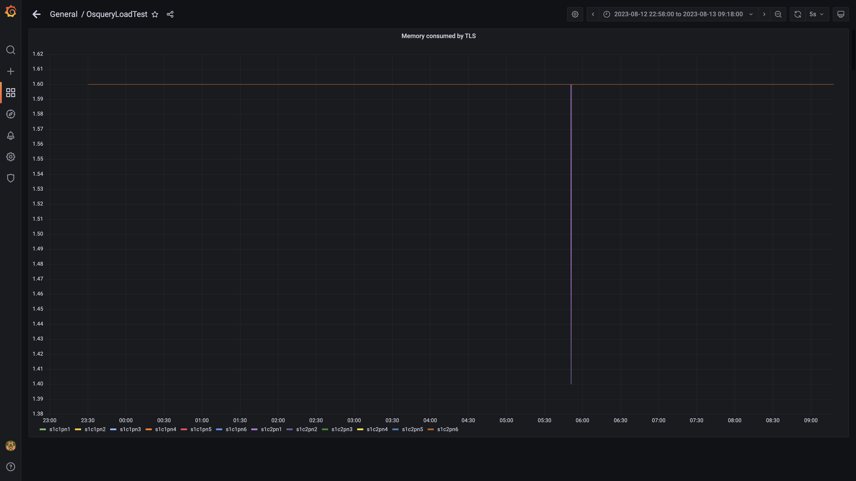

### Airflow memory usage

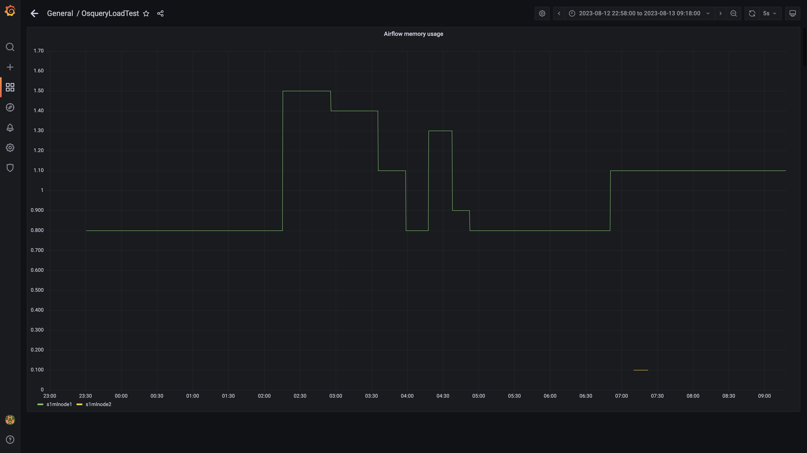

### Postgres node cpu busy percent

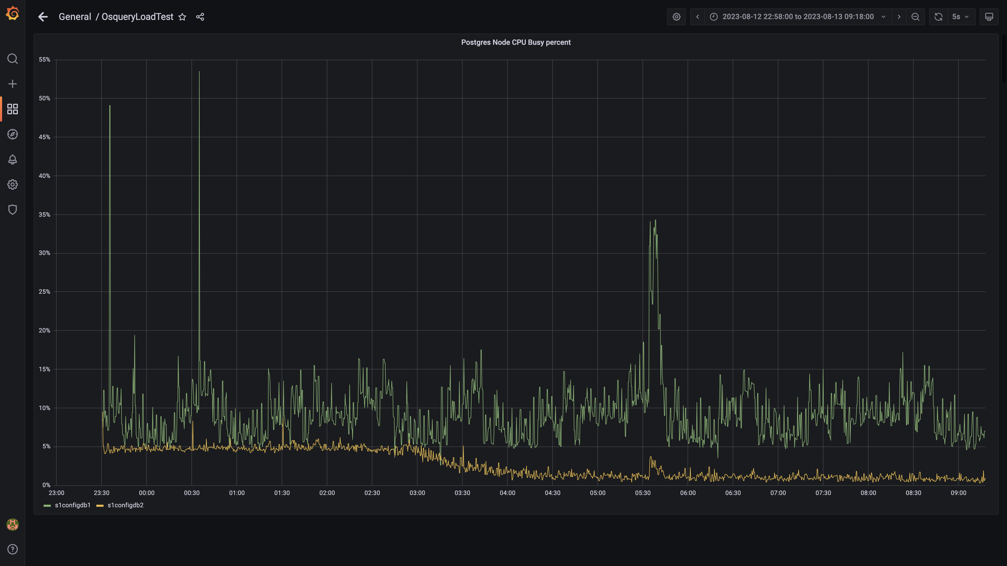

### Process node cpu busy percent

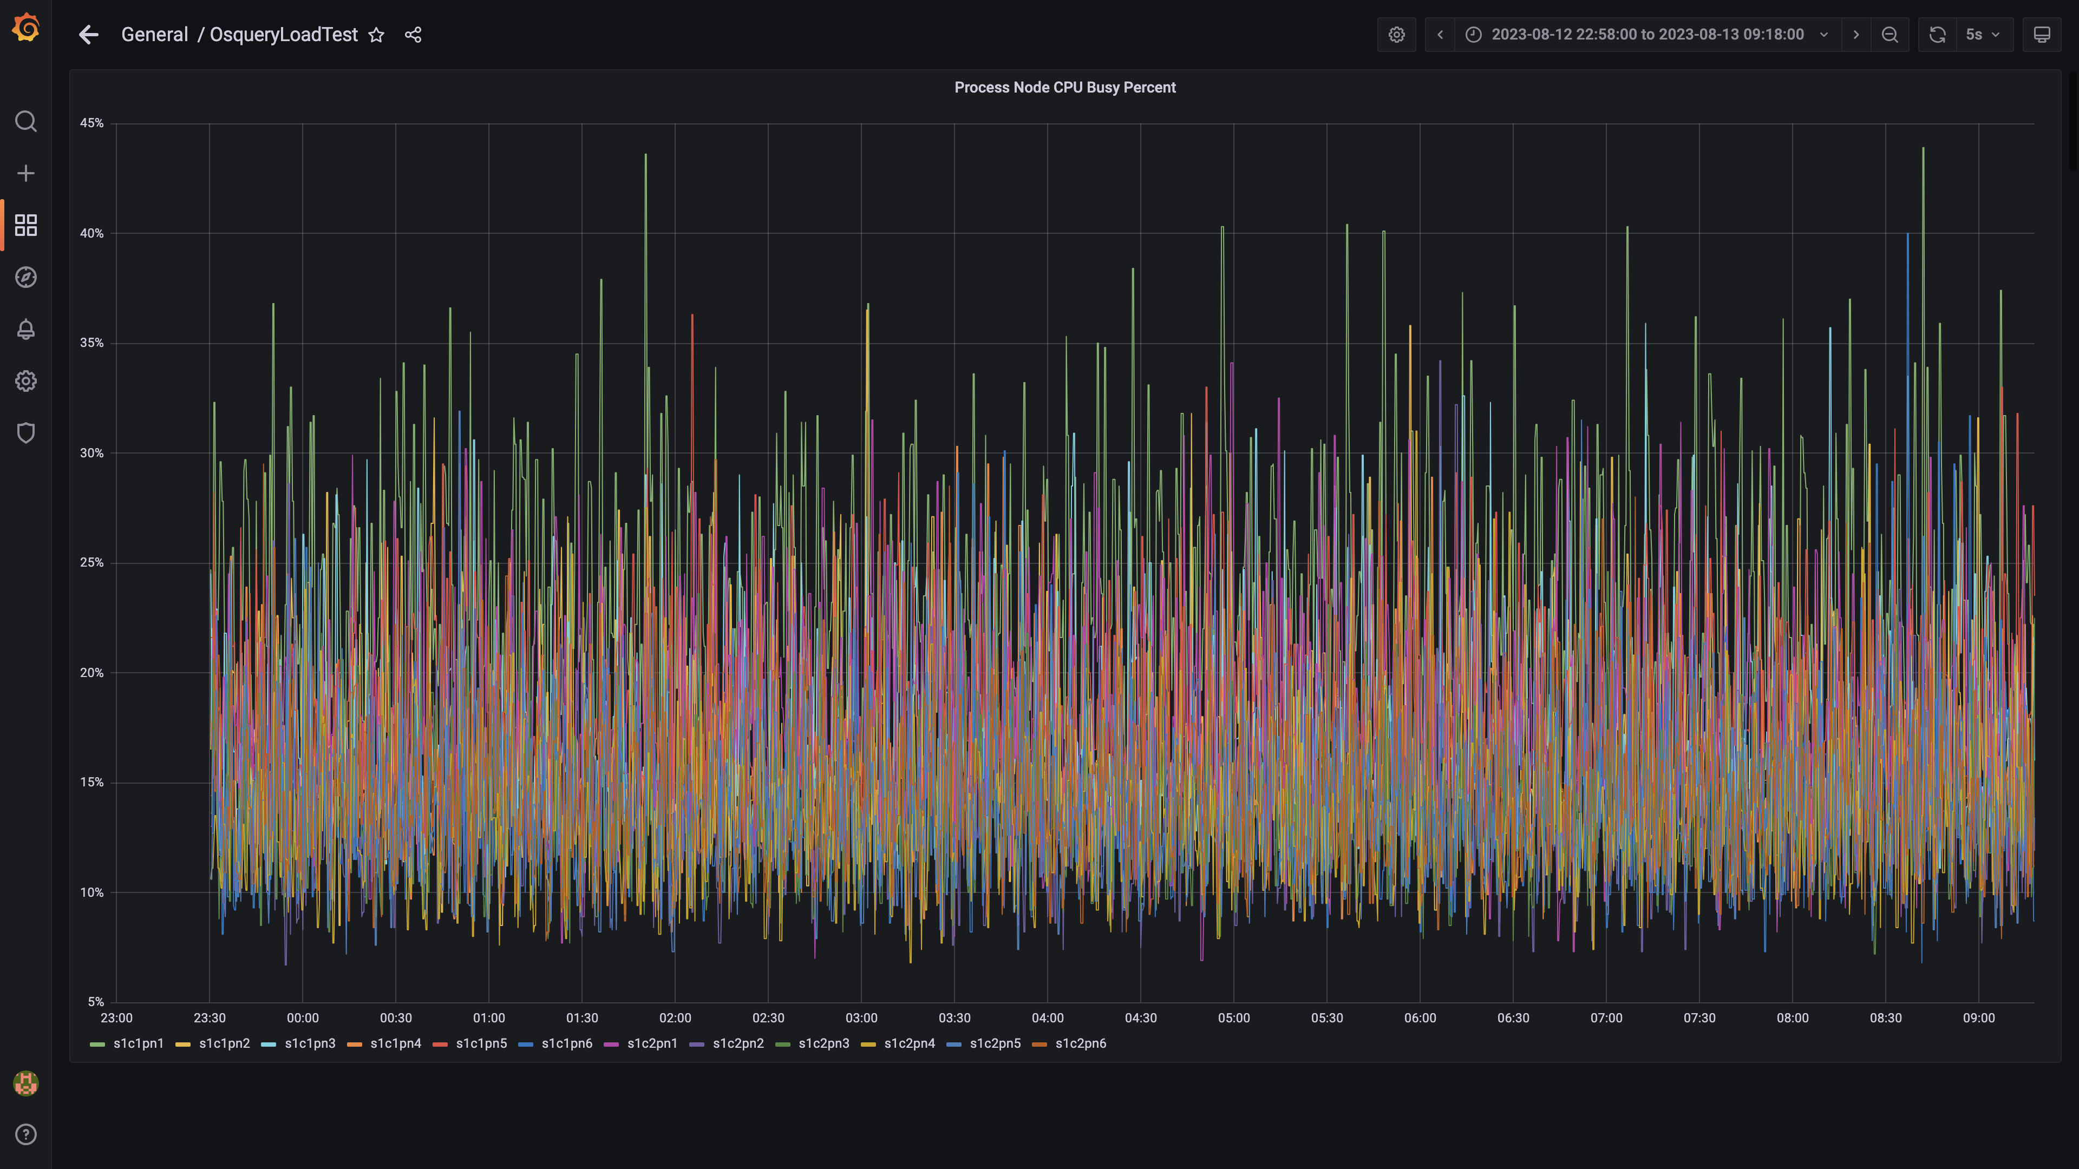

### Data node cpu busy percent

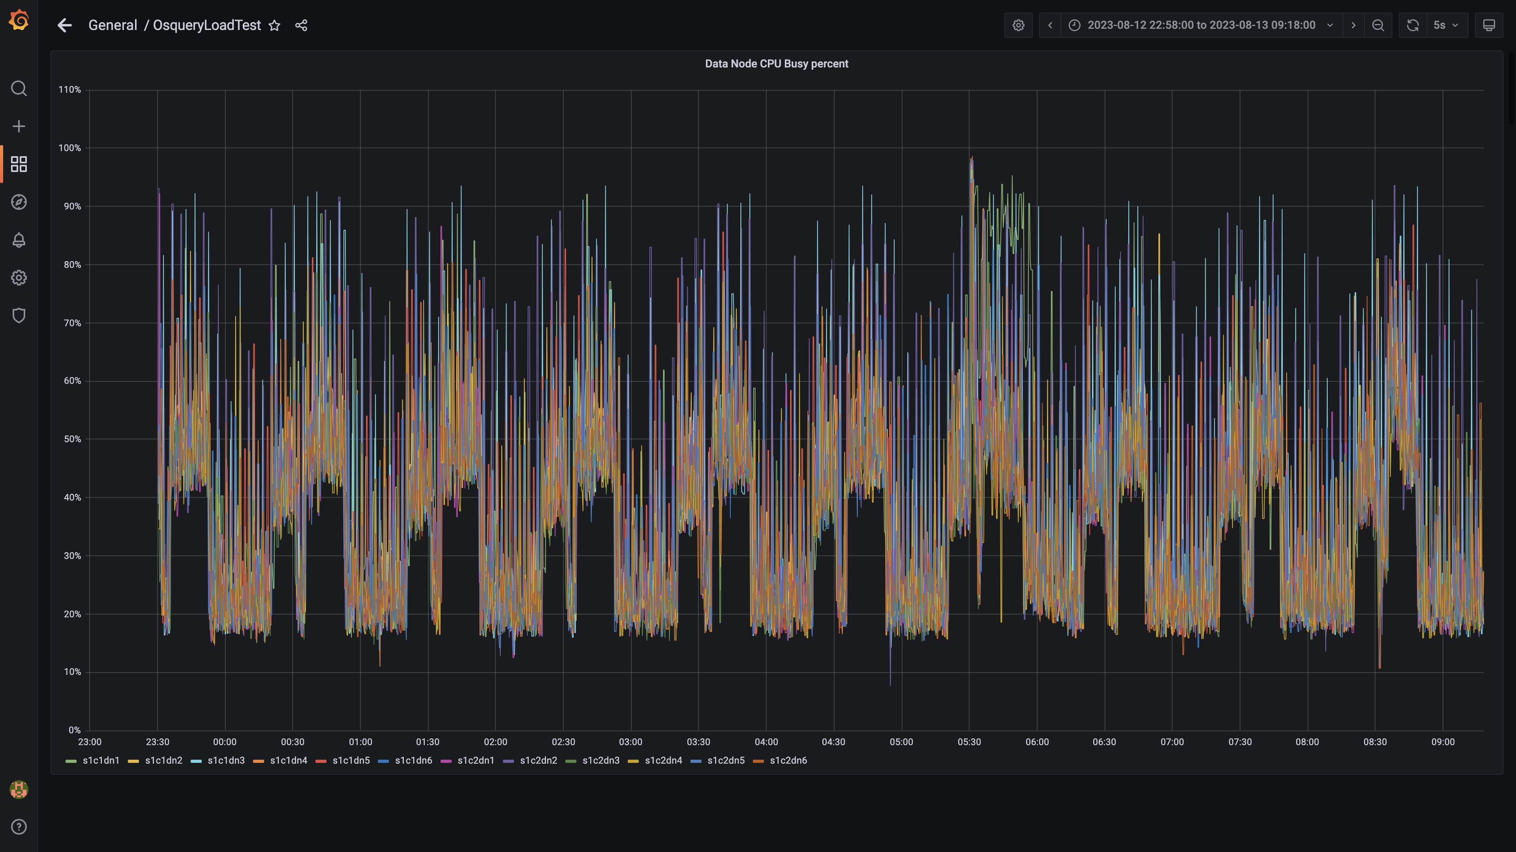

### Postgres-configdb cpu used percentage

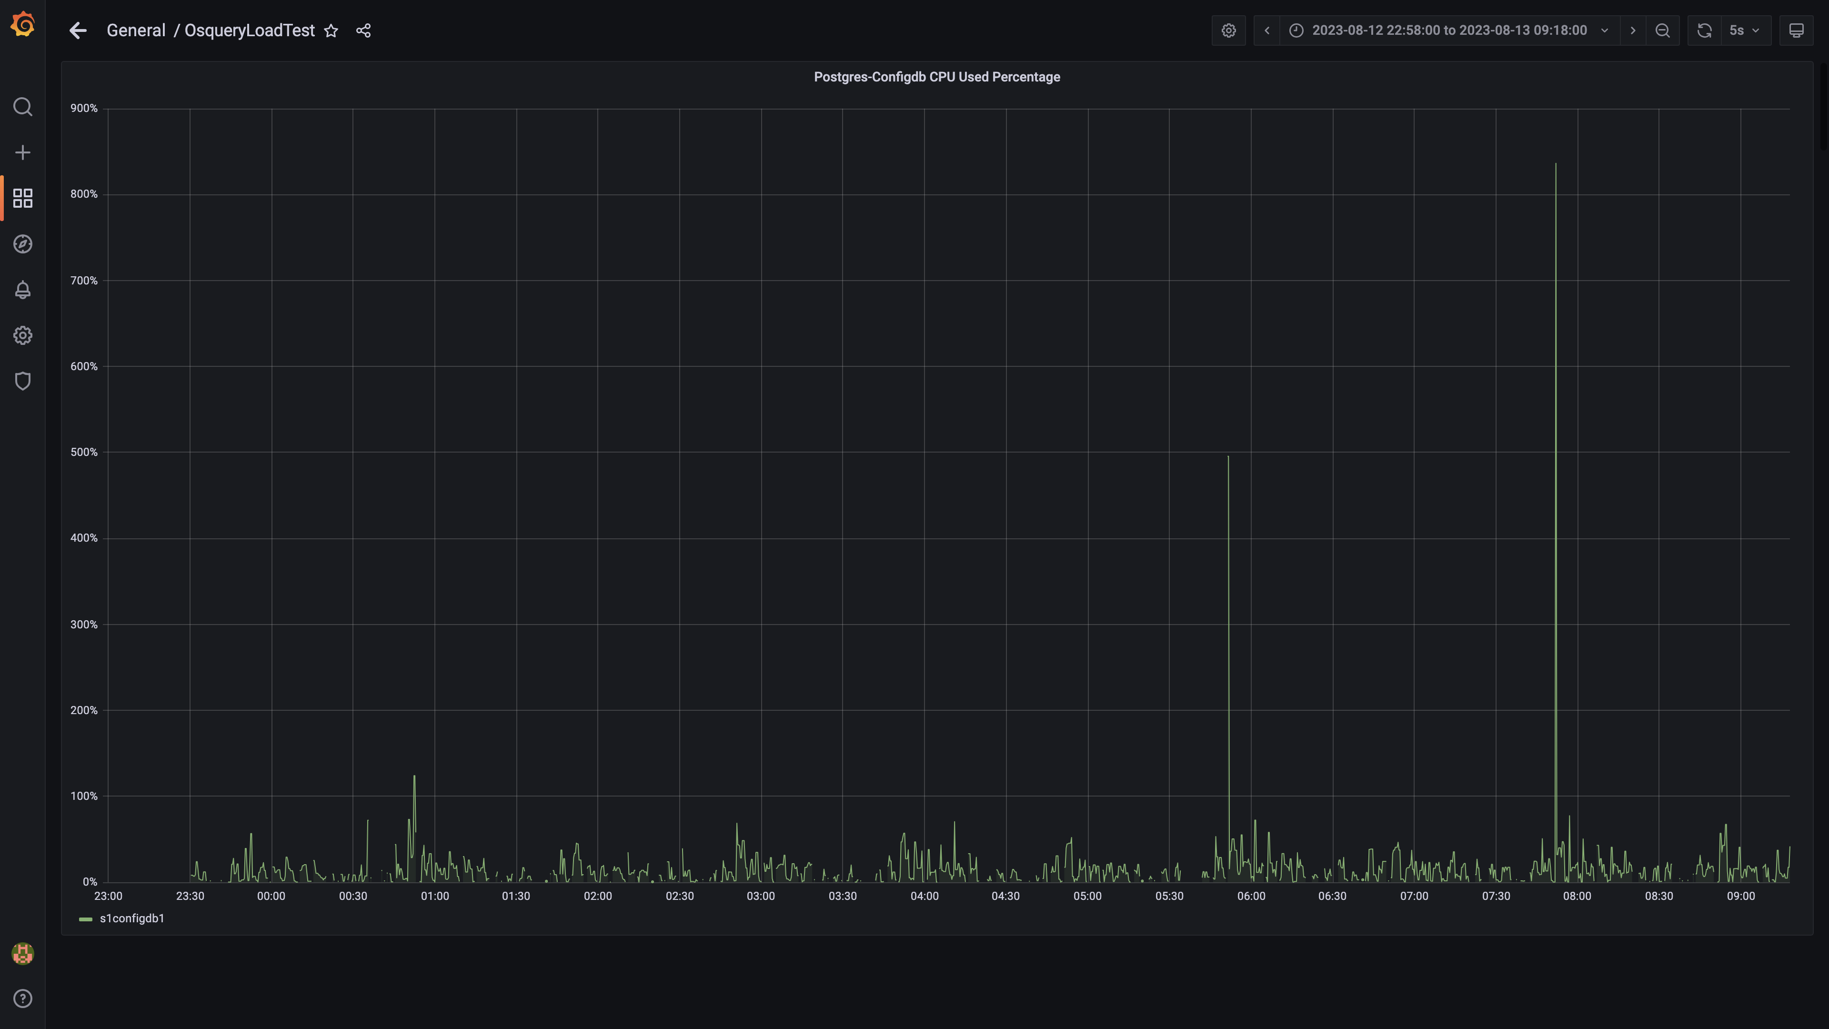

### Pgbouncer cpu used percentage

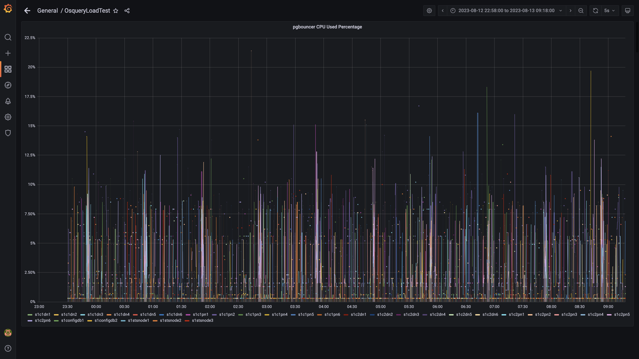

### Cpu consumed by eventsdbingestion

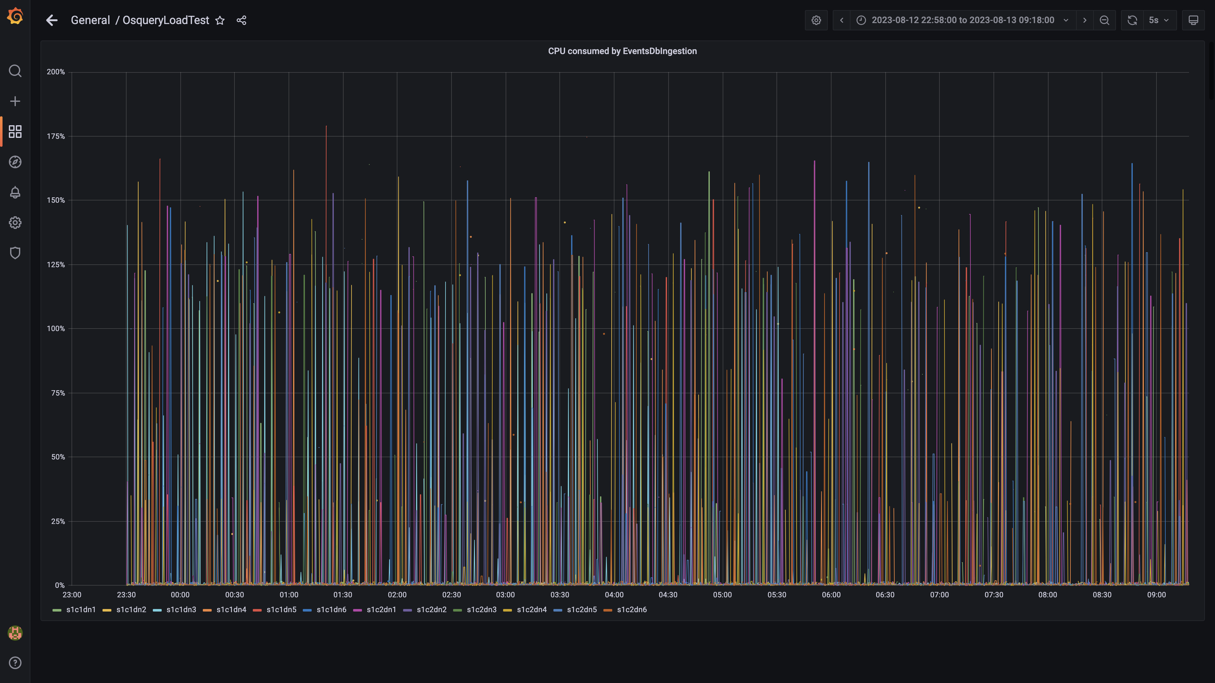

### Cpu consumed by pushgateway

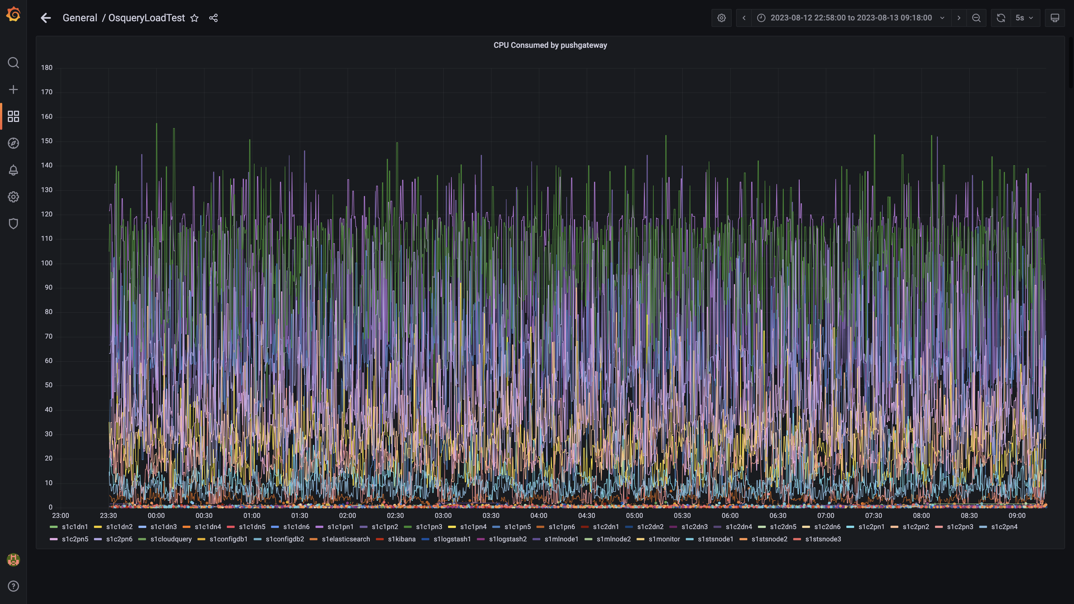

### Cpu consumed by ruleengine

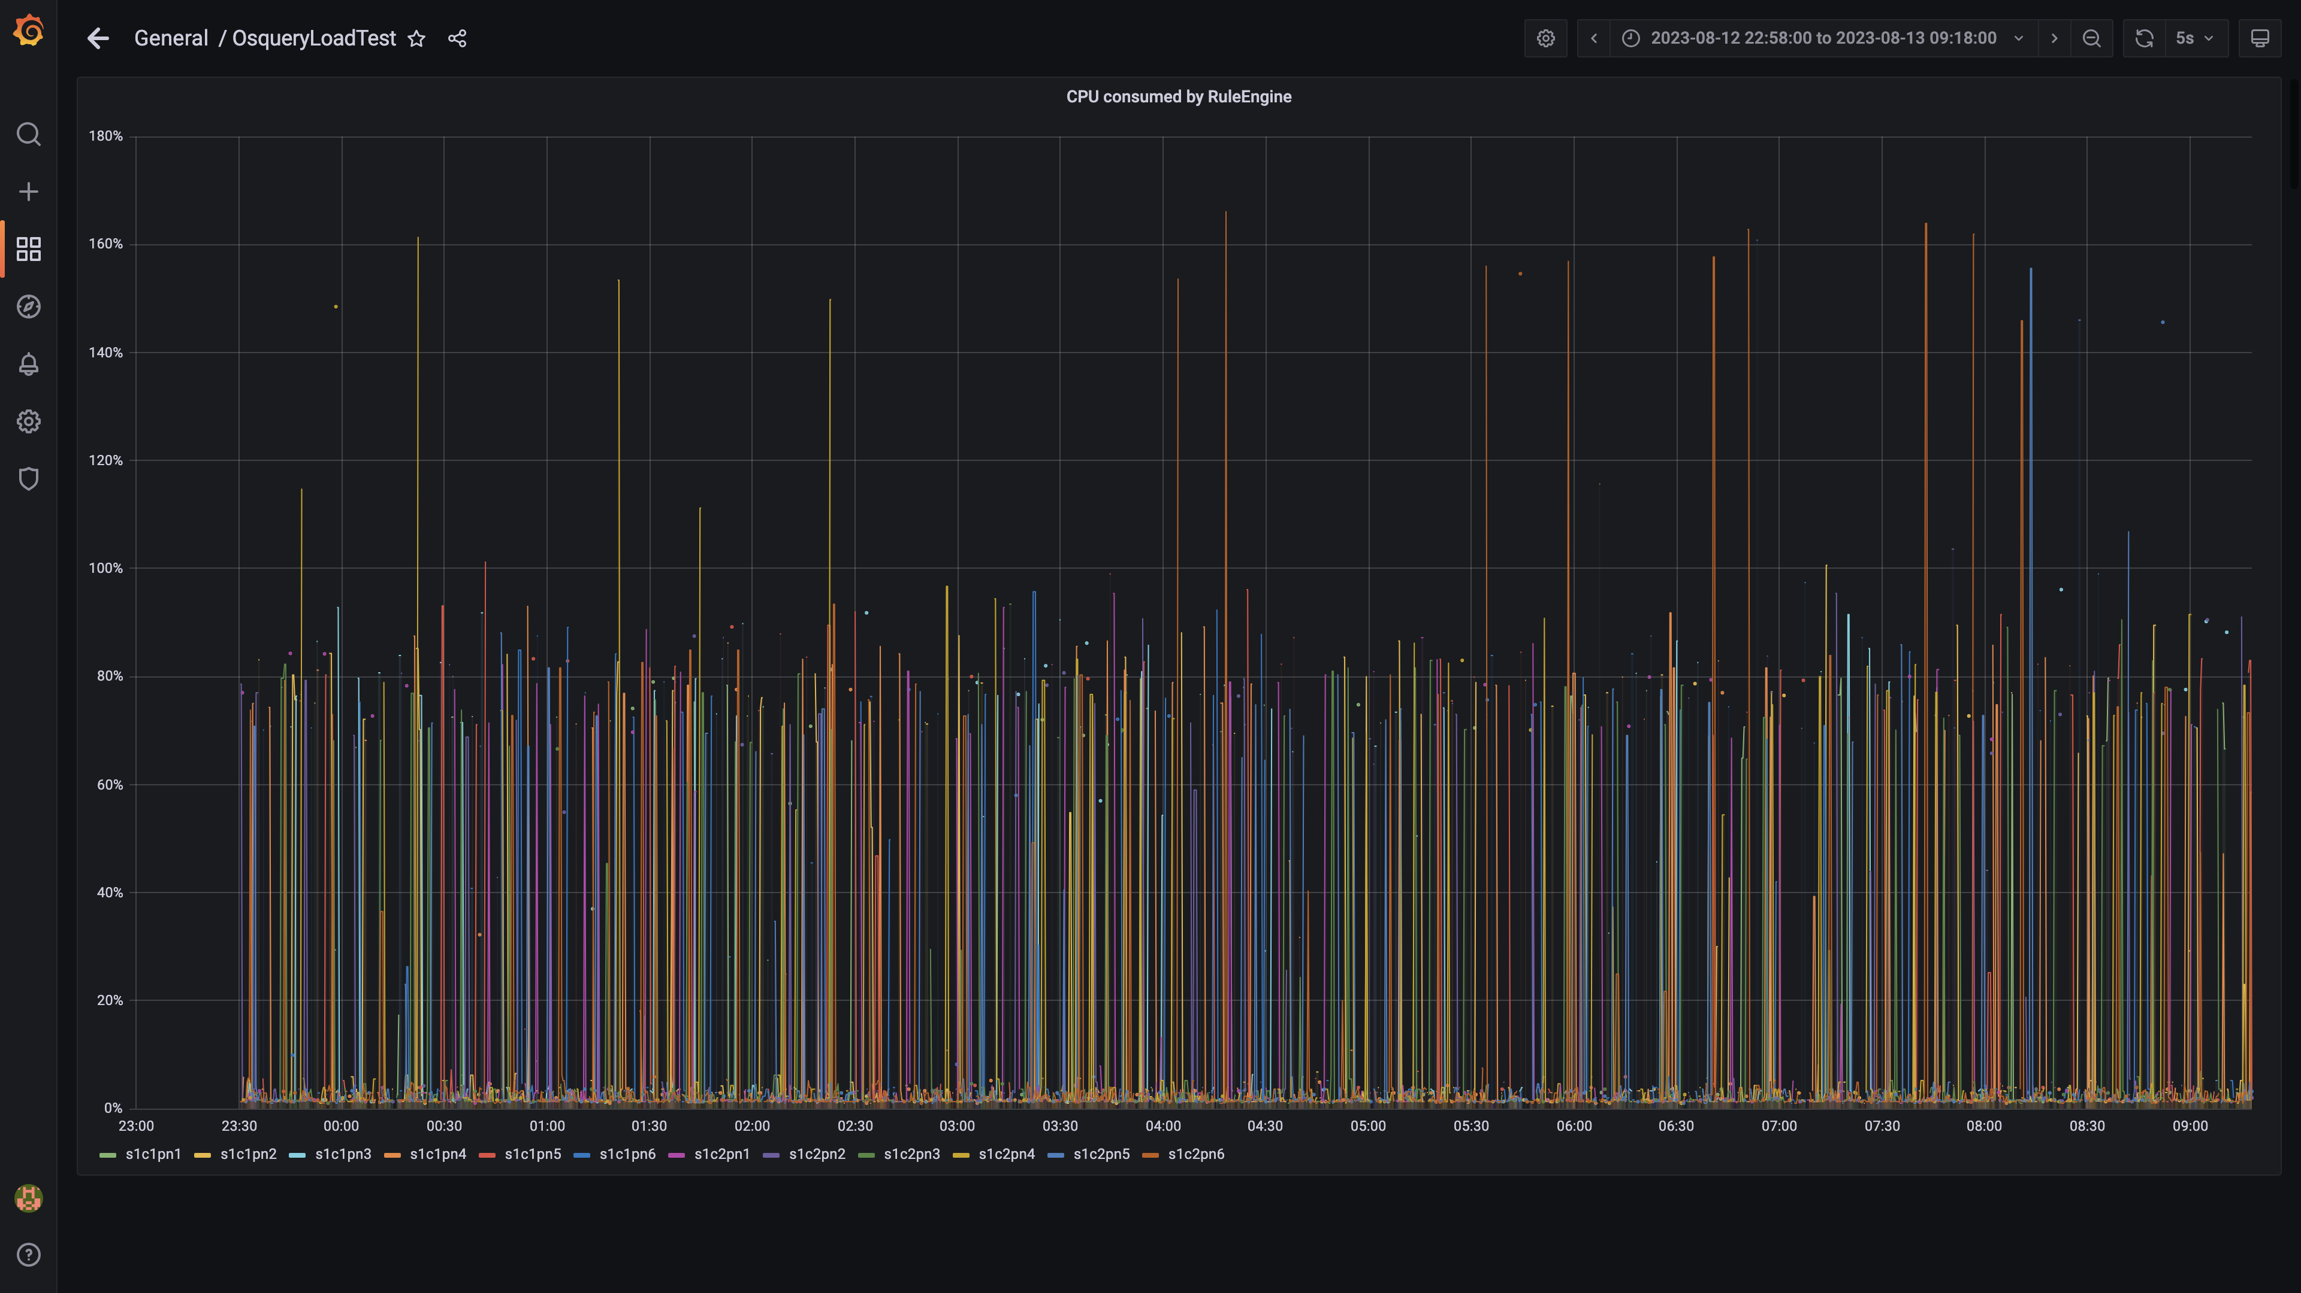

### Panel 68 not loaded in given time

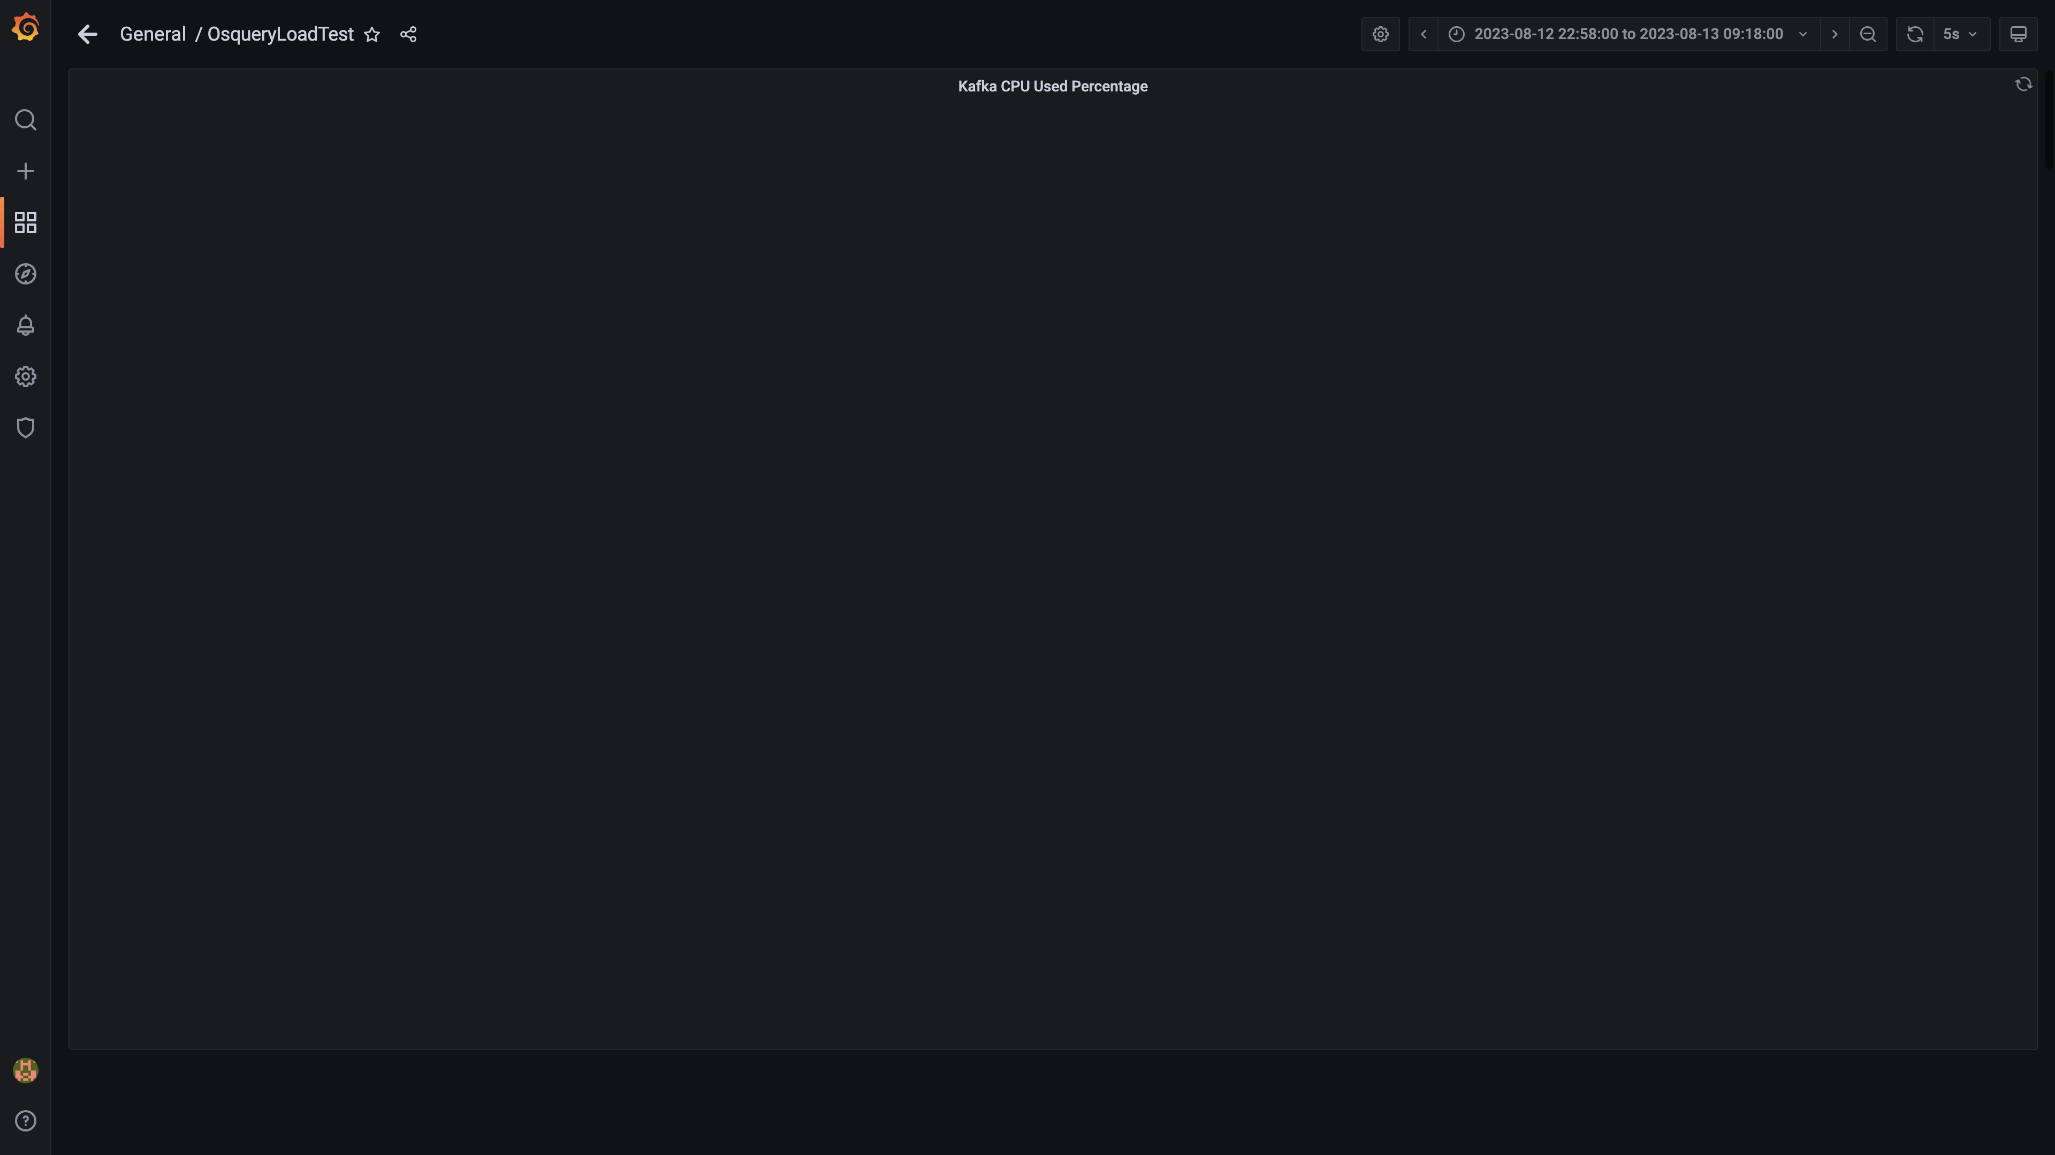

### Cpu used by data-archival

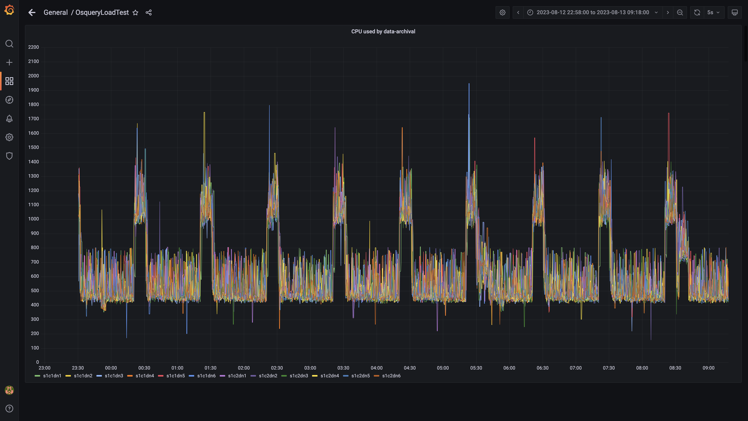

### Cpu consumed by osqueryingestion

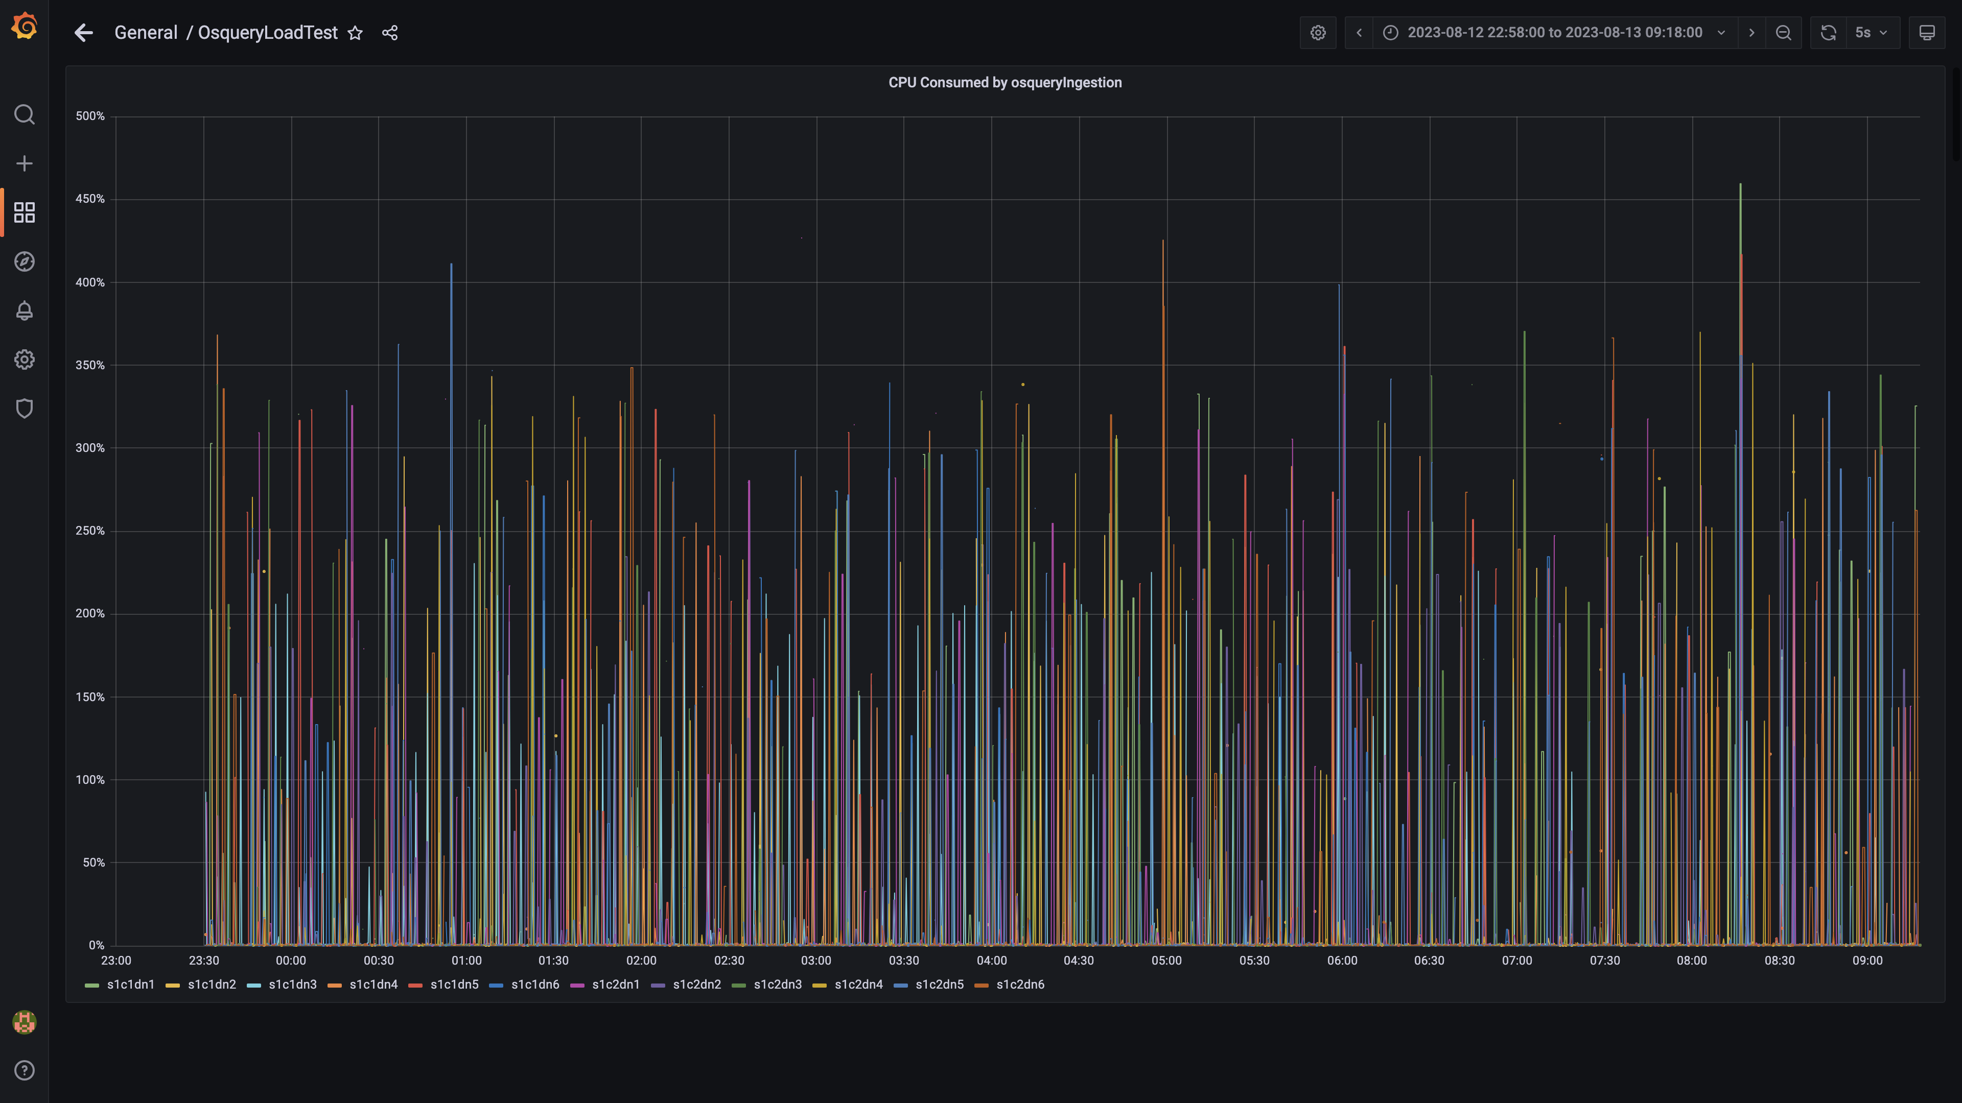

### Cpu consumed by redis server

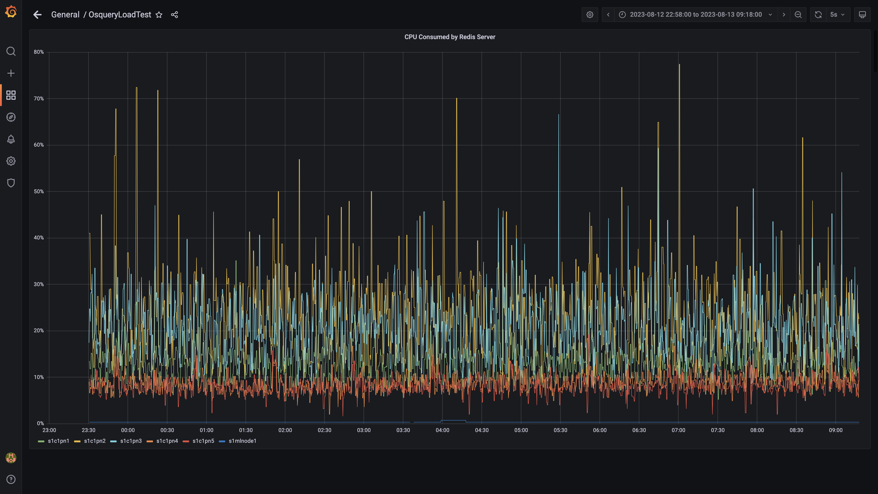

### Cpu consumed by orc-compaction

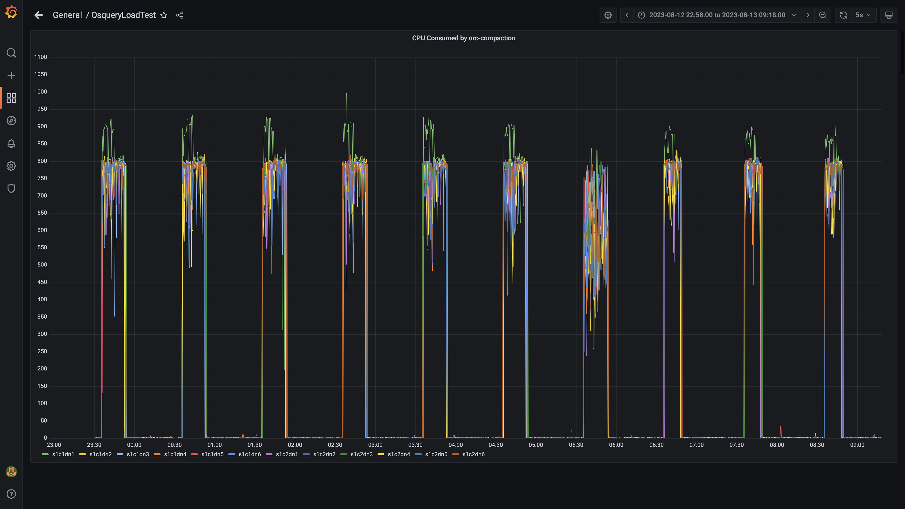

### Cpu consumed by spark-worker

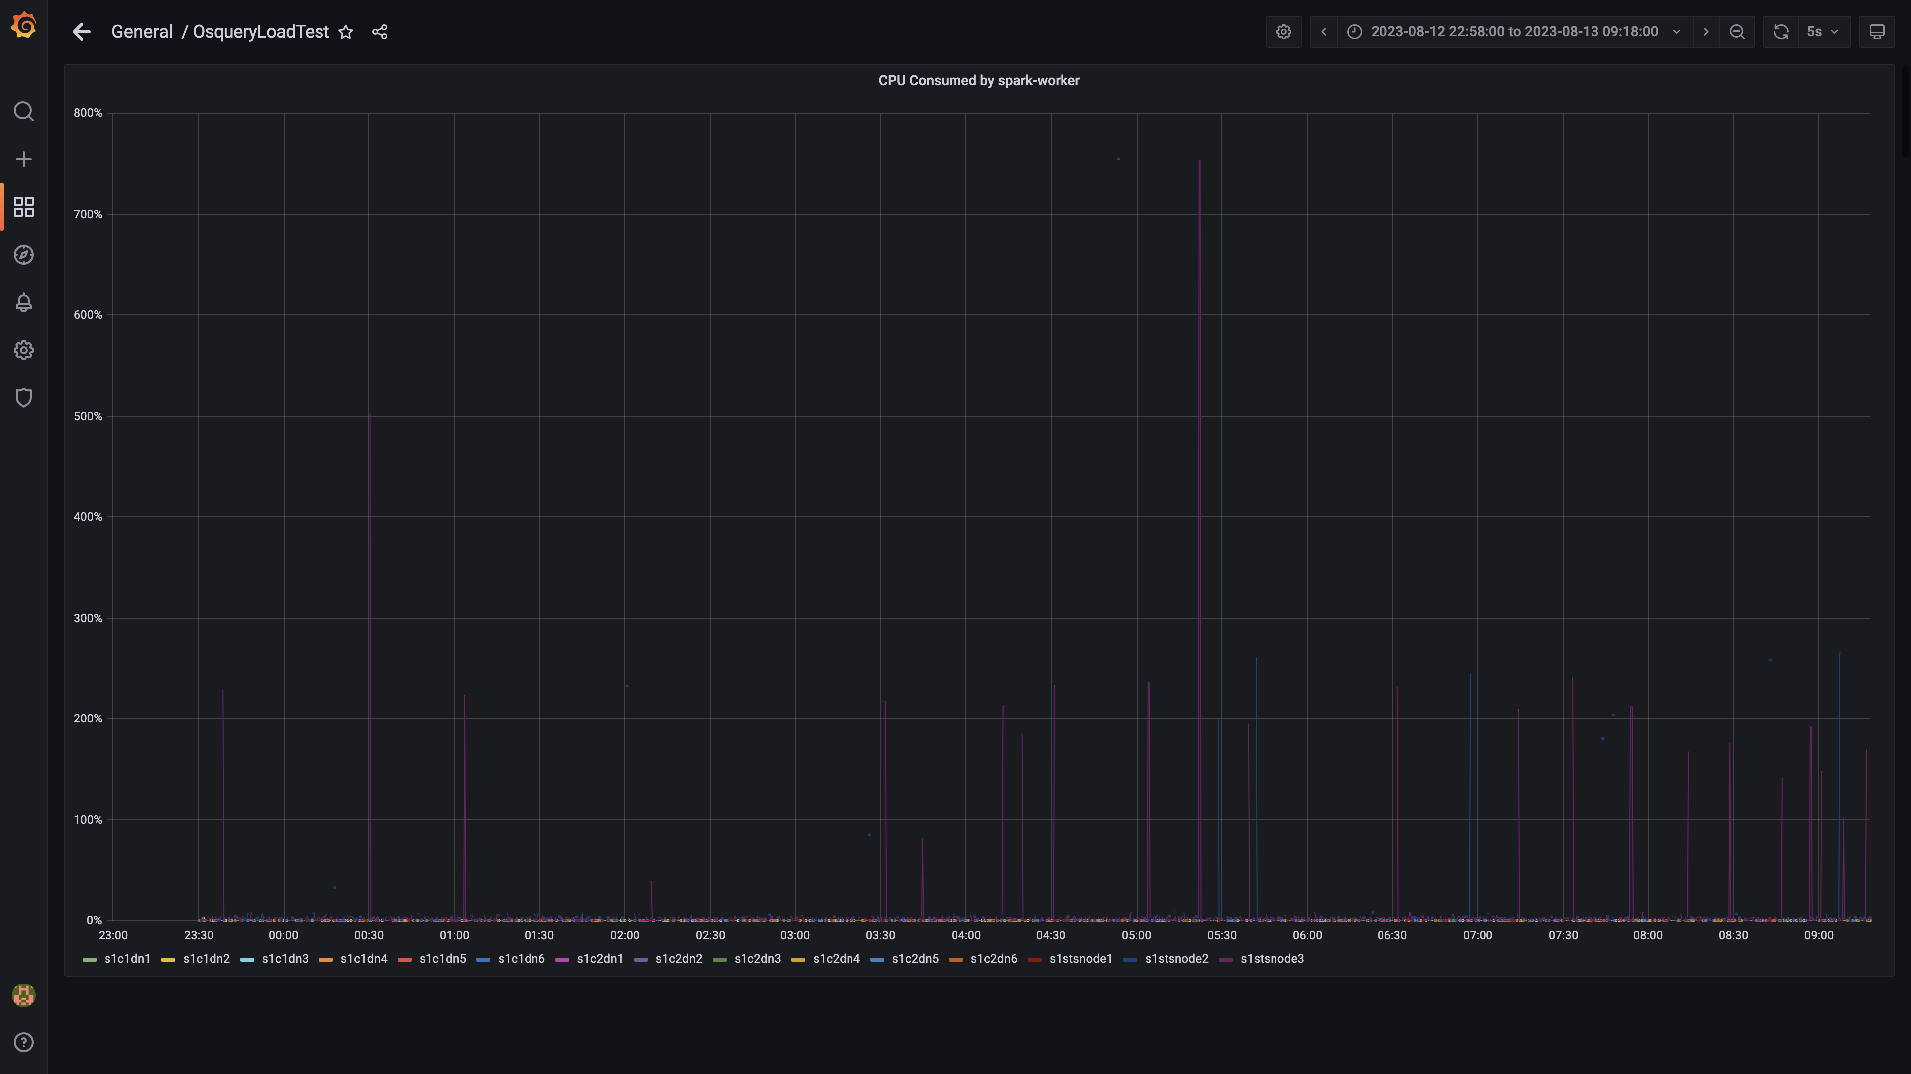

### Cpu consumed by logger

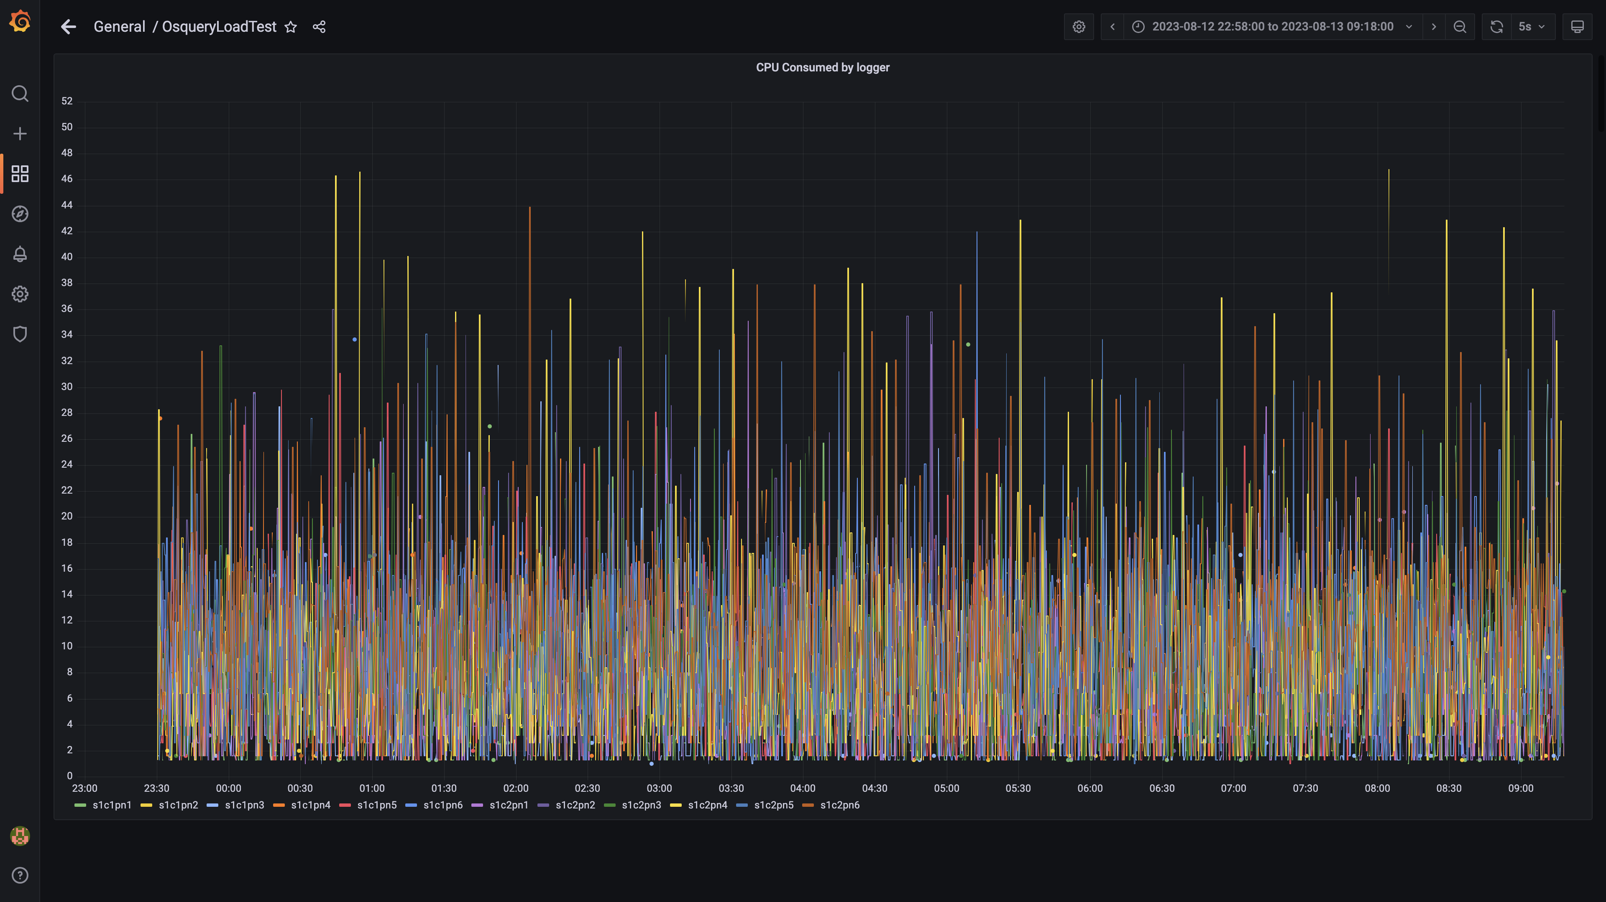

### Compliance summary consumer cpu consumption

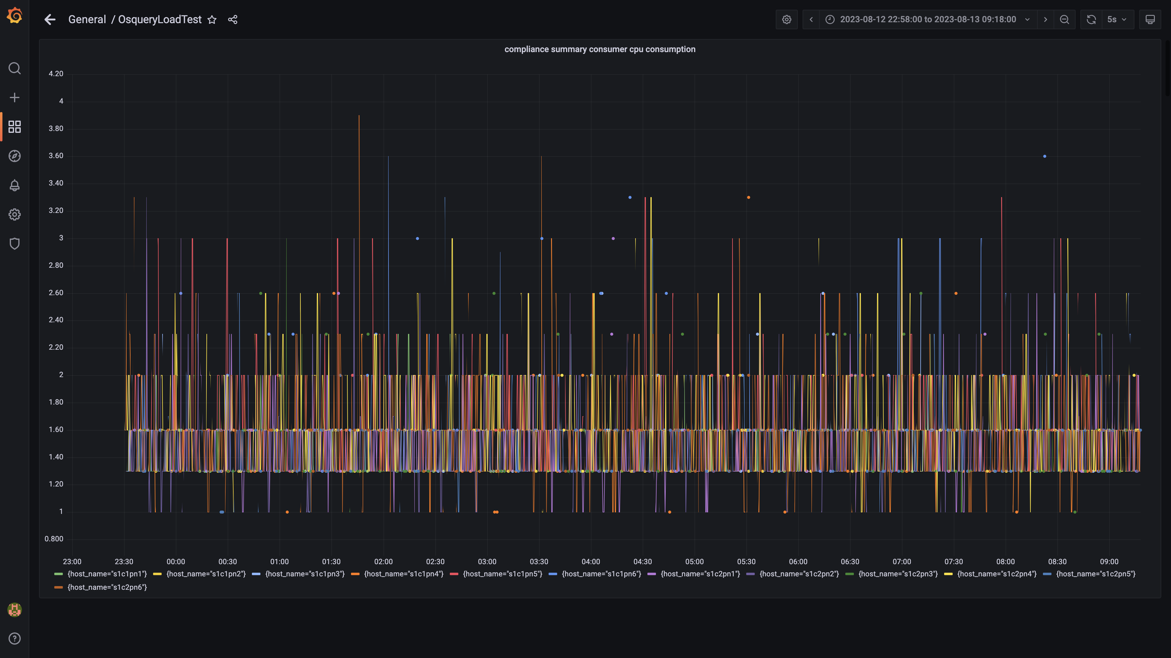

### Cpu consumed by trino

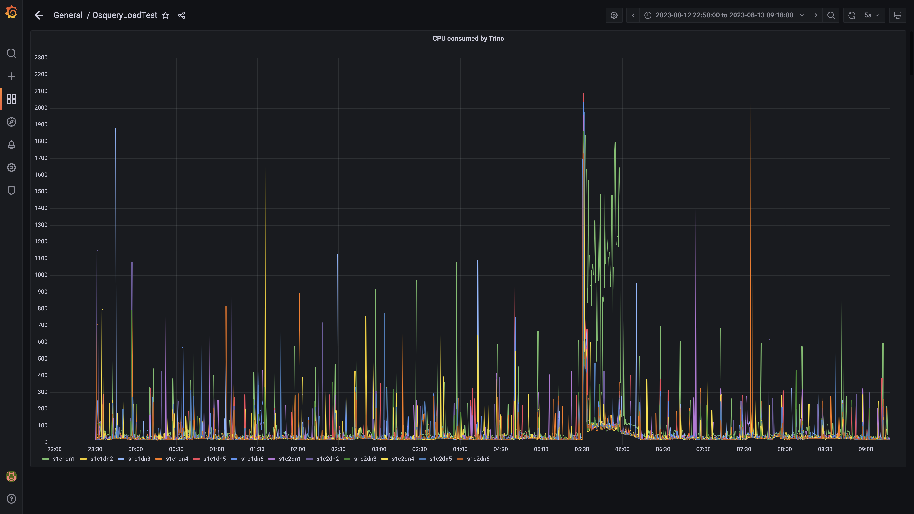

### Debezium cpu usage

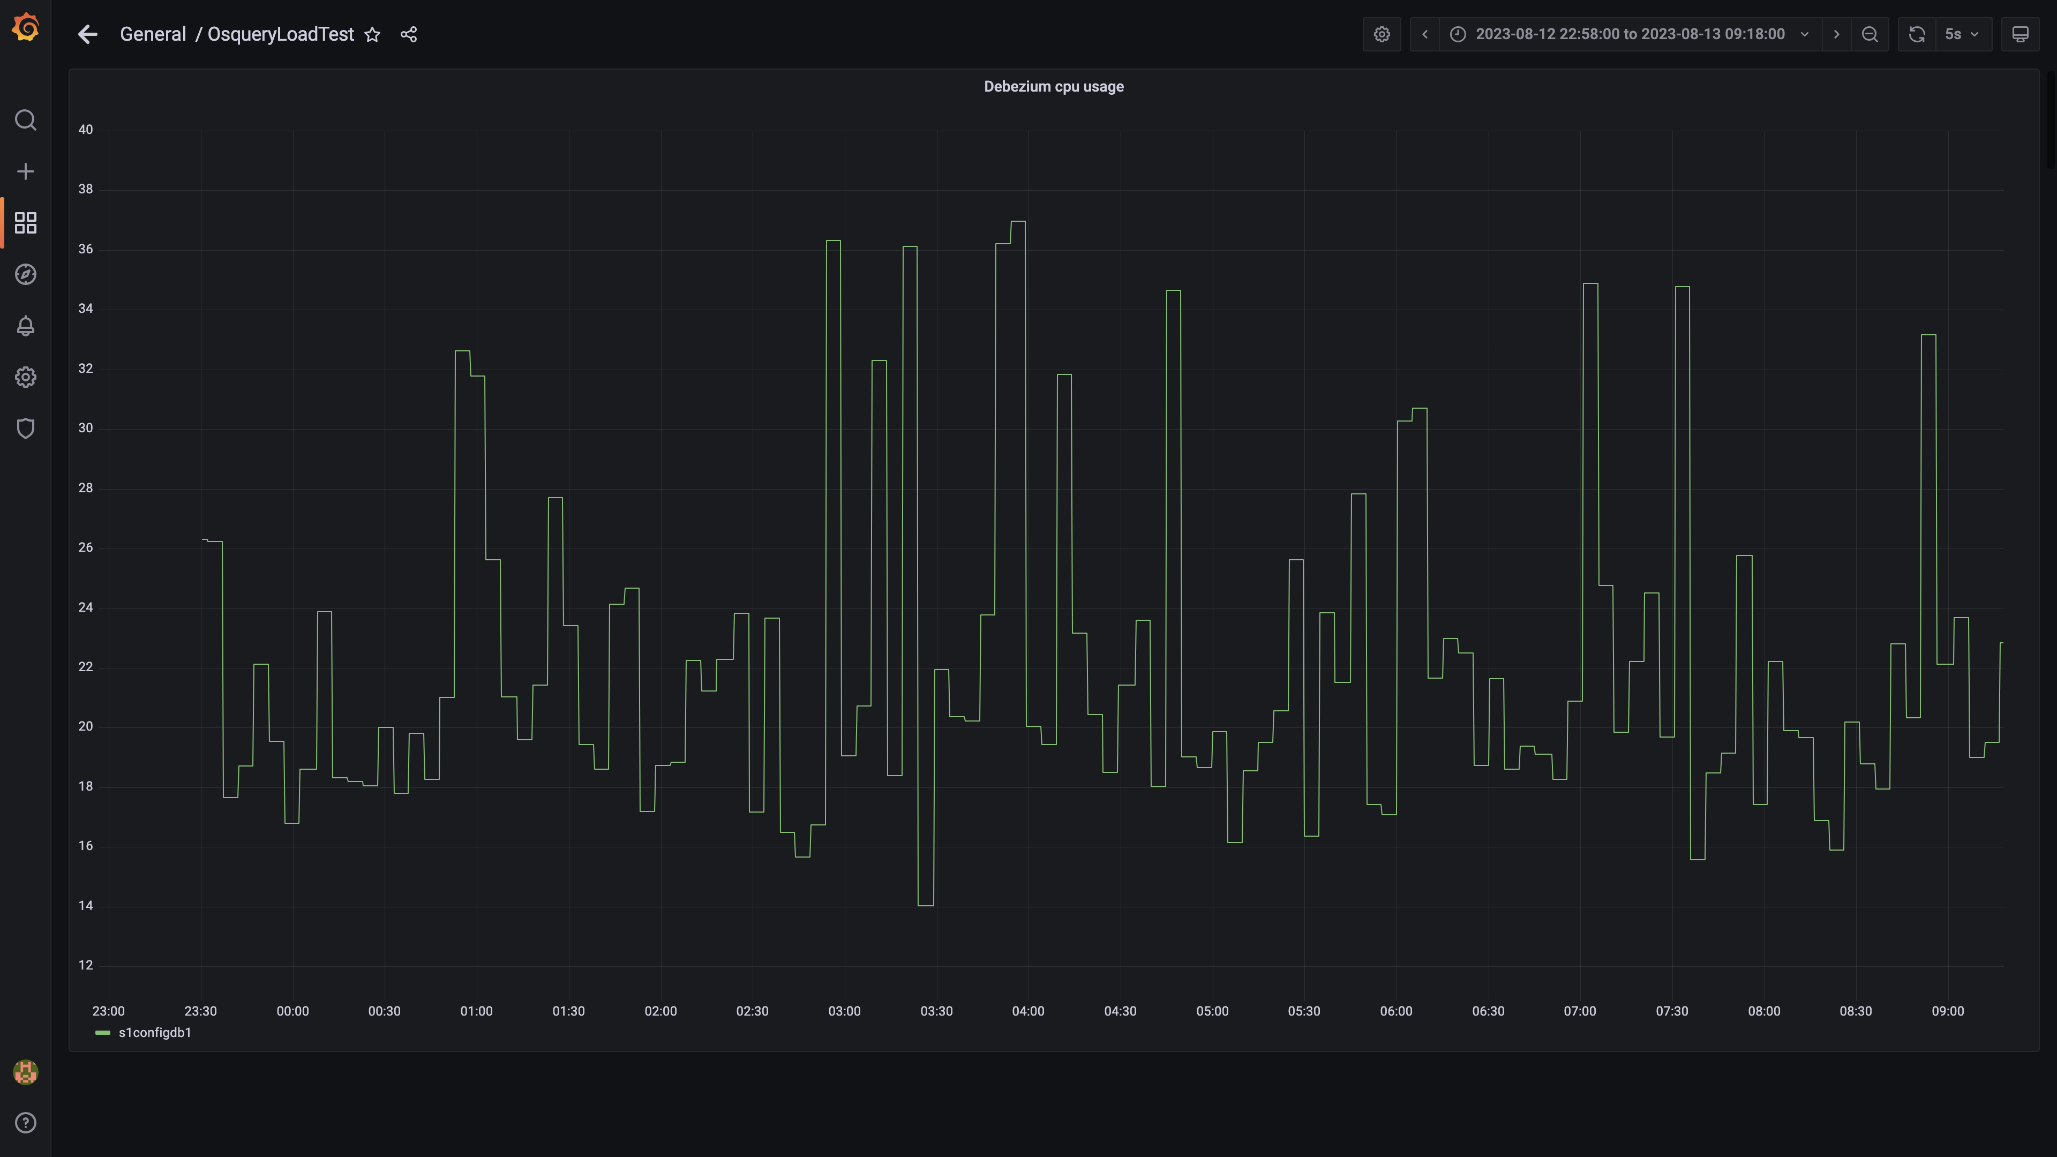

### Cpu consumed by spark-master

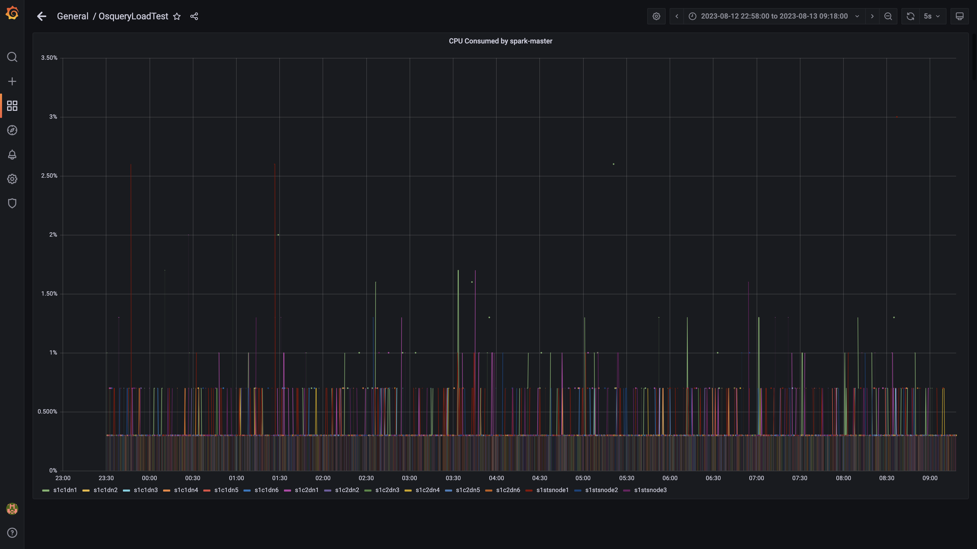

### Cpu consumed by tls

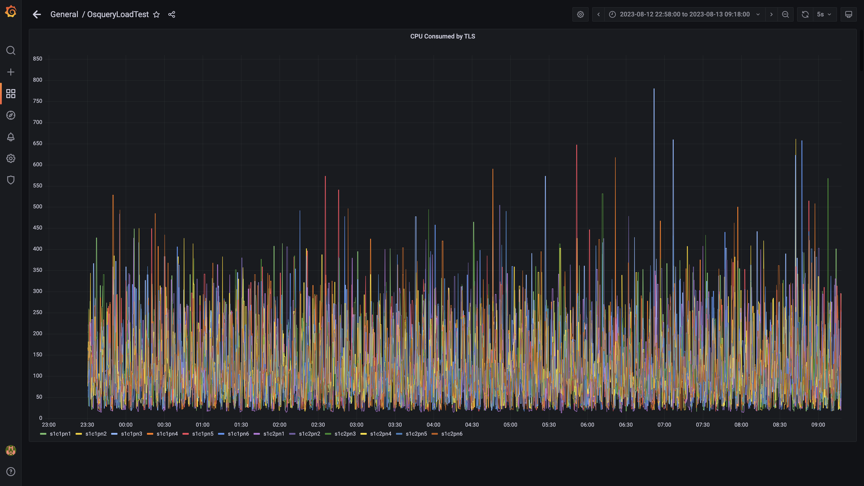

### Airflow cpu usage

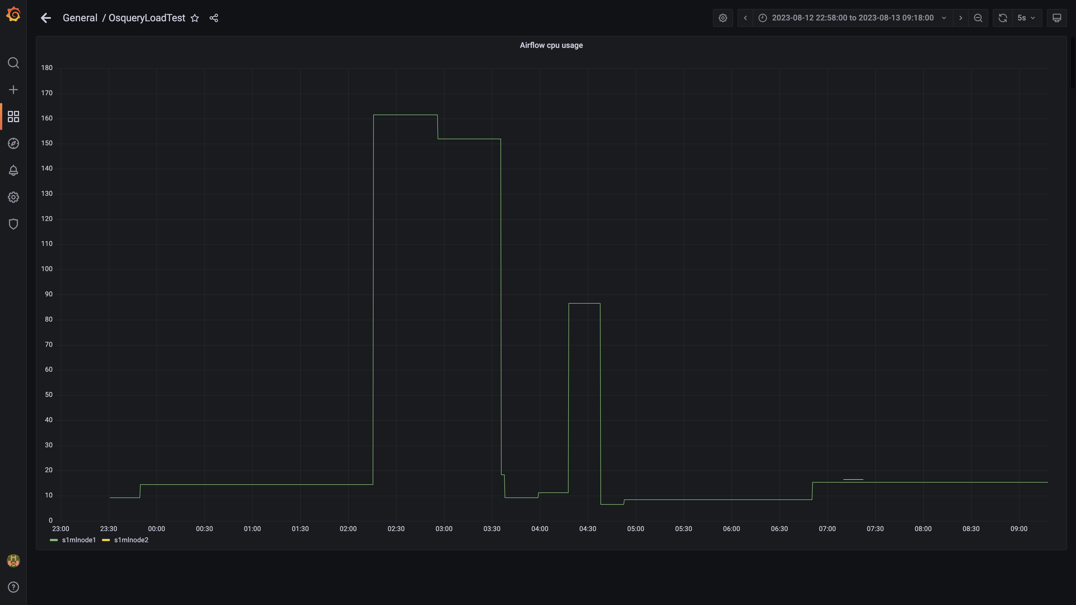

### Spark inject and drain rate agent osquery

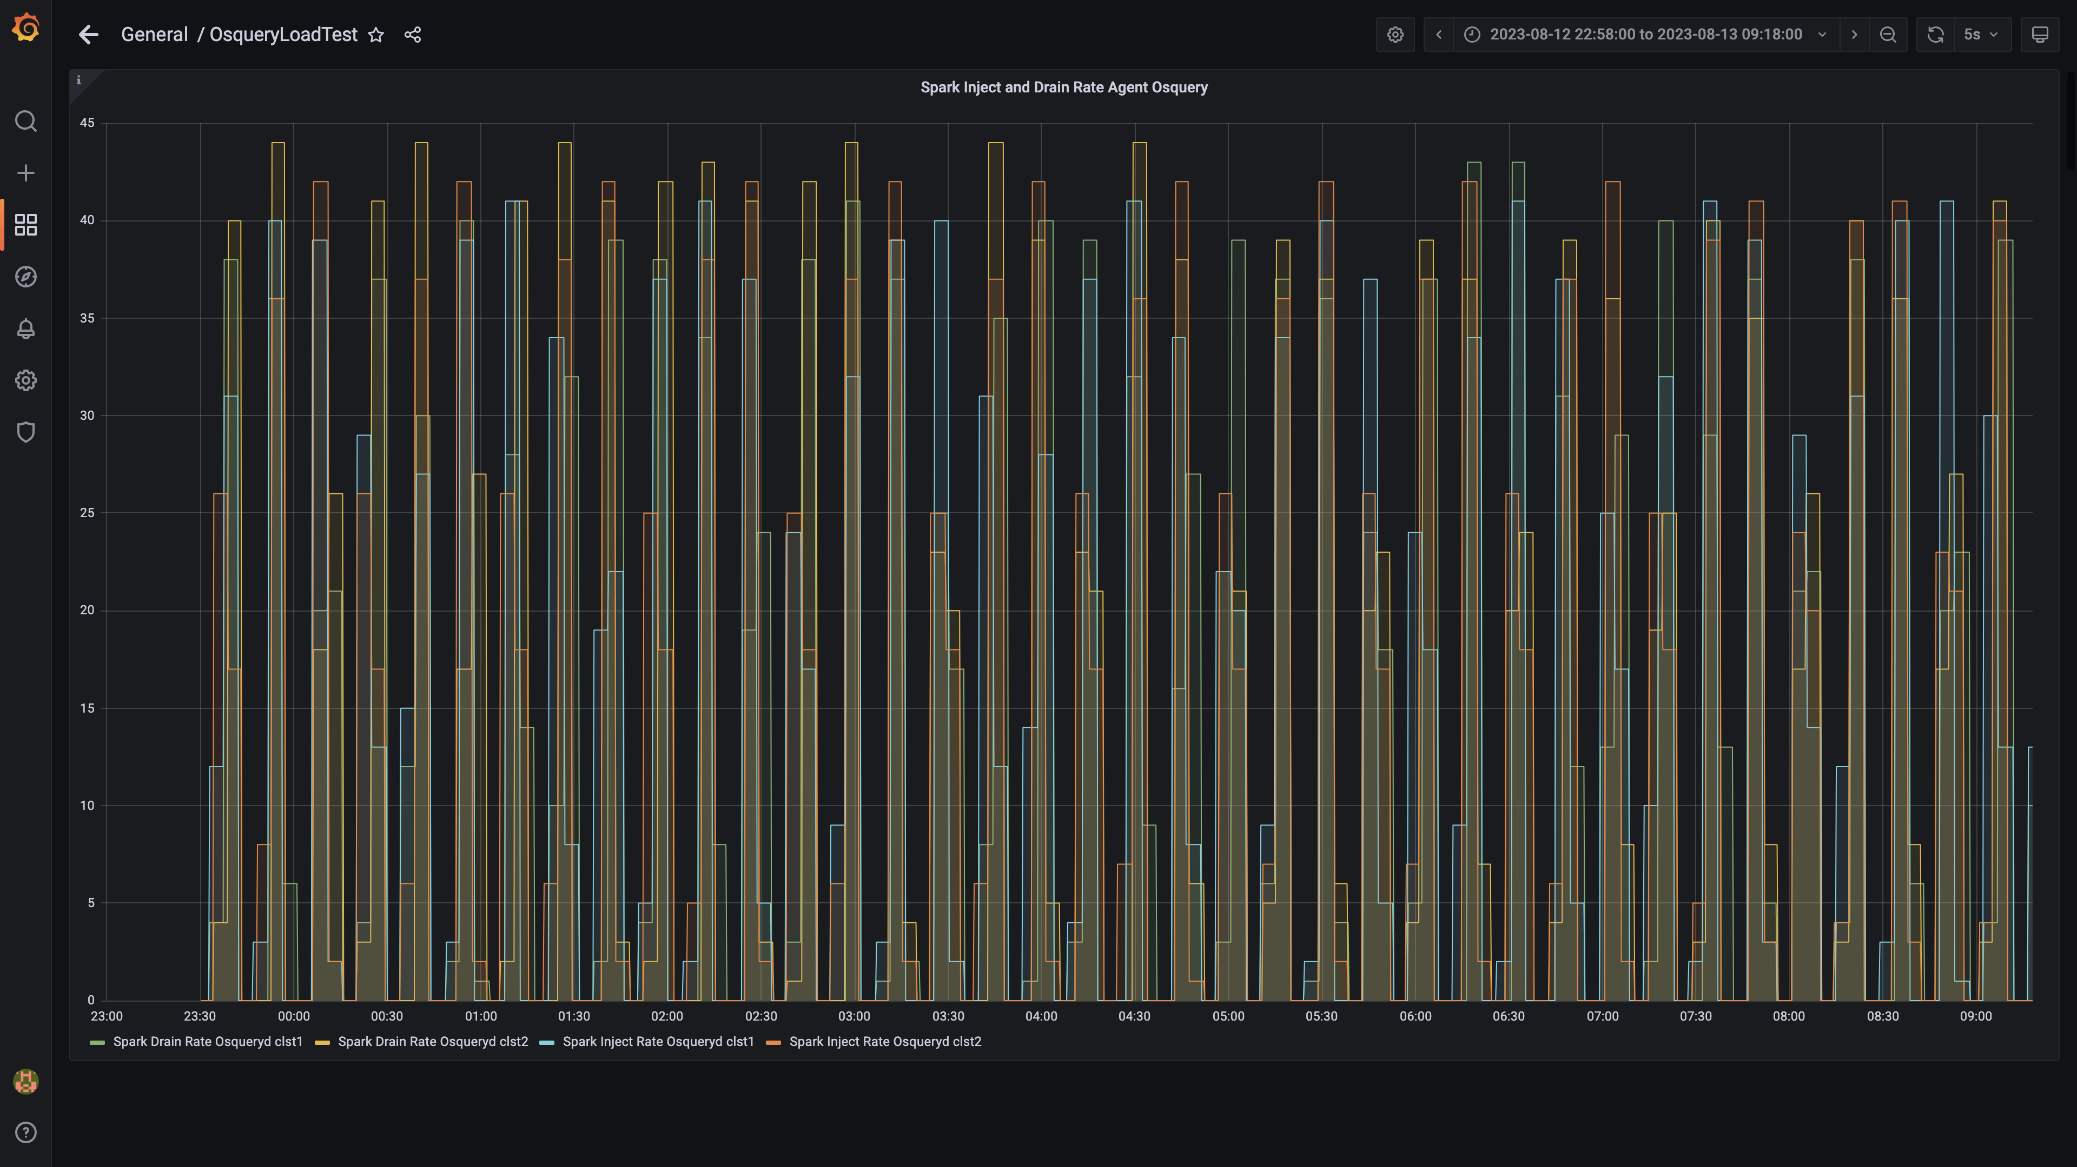

### Spark lag for agent osquery

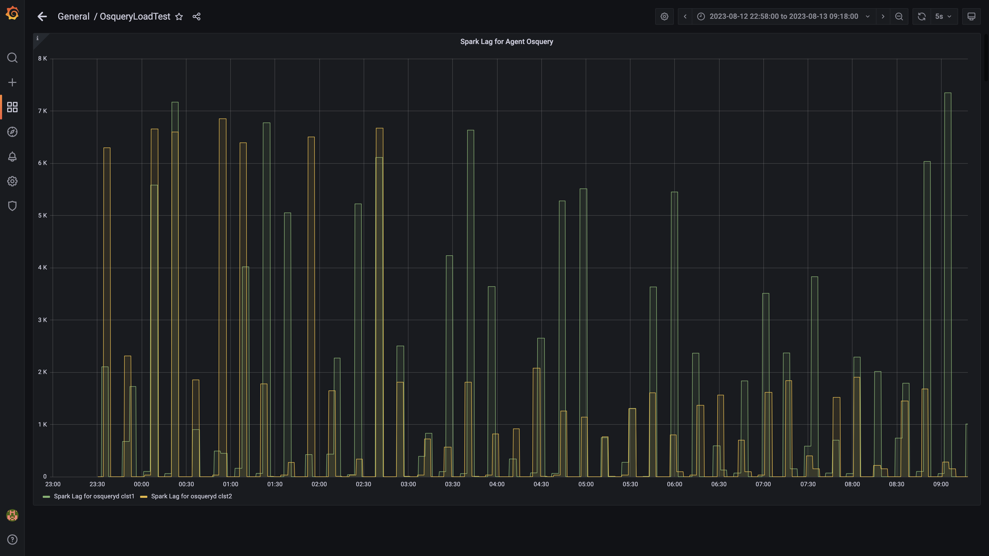

### Spark inject and drain rate events

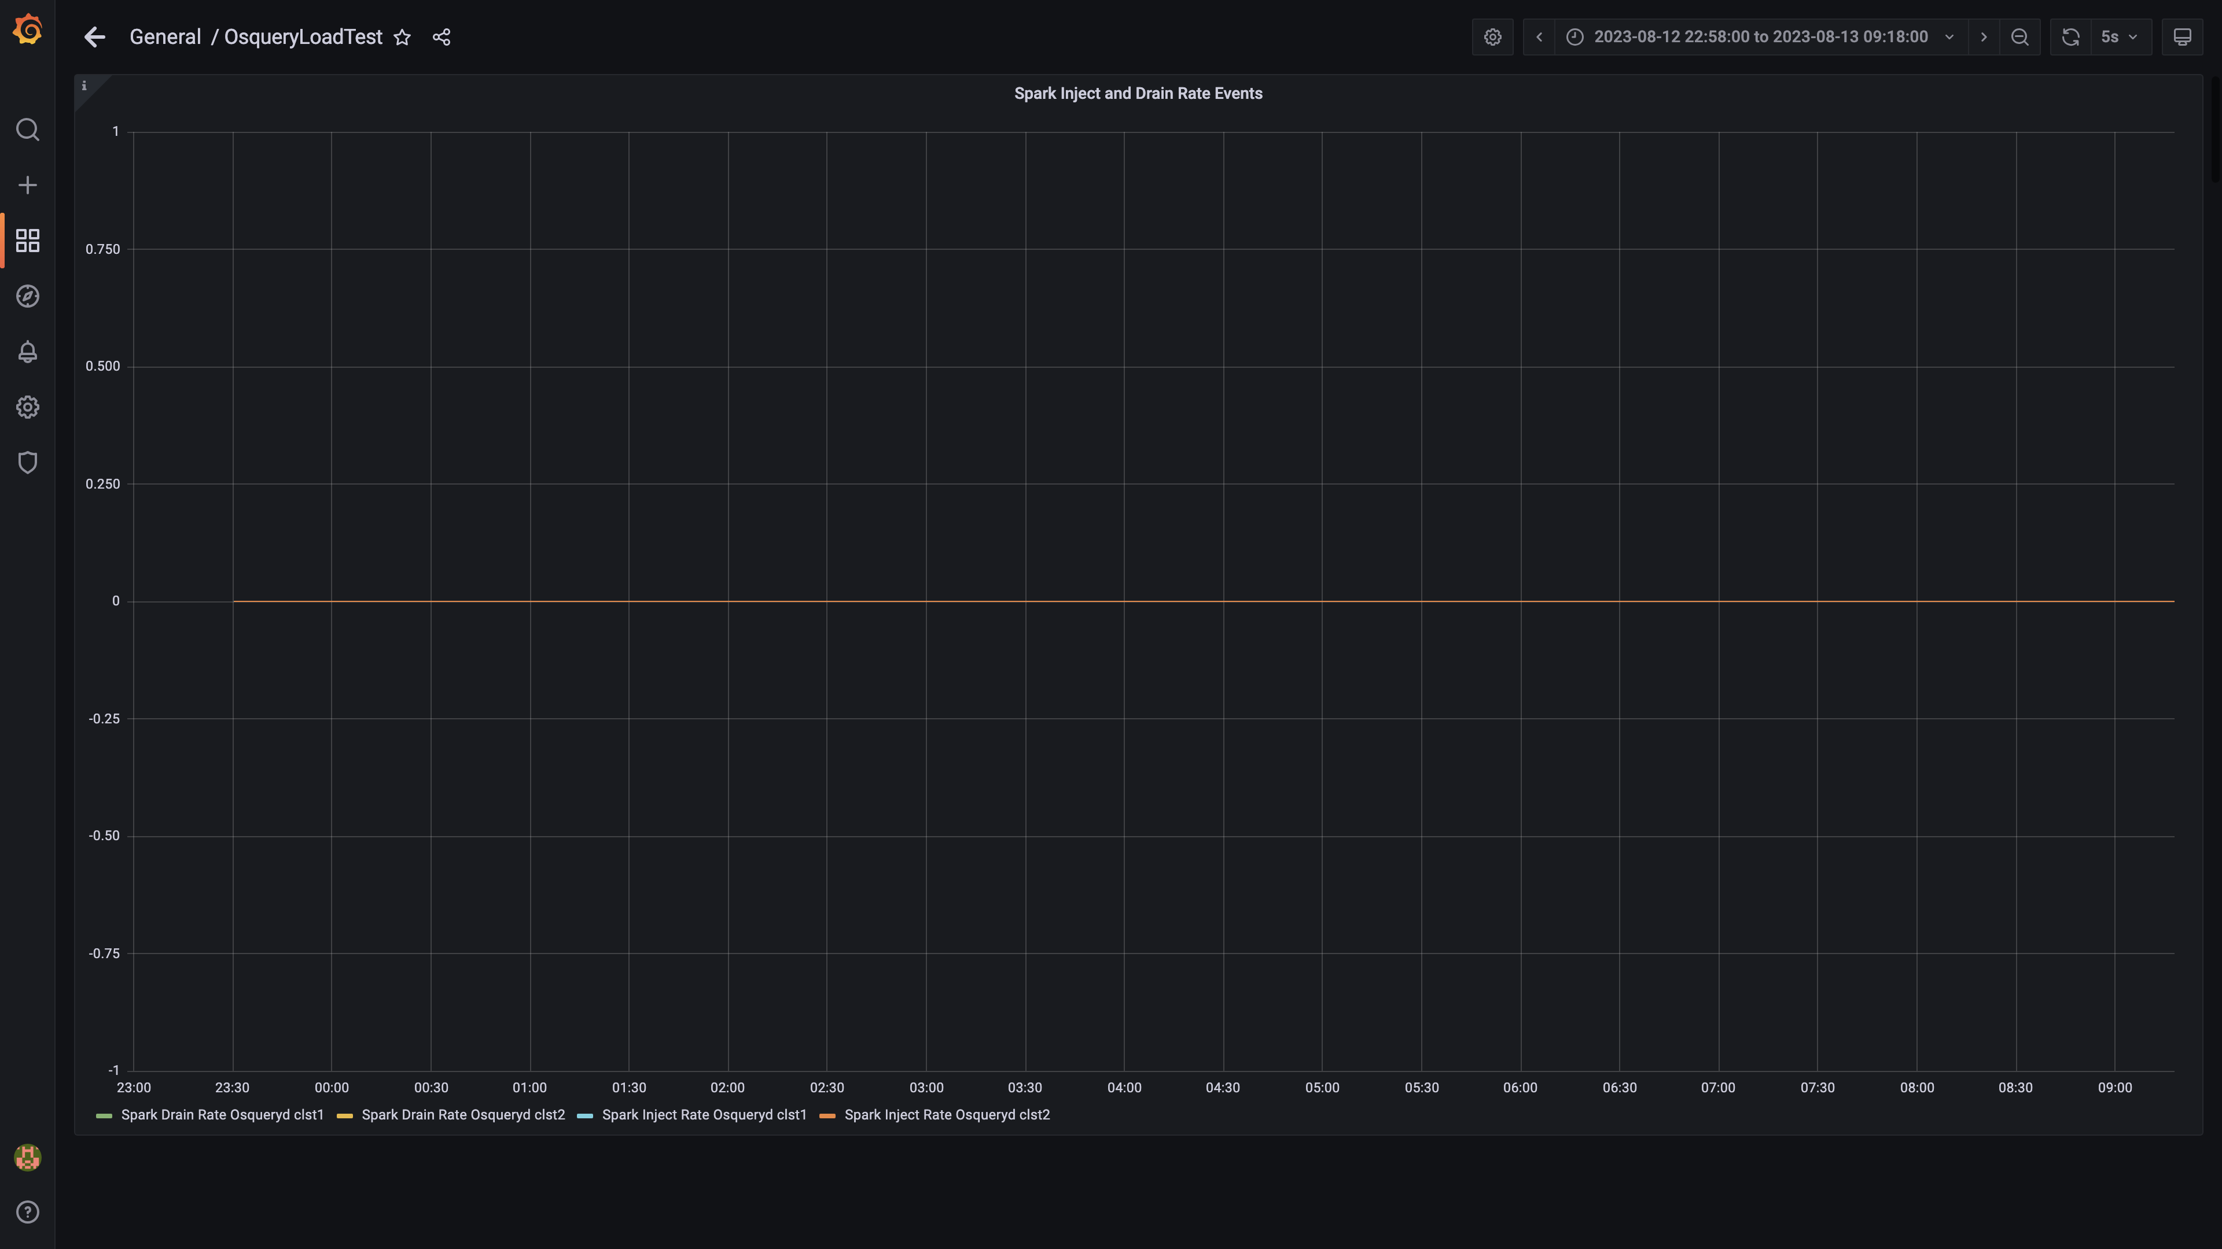

### Spark lag for events

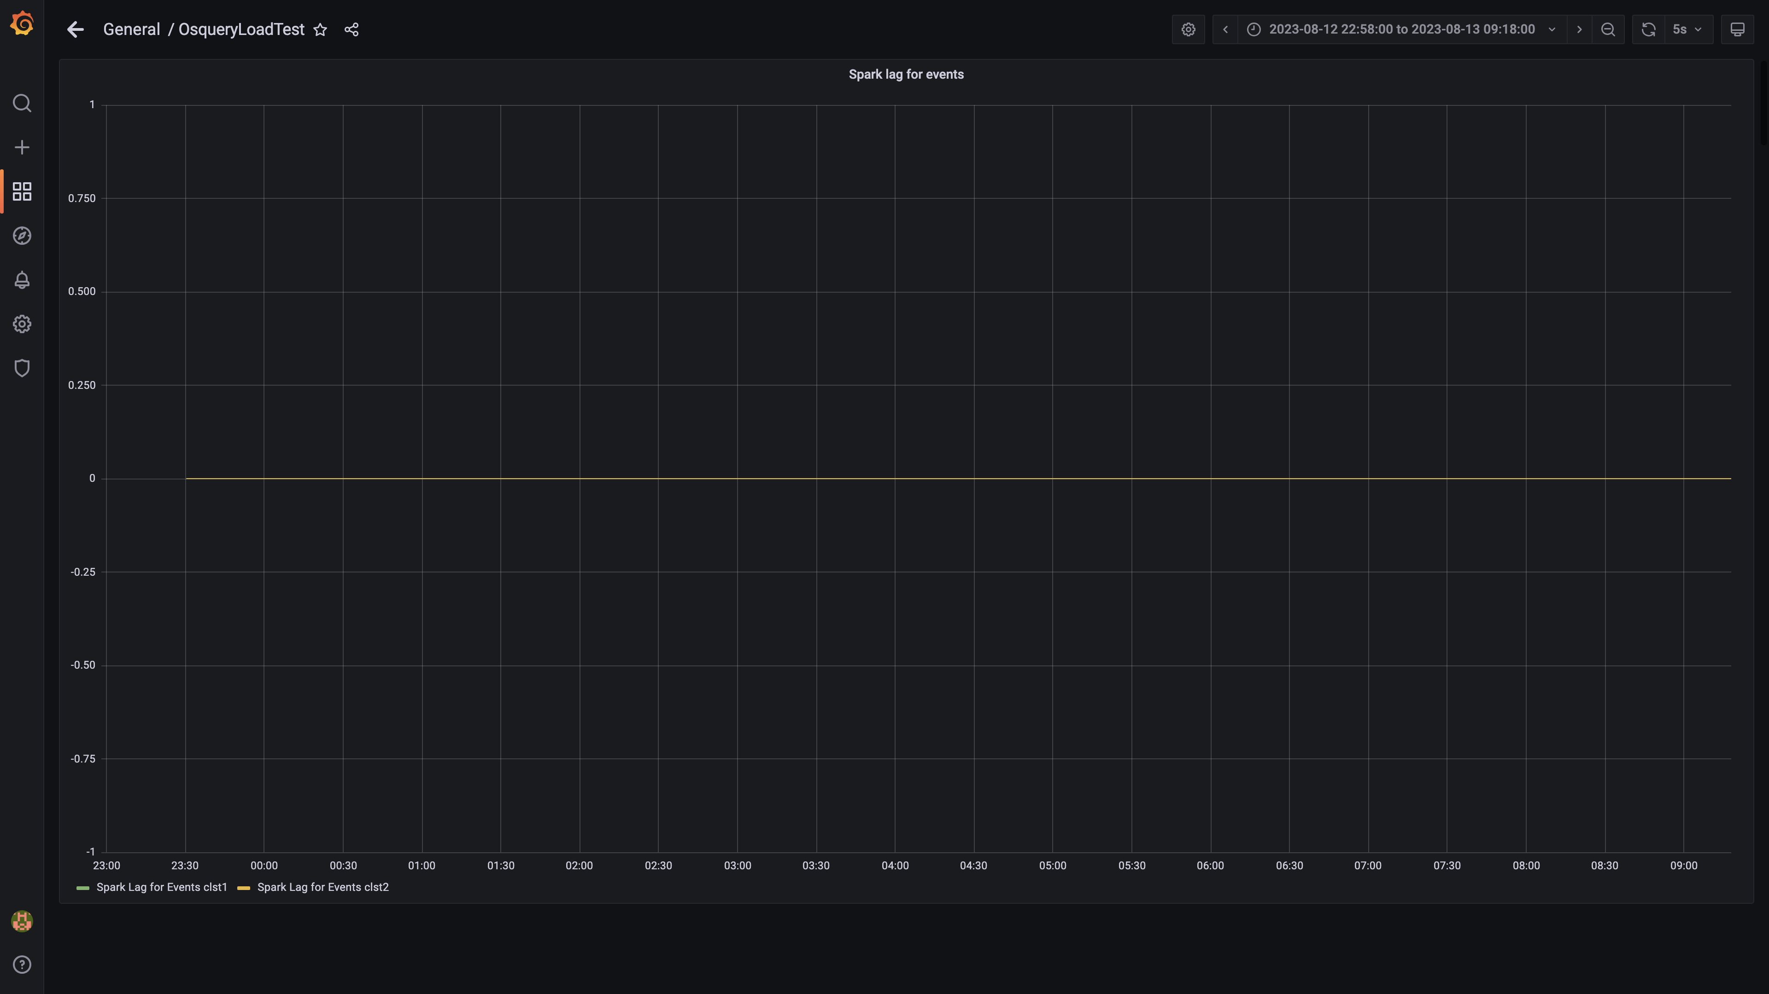

### Inject and drain rate db-alerts group

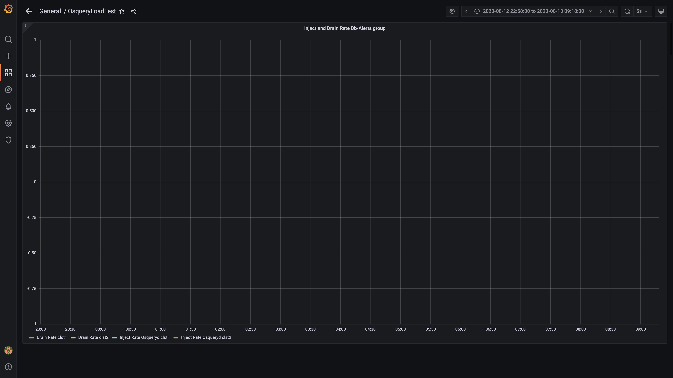

### Kafka lag for db-alerts group

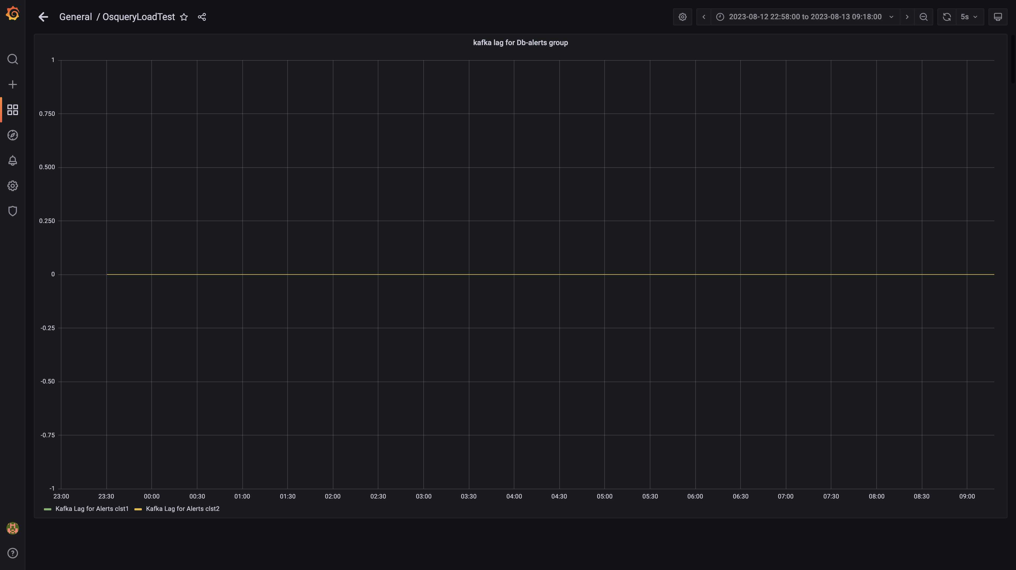

### Inject drain rates for ruleengine group

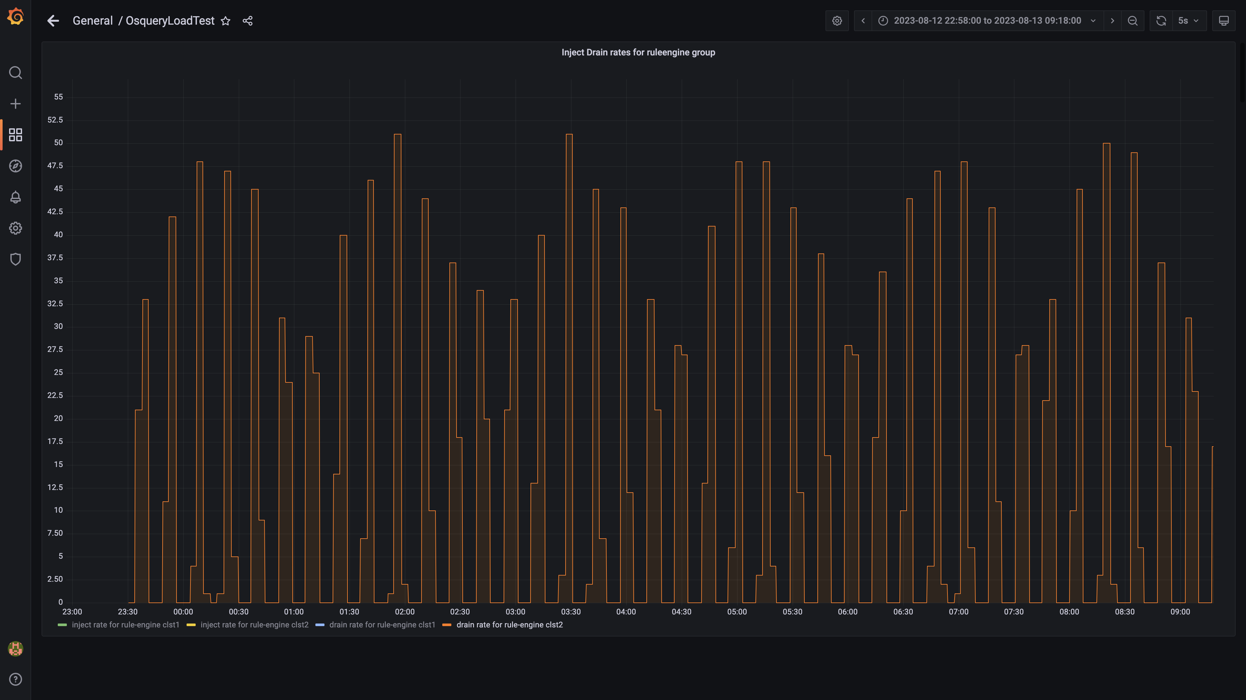

### Kafka lag for ruleengine group

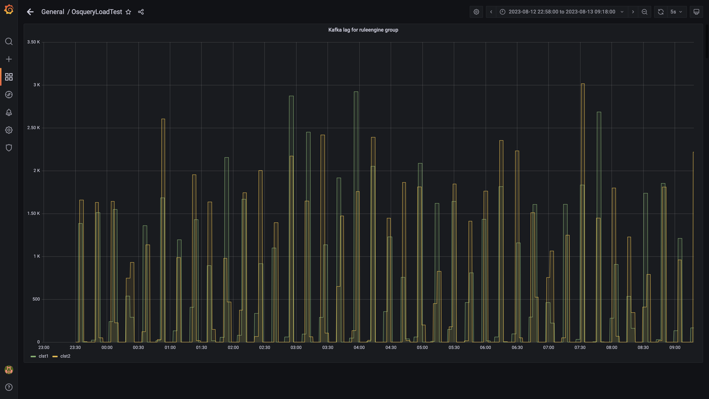

### Kafka inject and drain rates for debezium group

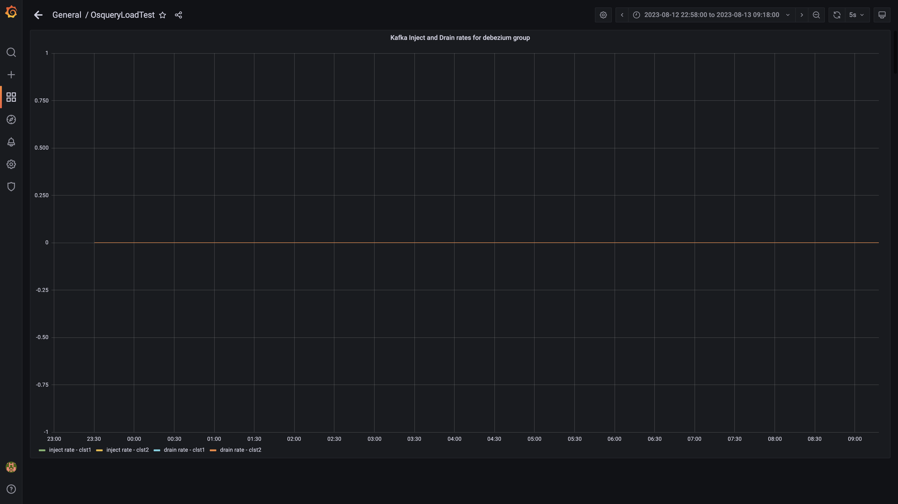

### Aggregate lag

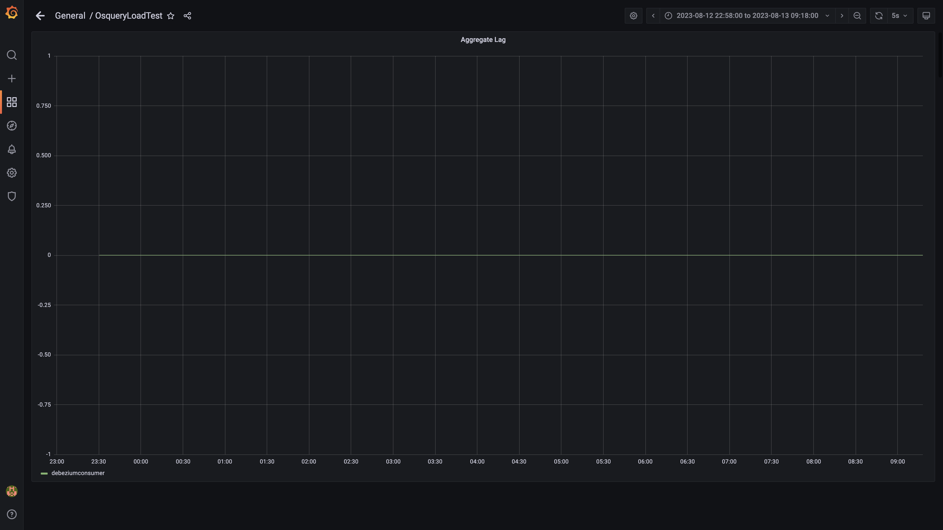

### Debezium replication lag

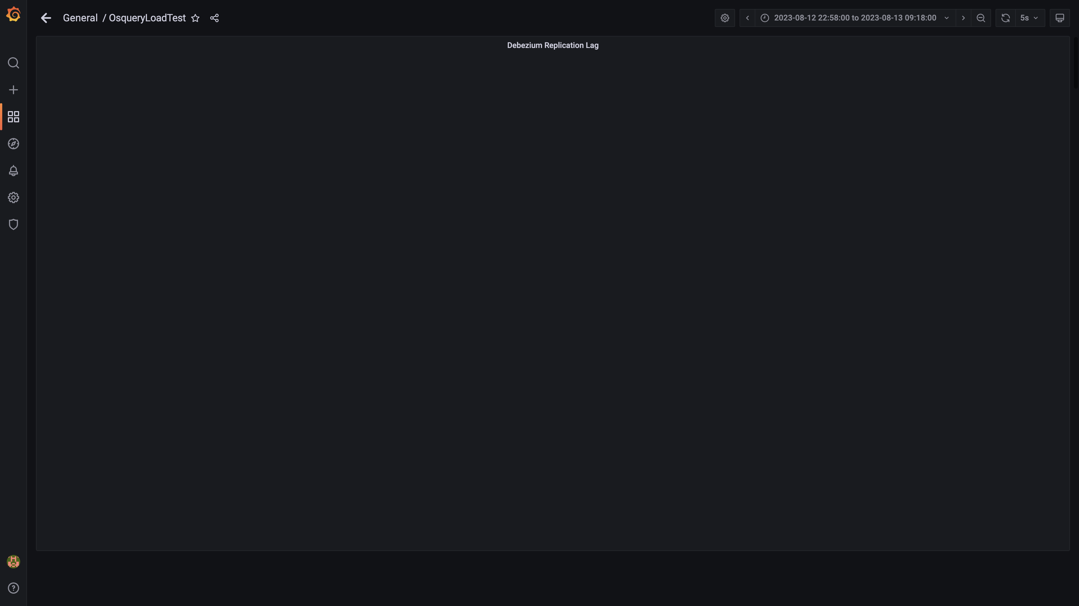

### Active client connections

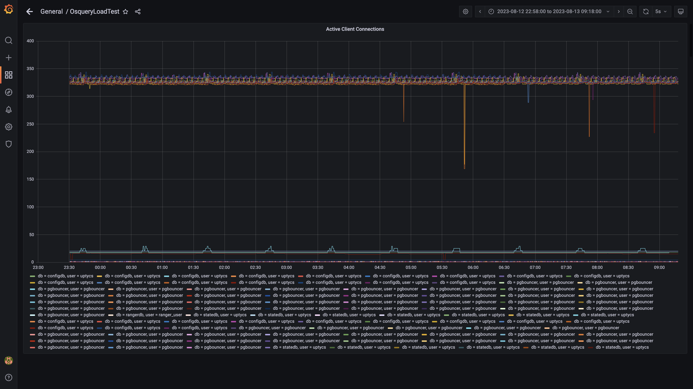

### Panel 130 not loaded in given time

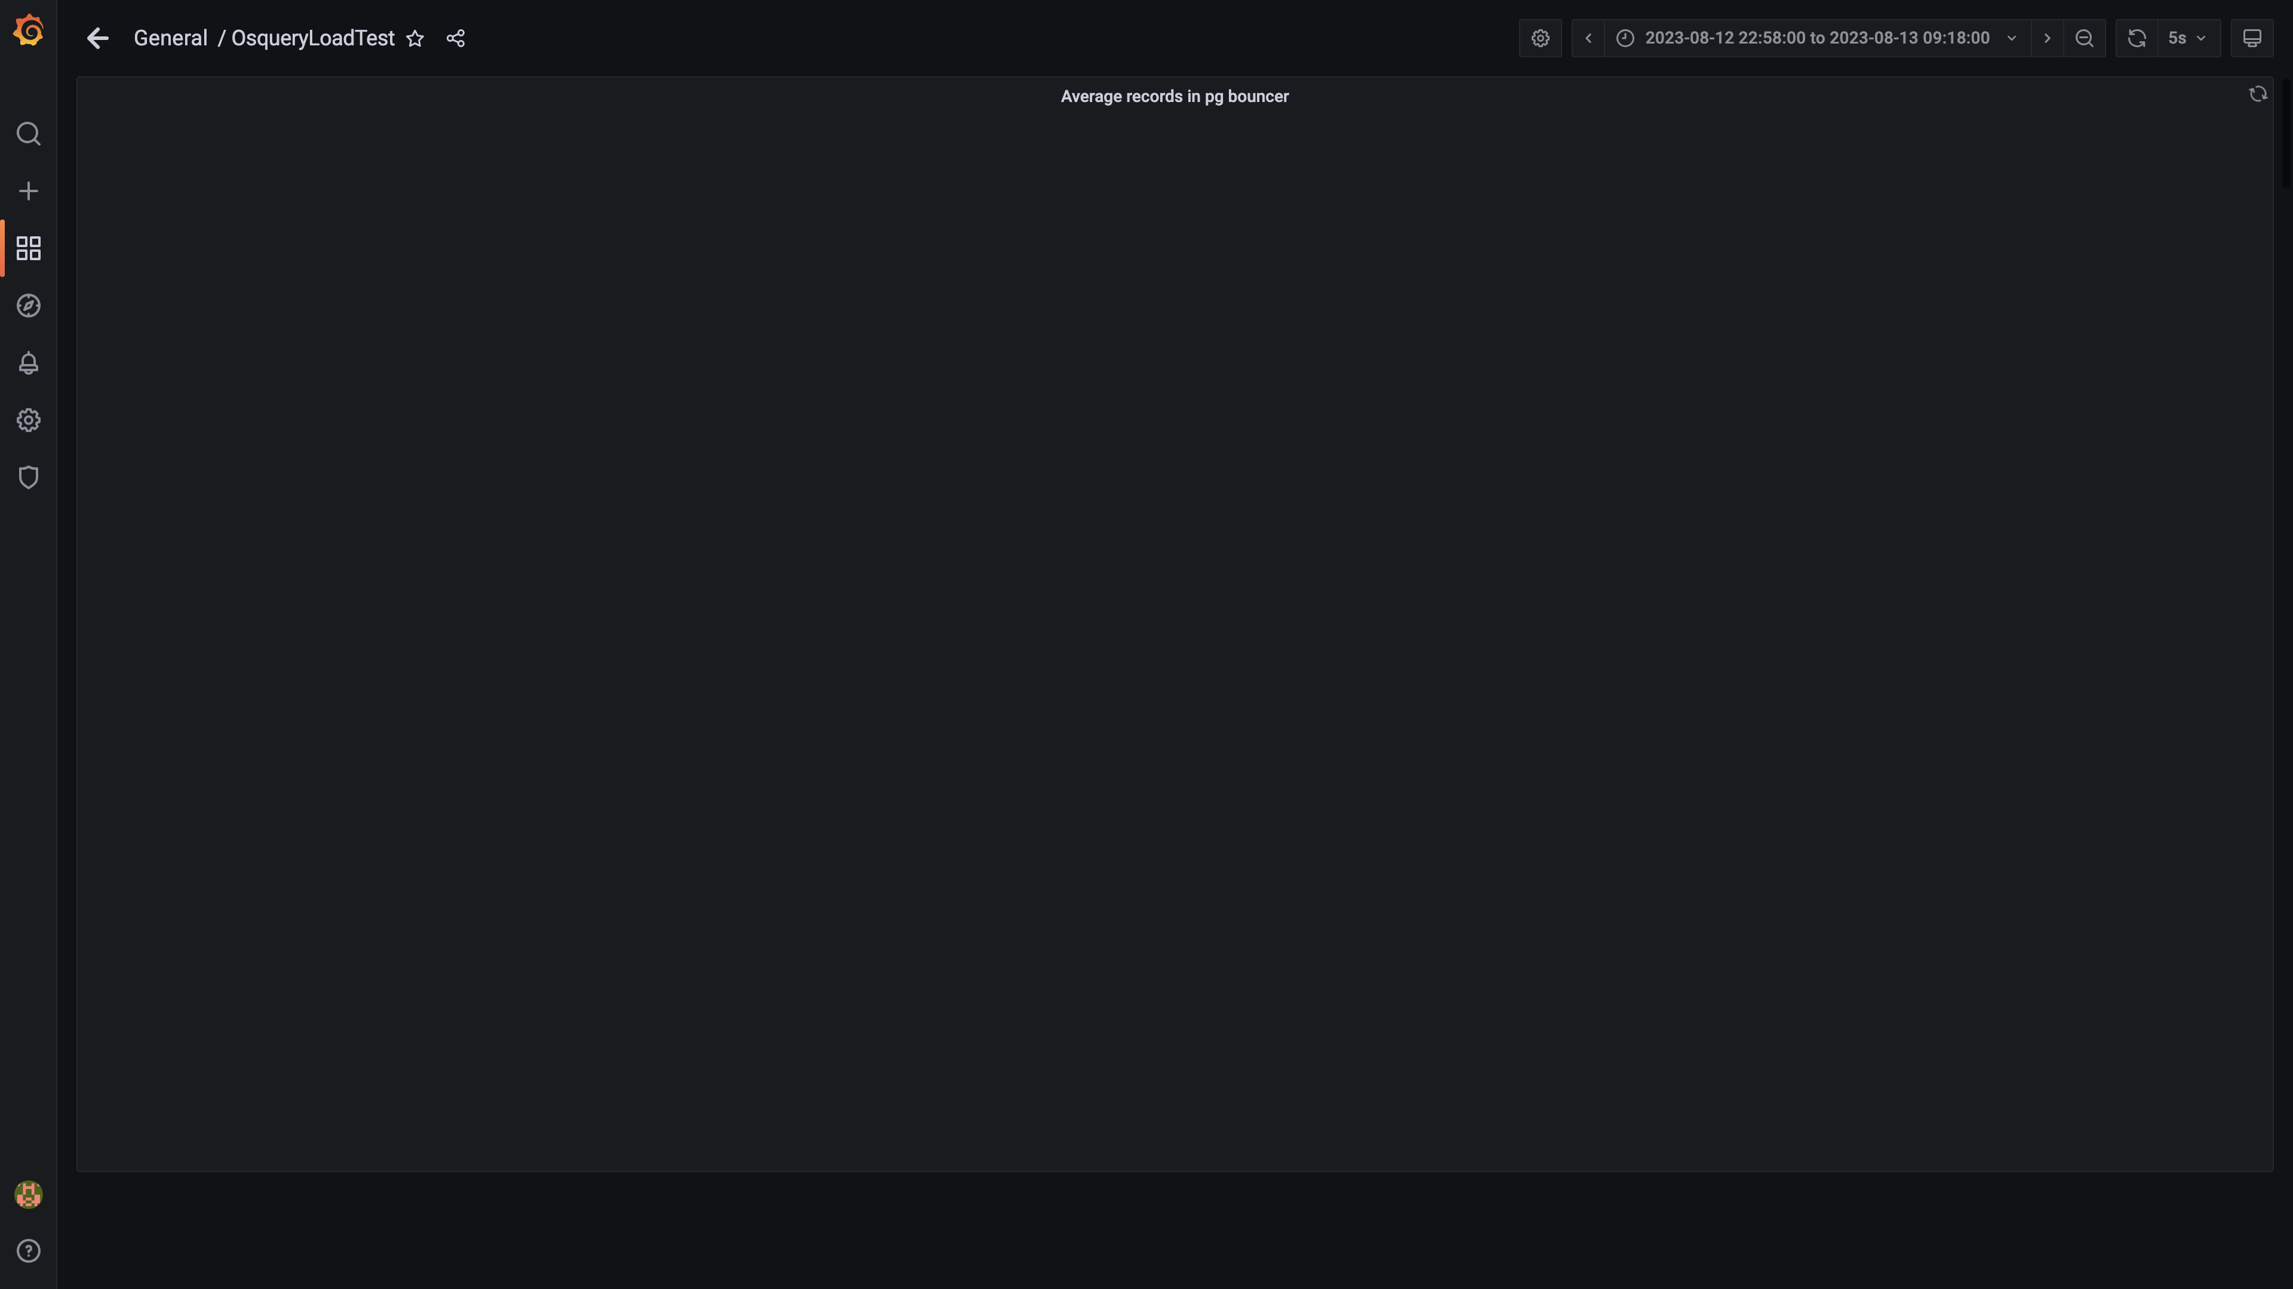

### Panel 128 not loaded in given time

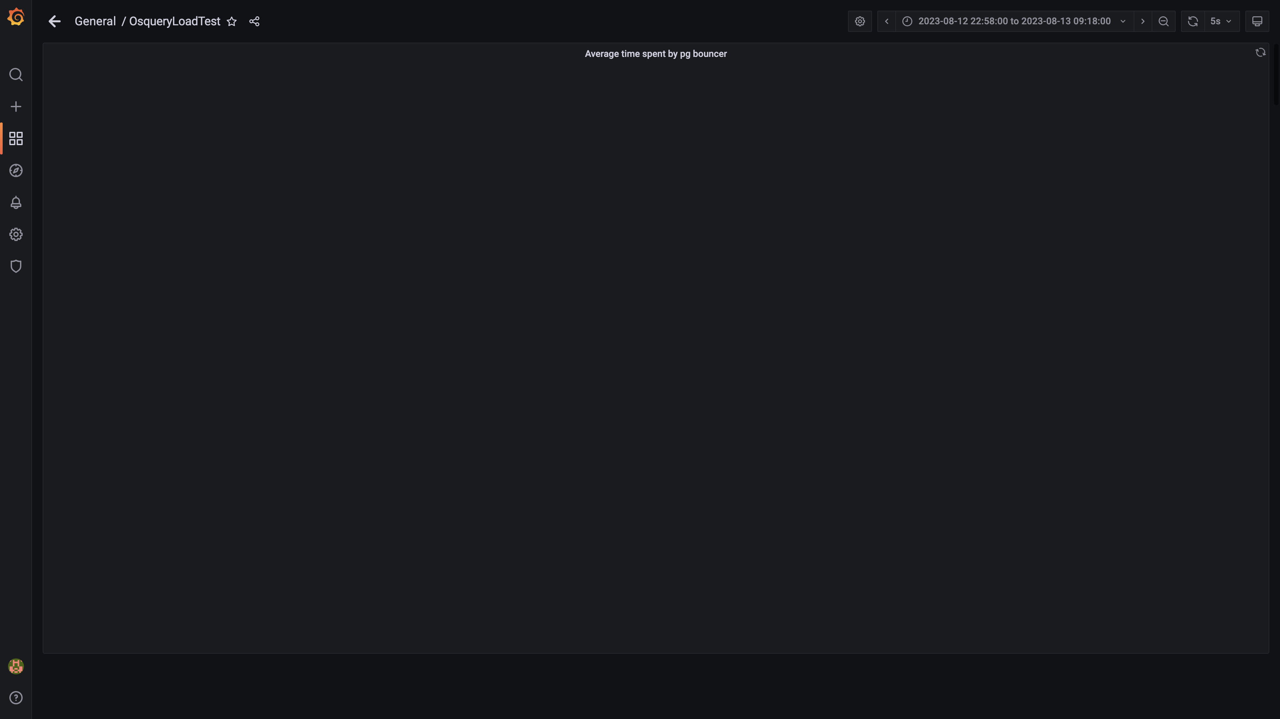

### Redis client connections for tls

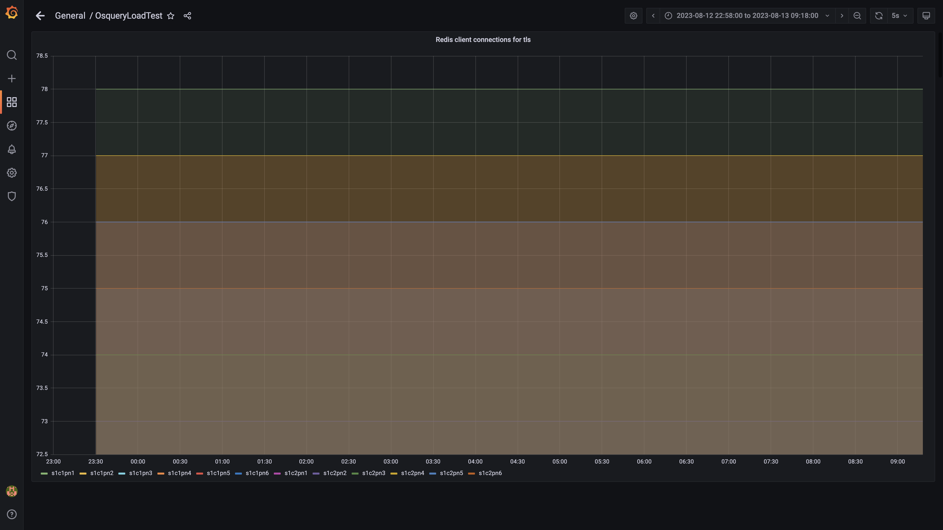

### Configdb pg wal folder size

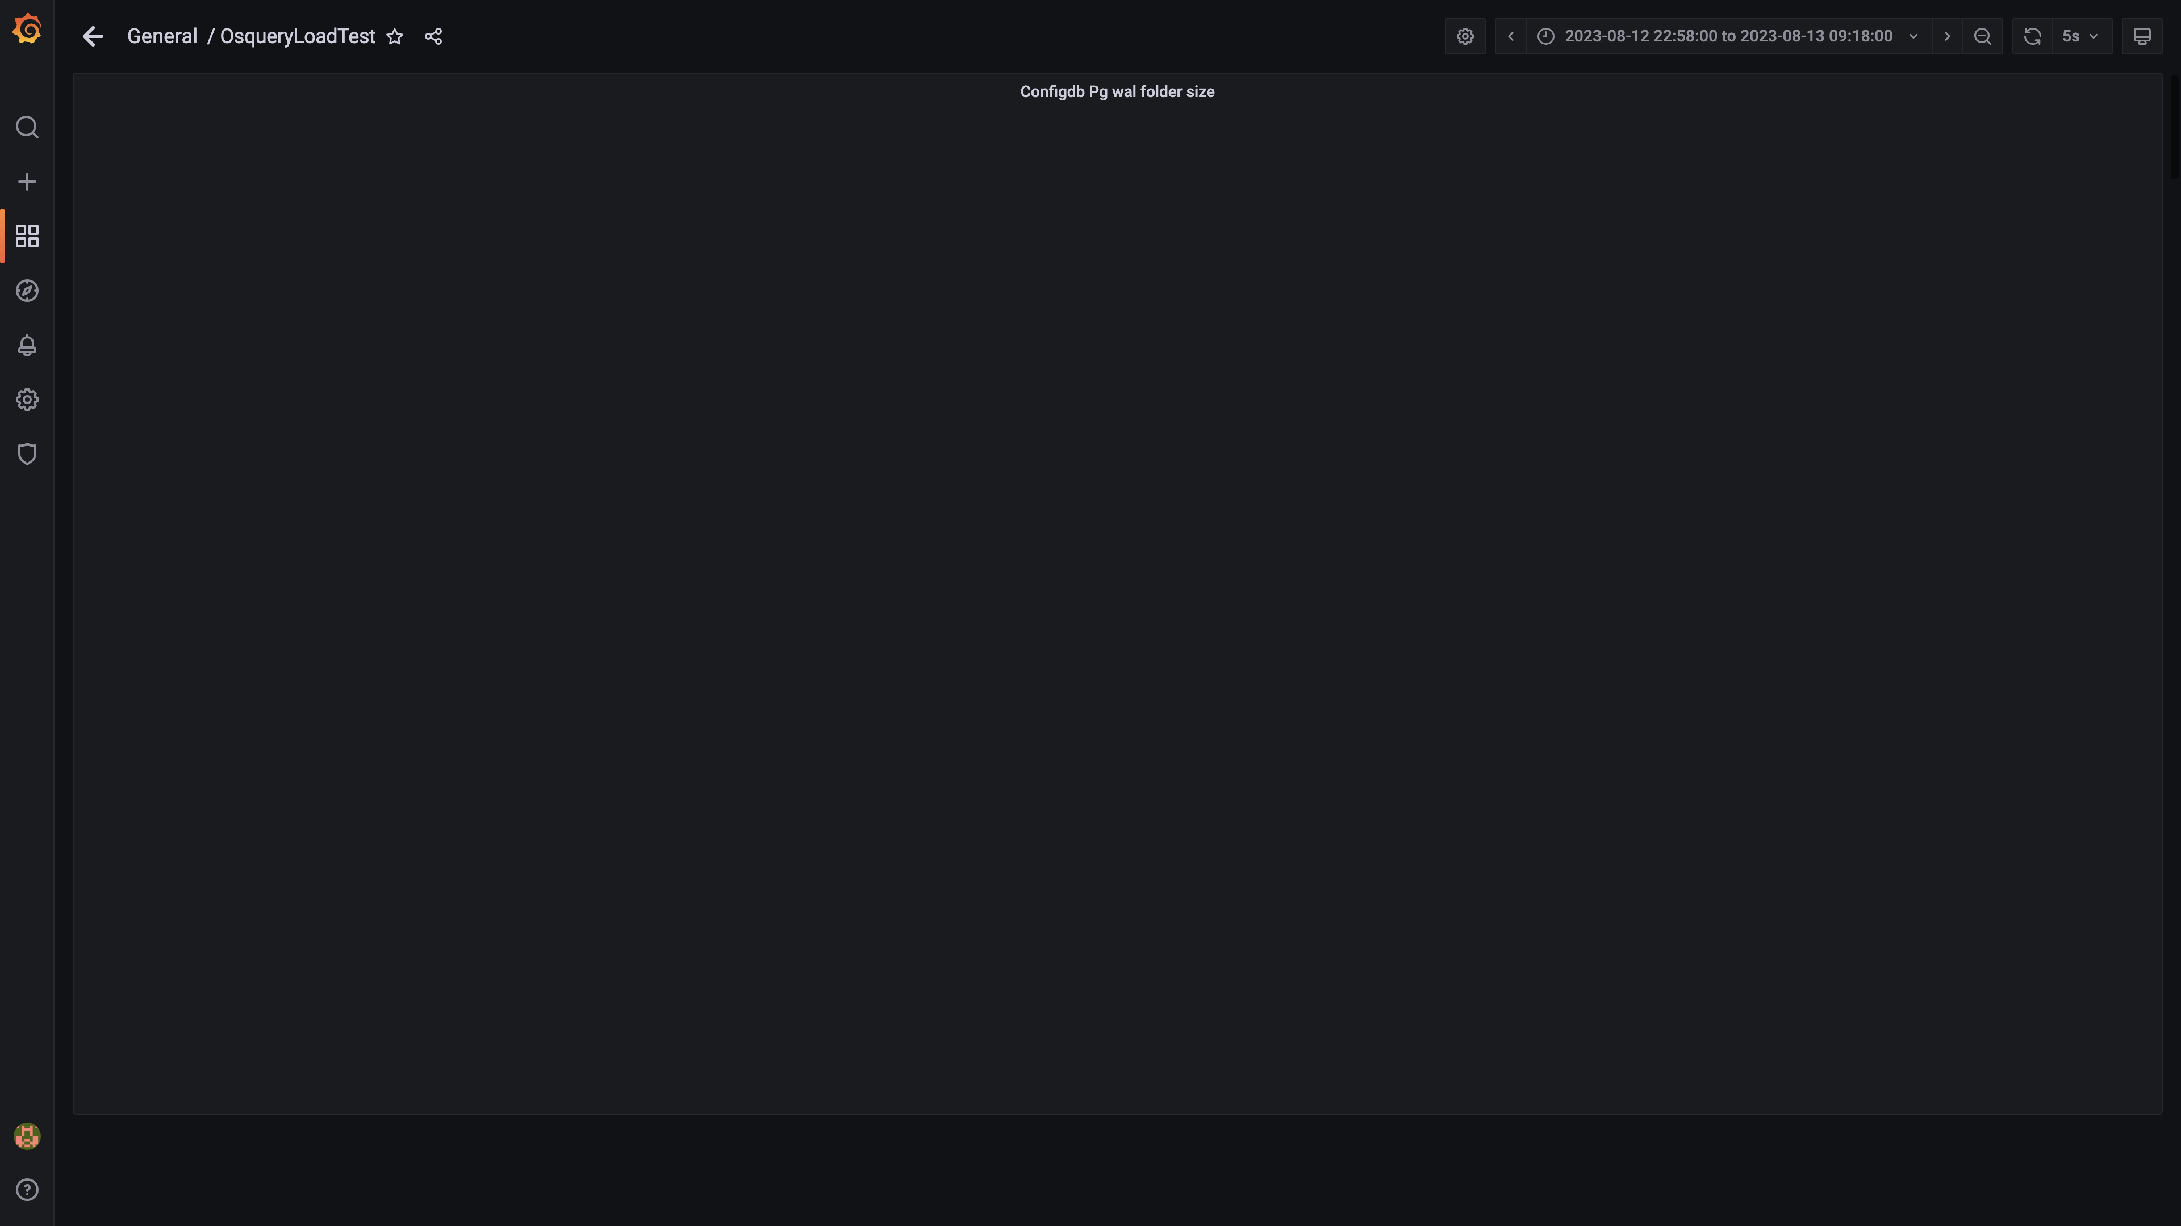

### Configdb number of wal files

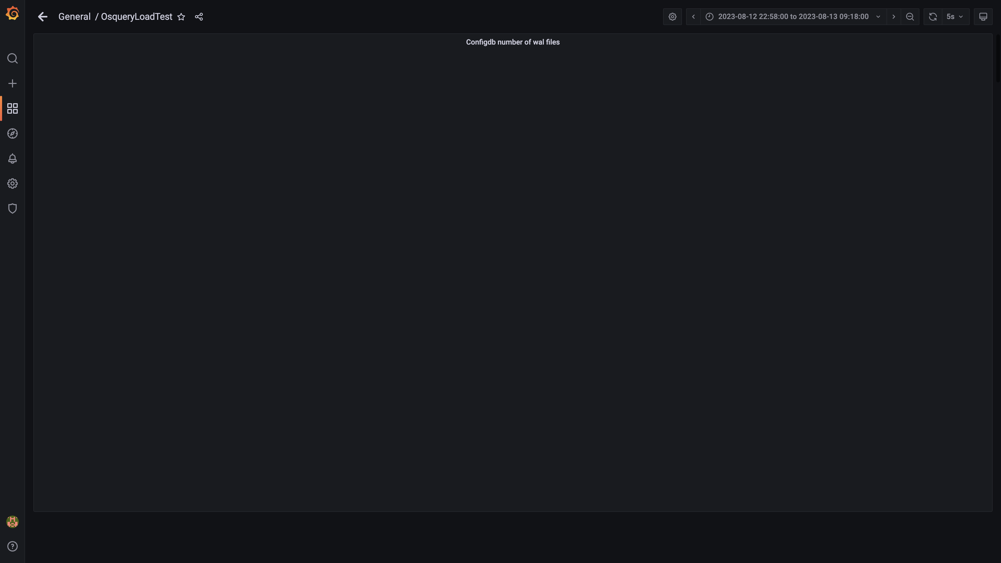

### Top 10 redis client connections by app

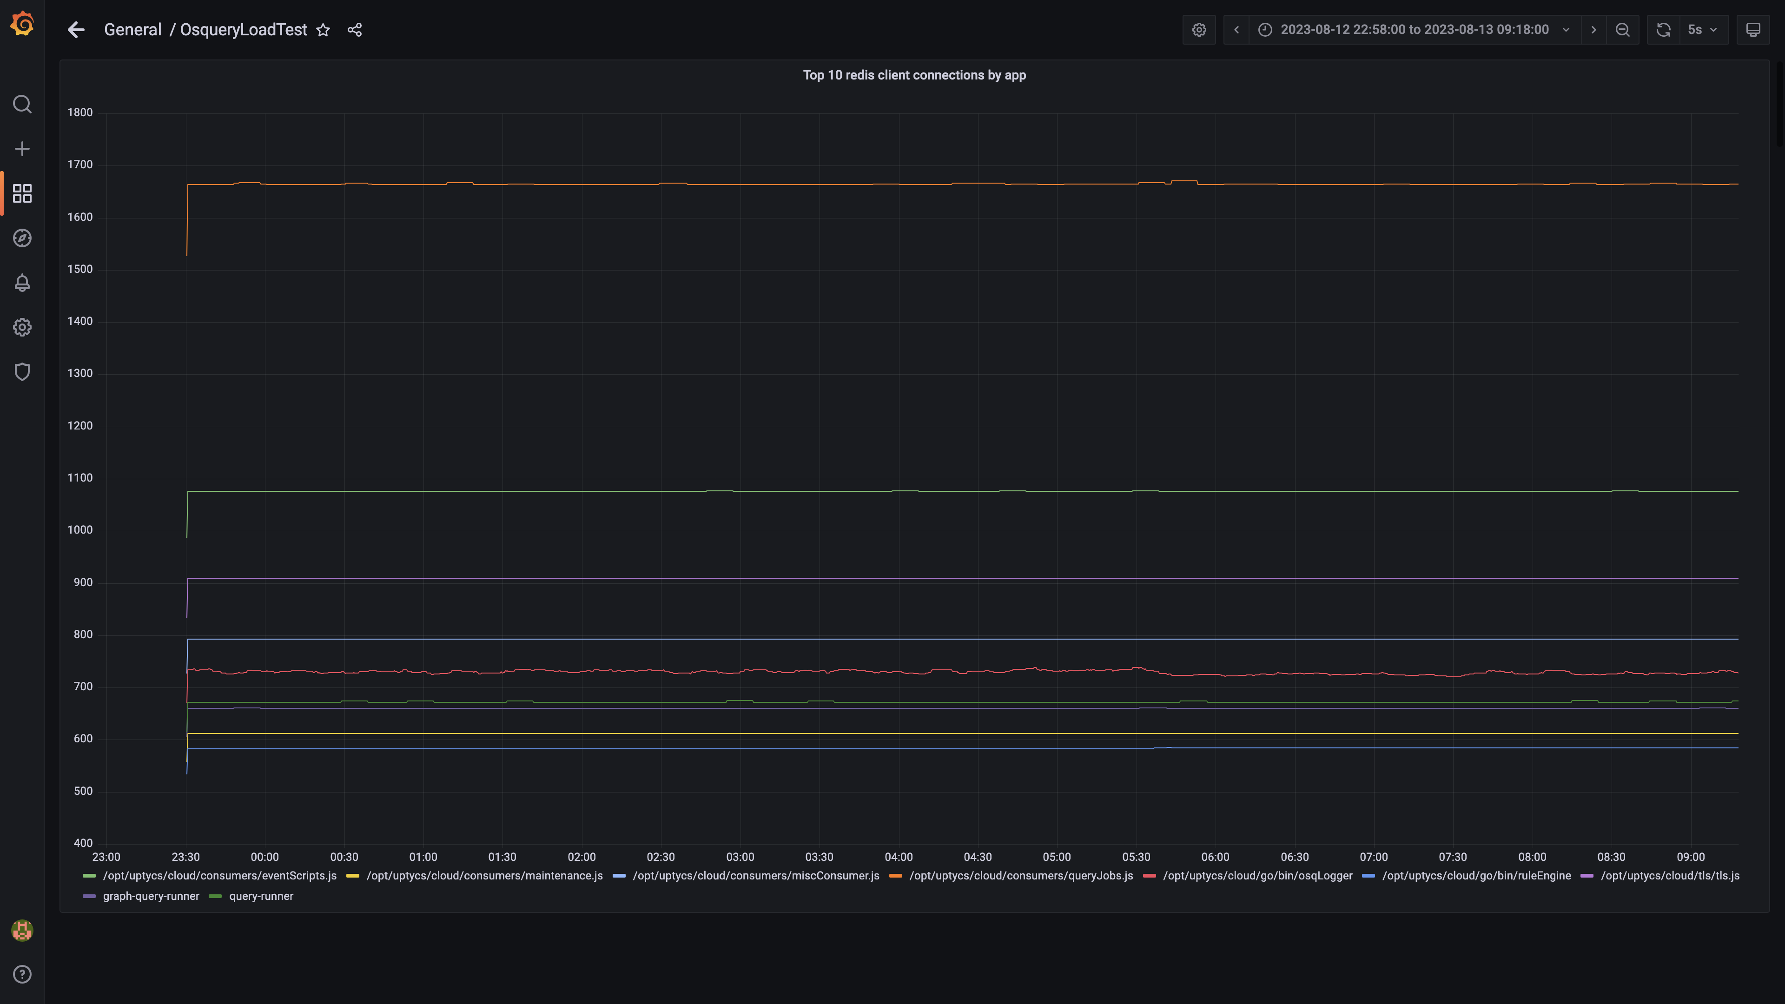

### Configdb folder size

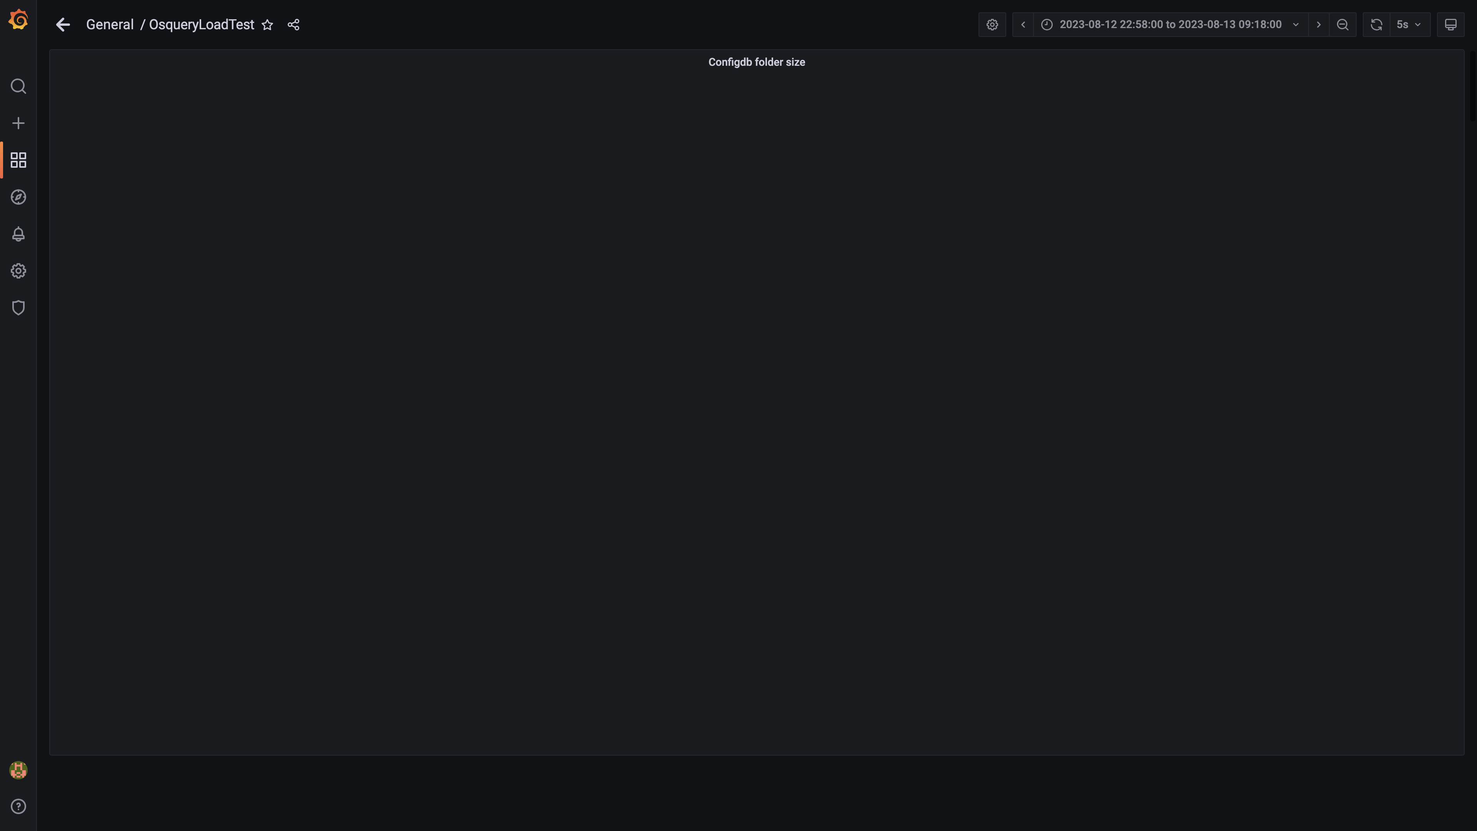

### Cpu and memory usages

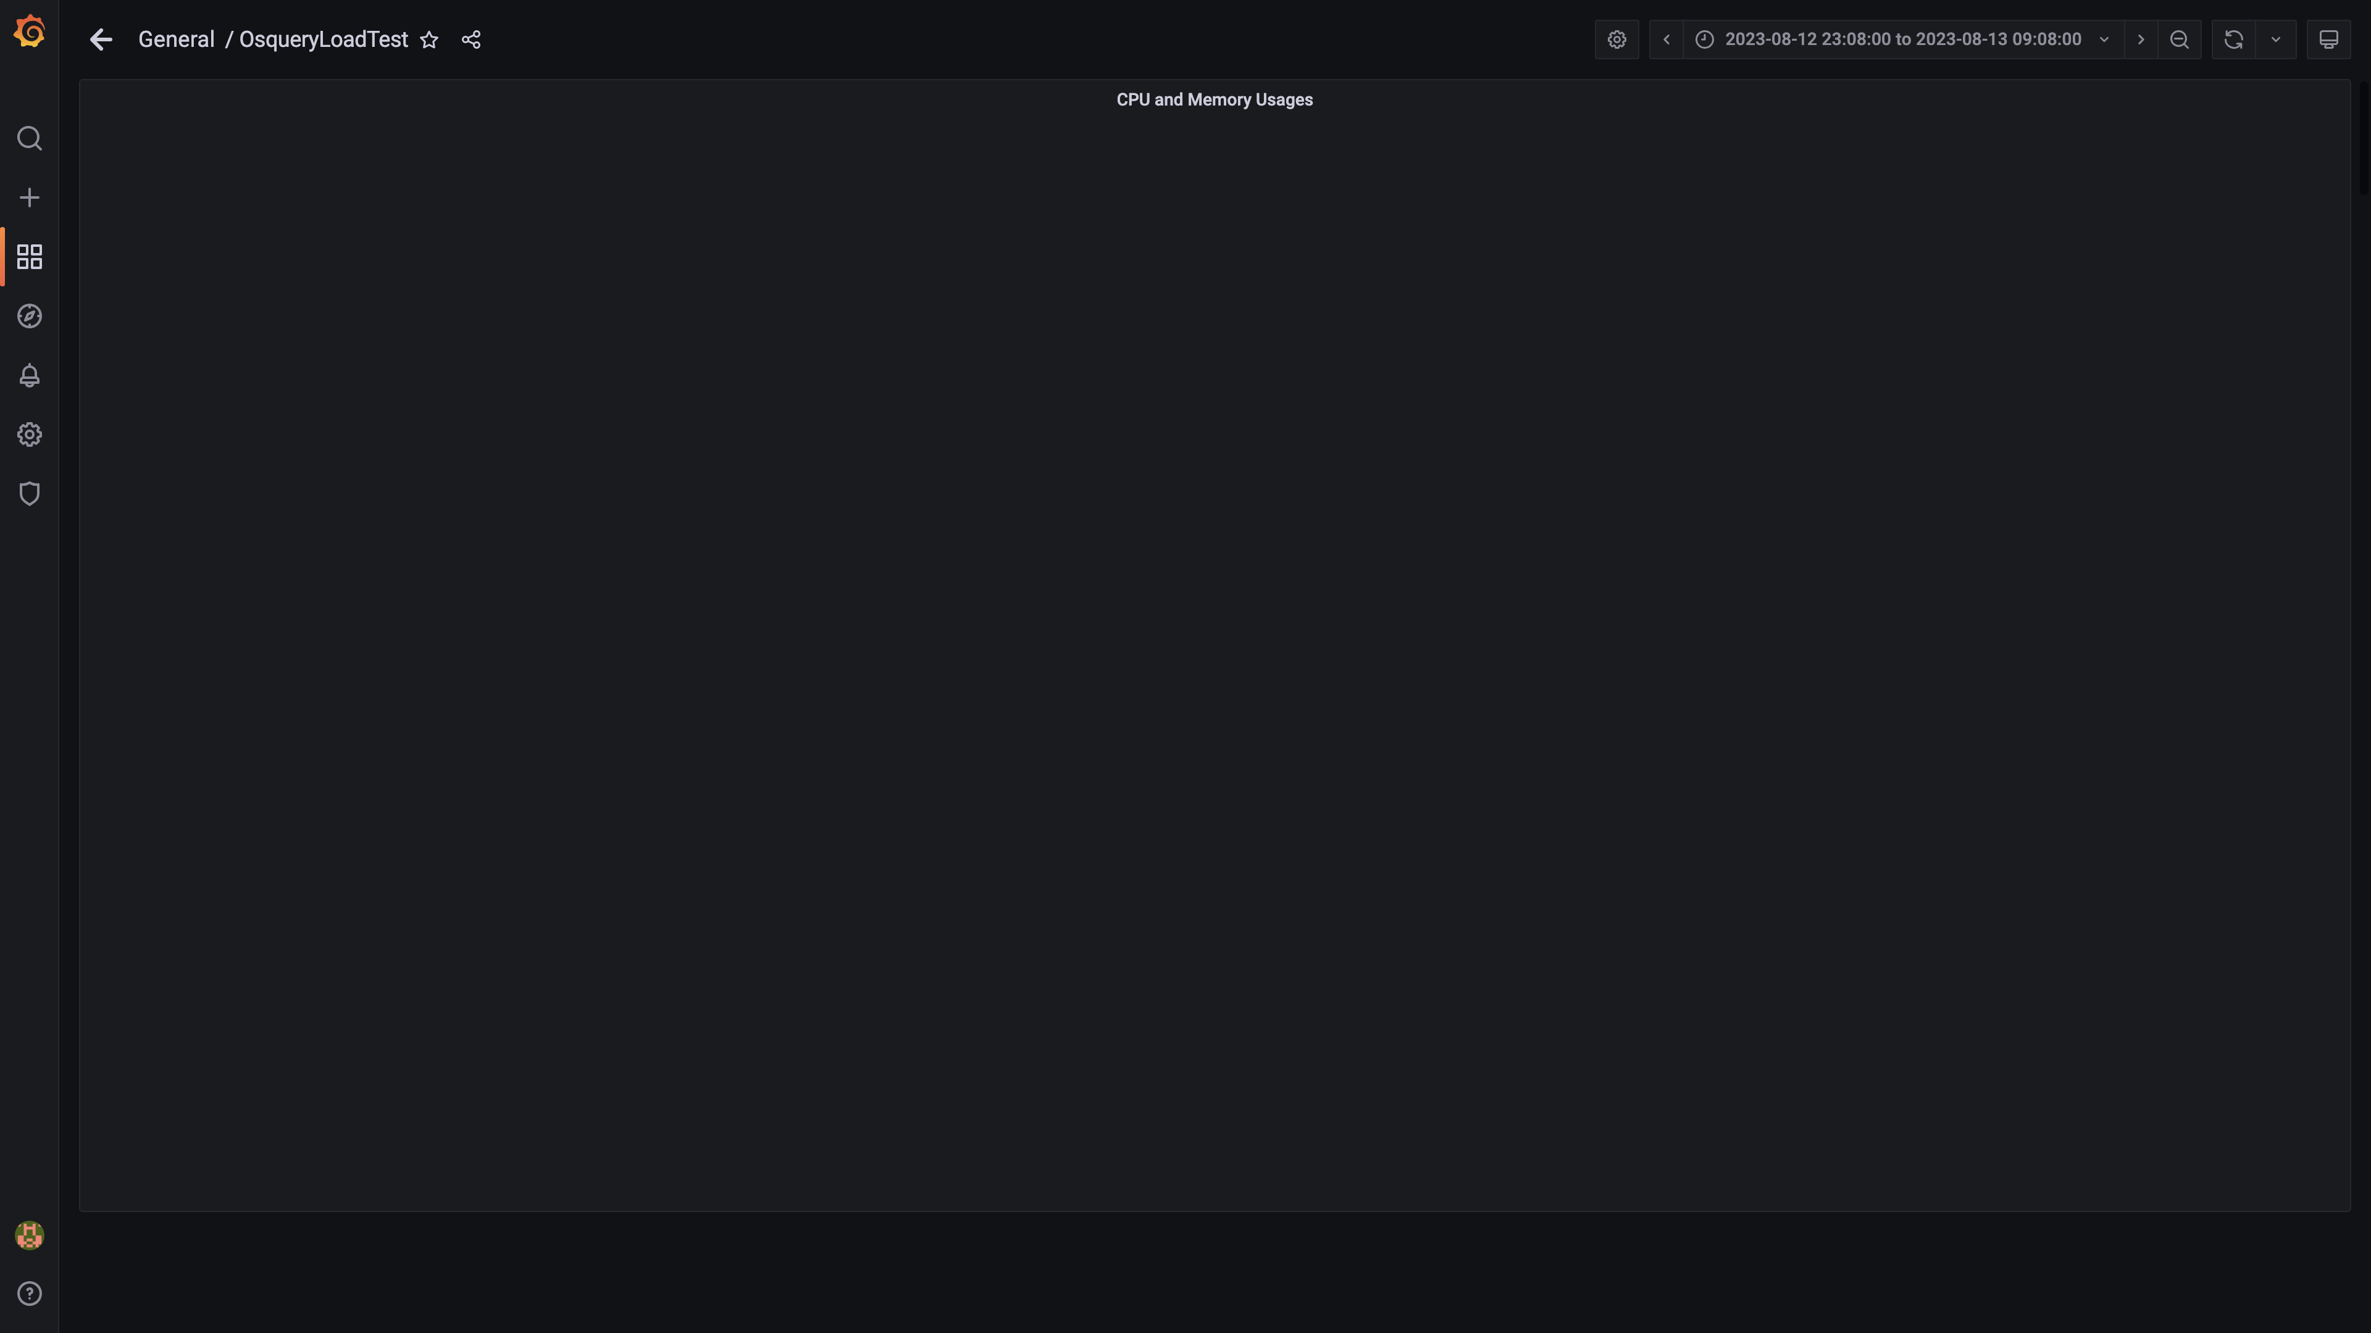

### Overall container memory and cpu usage

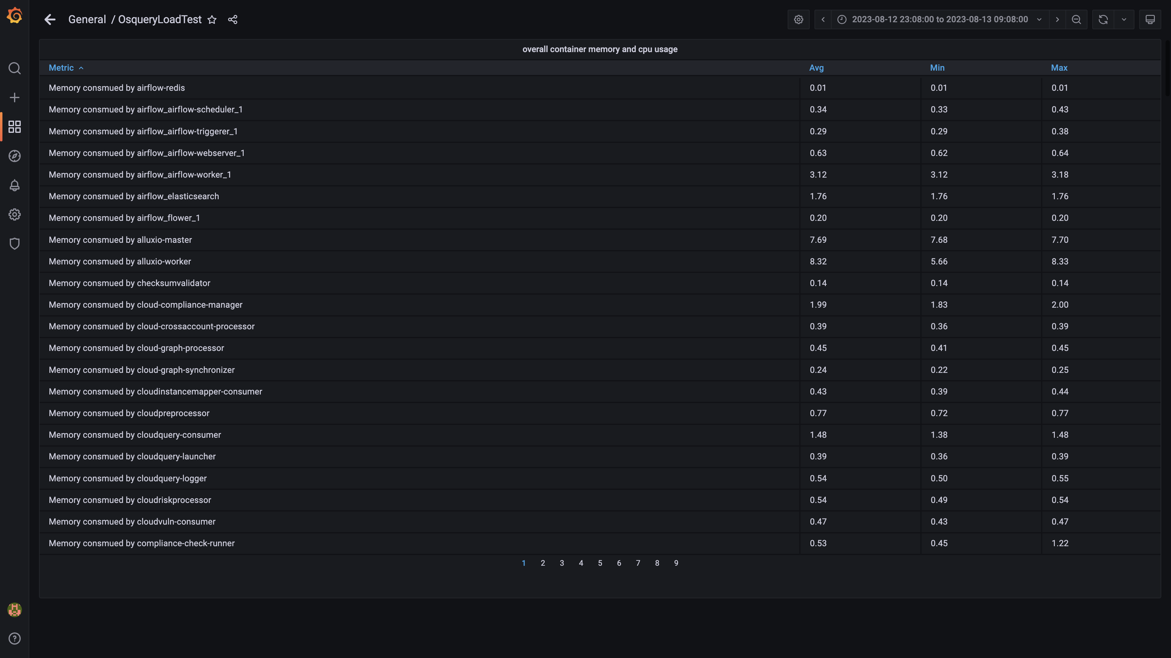

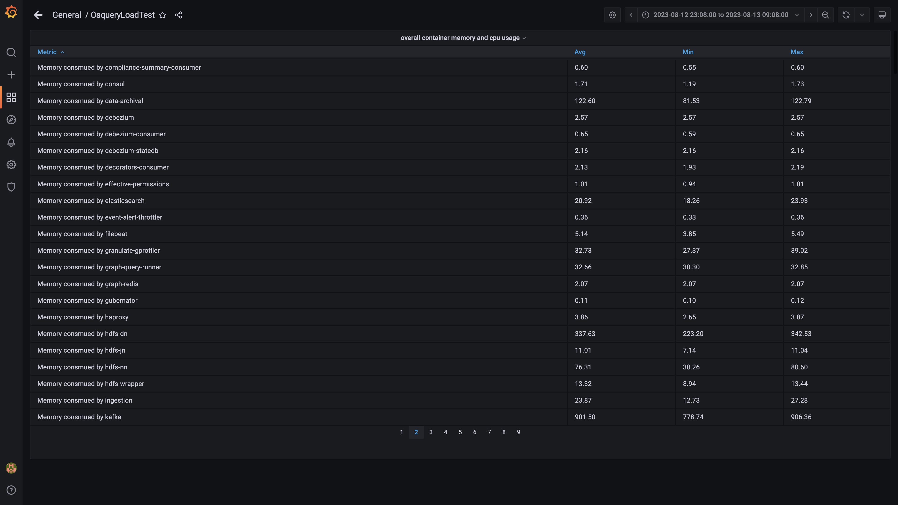

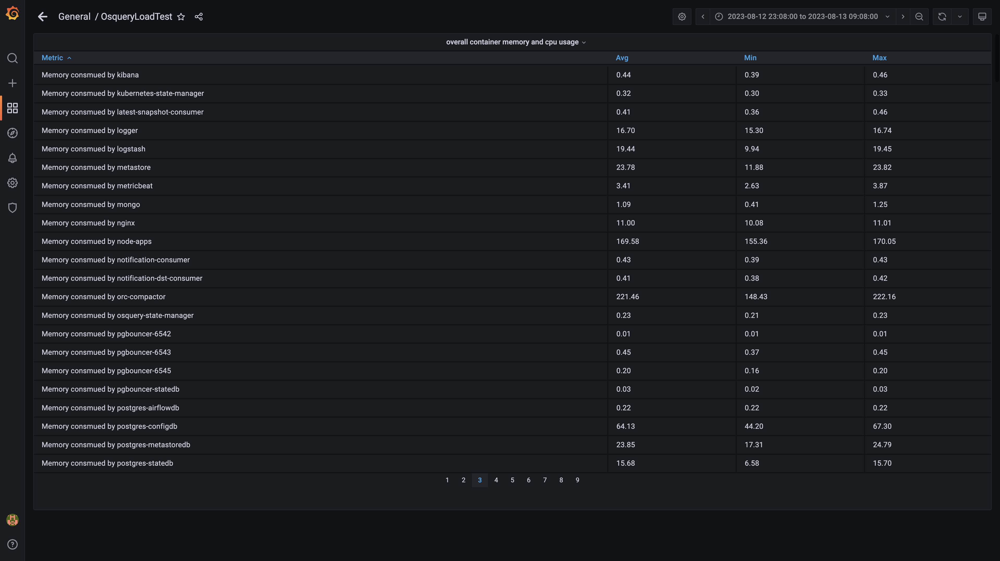

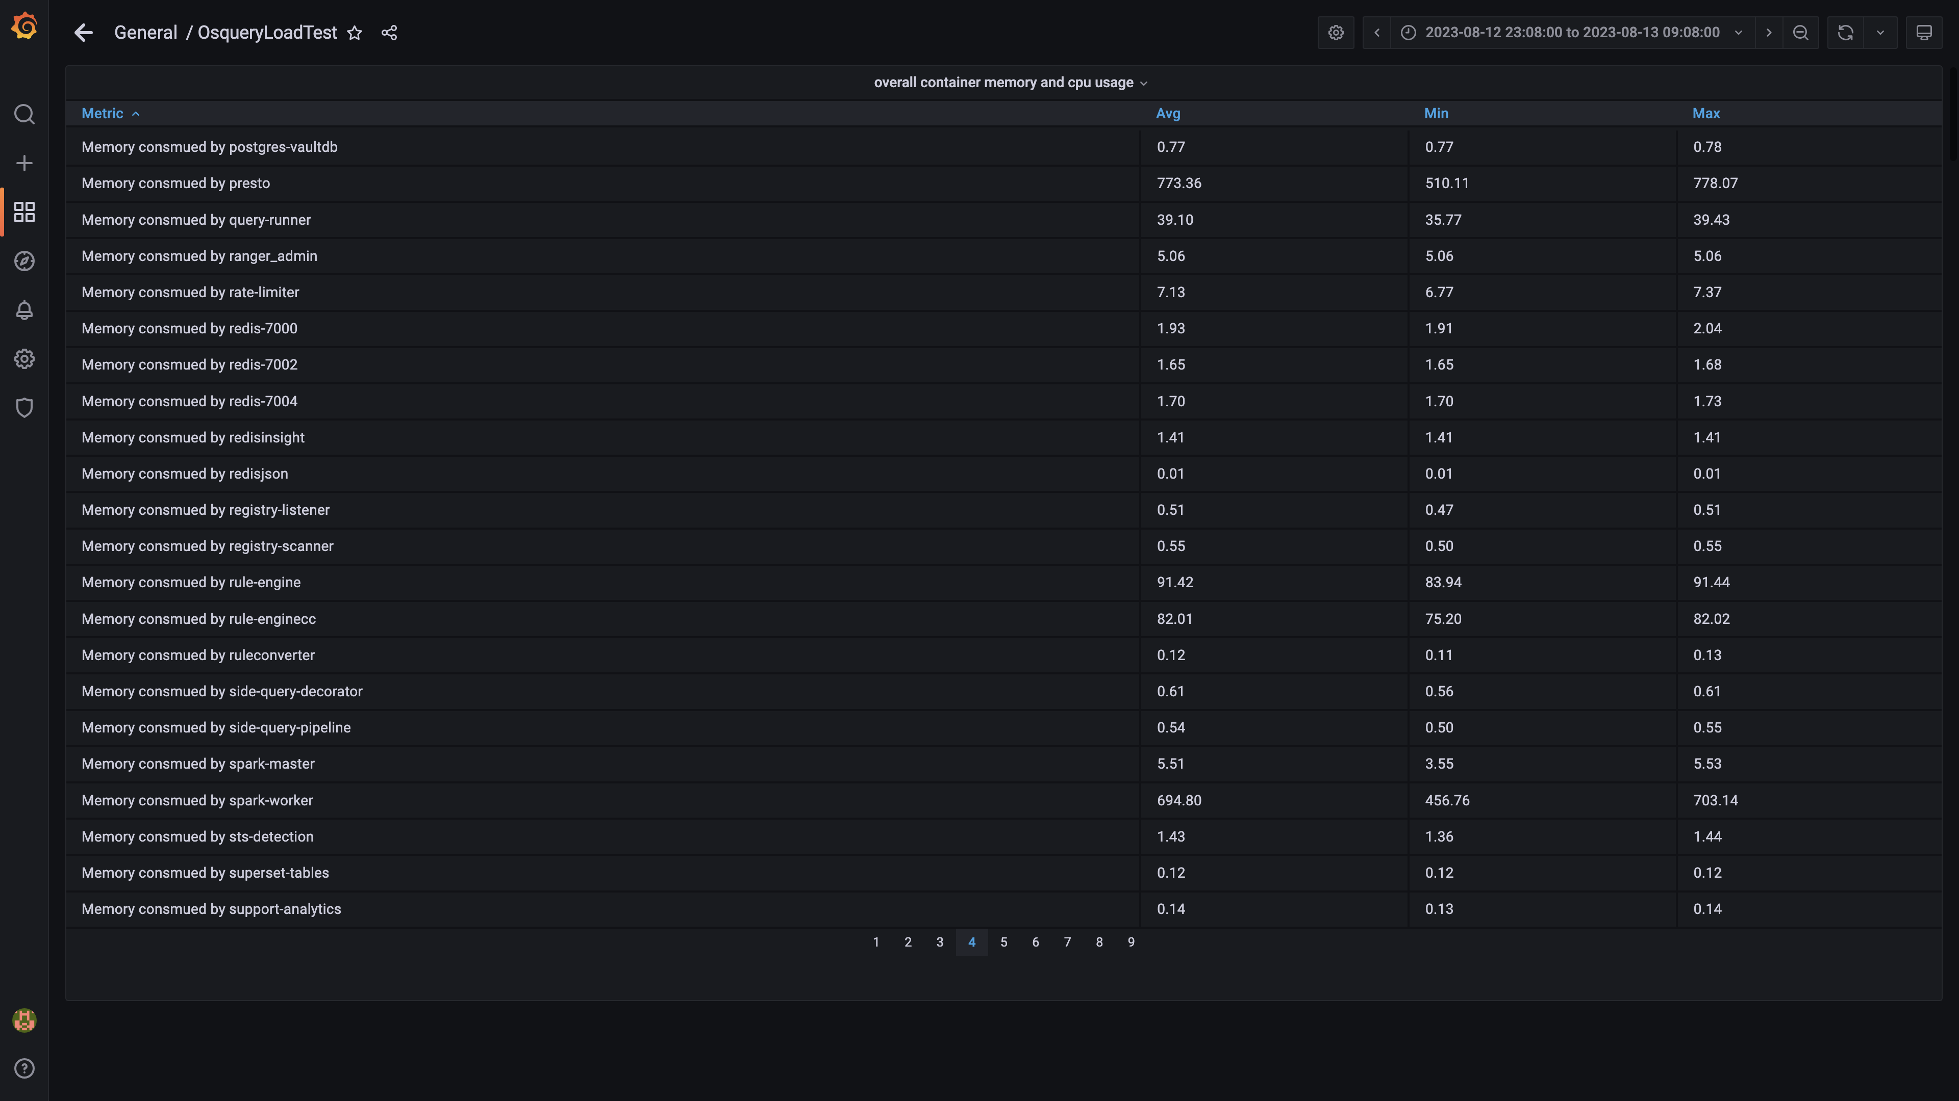

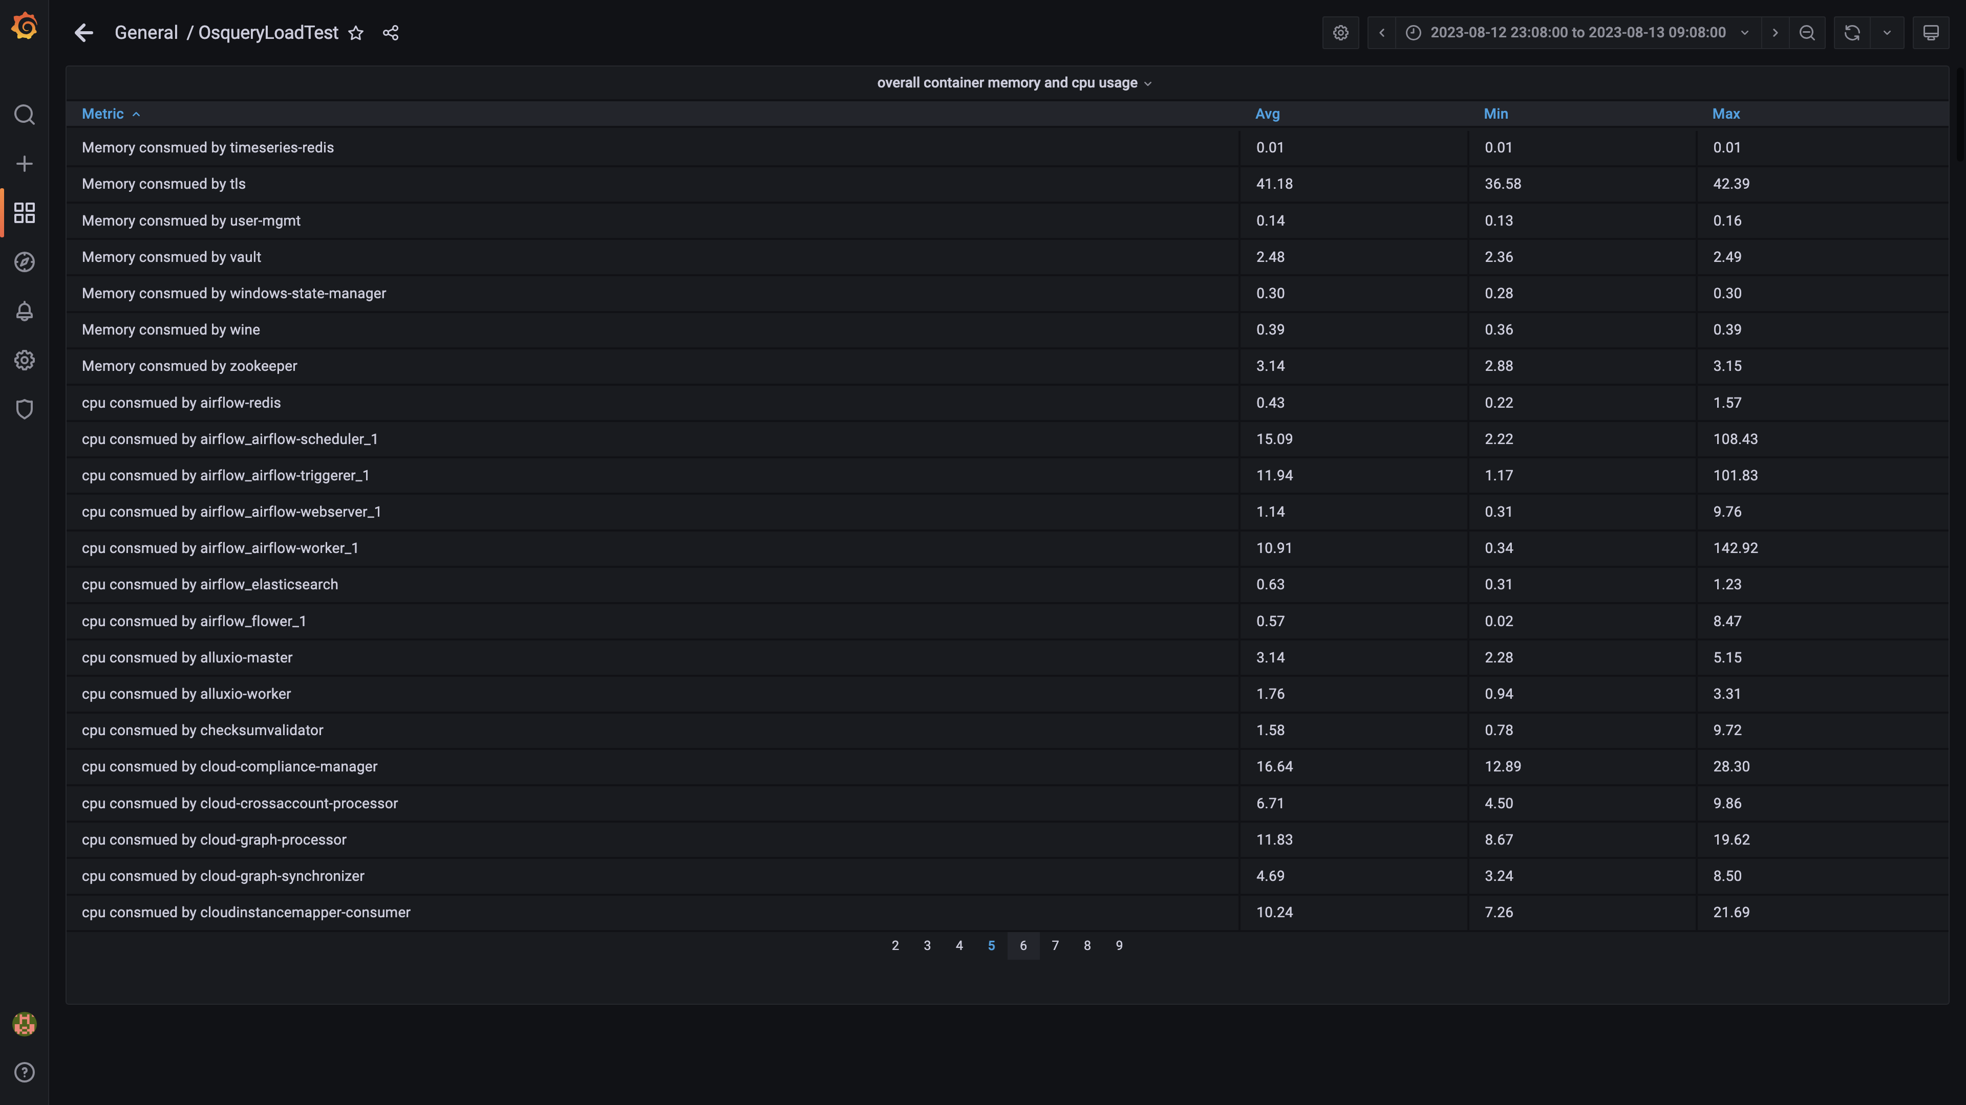

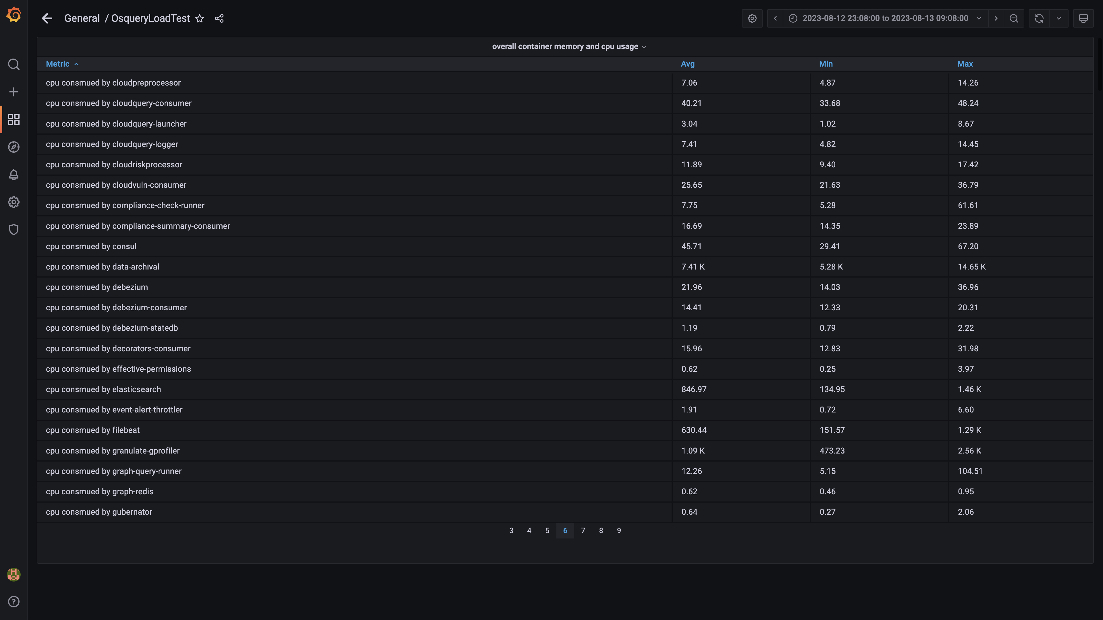

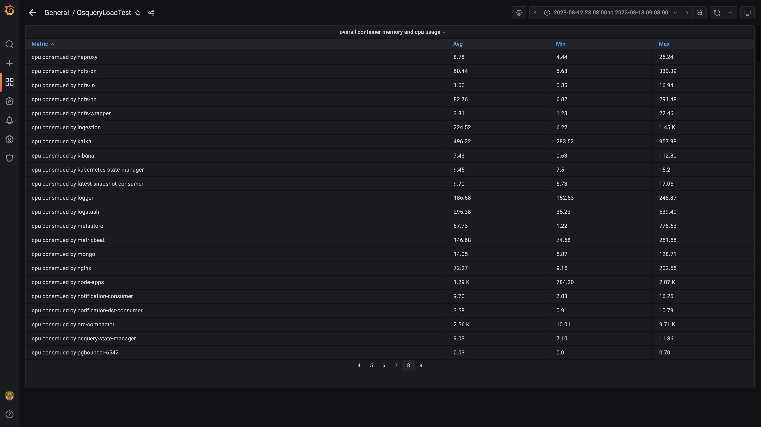

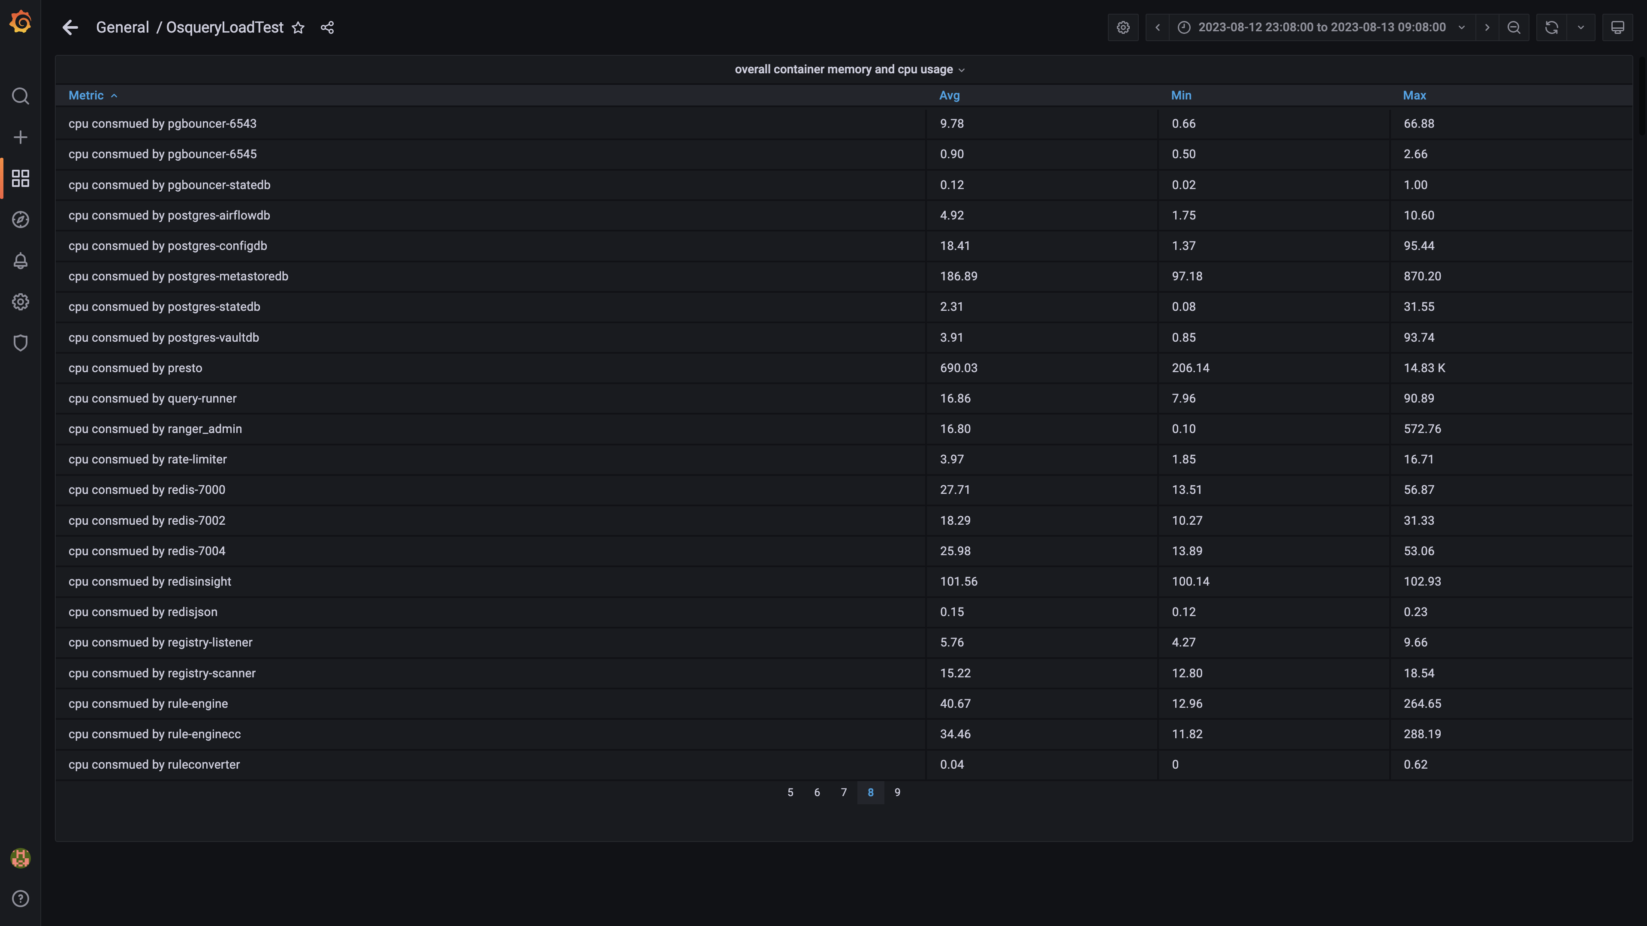

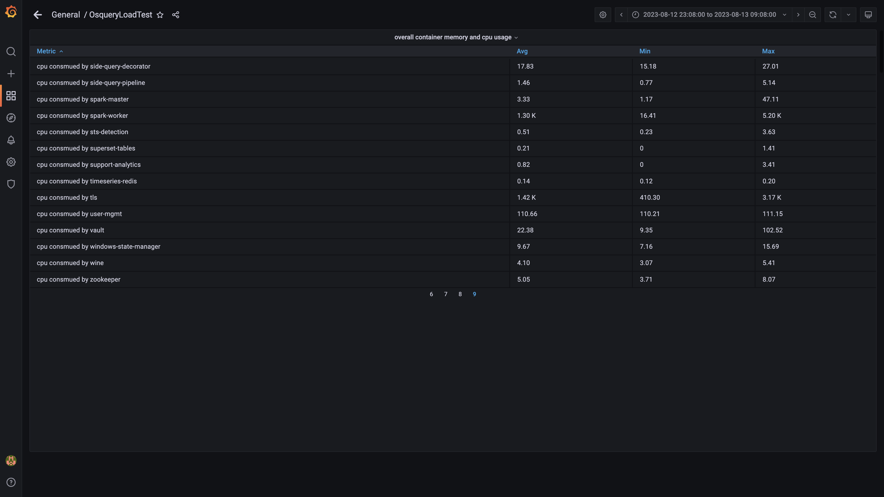

### Overall memory and cpu usages

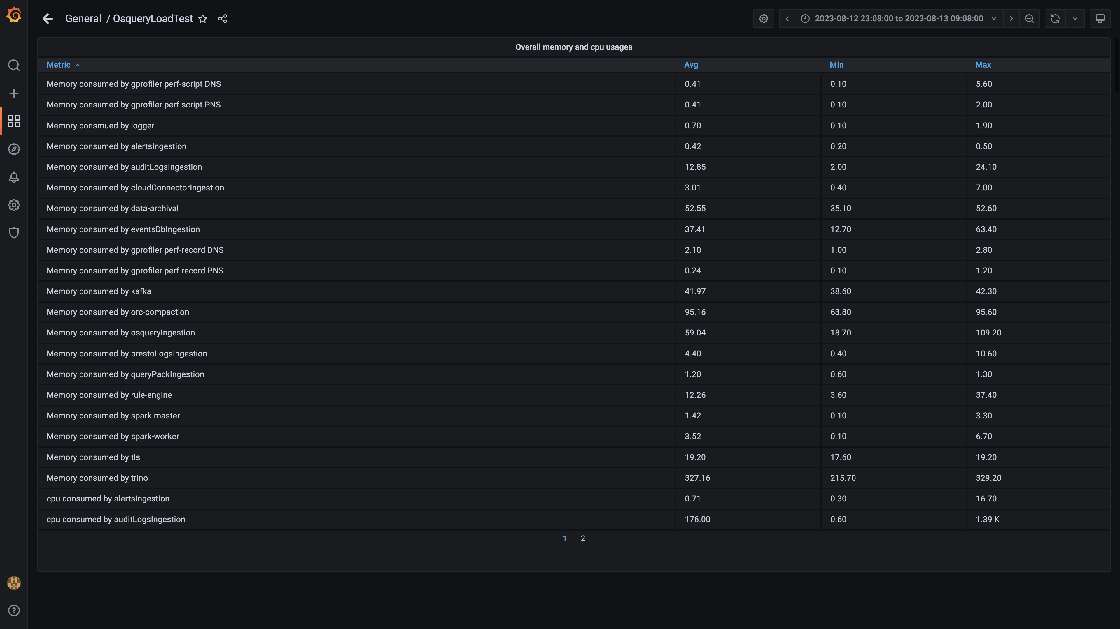

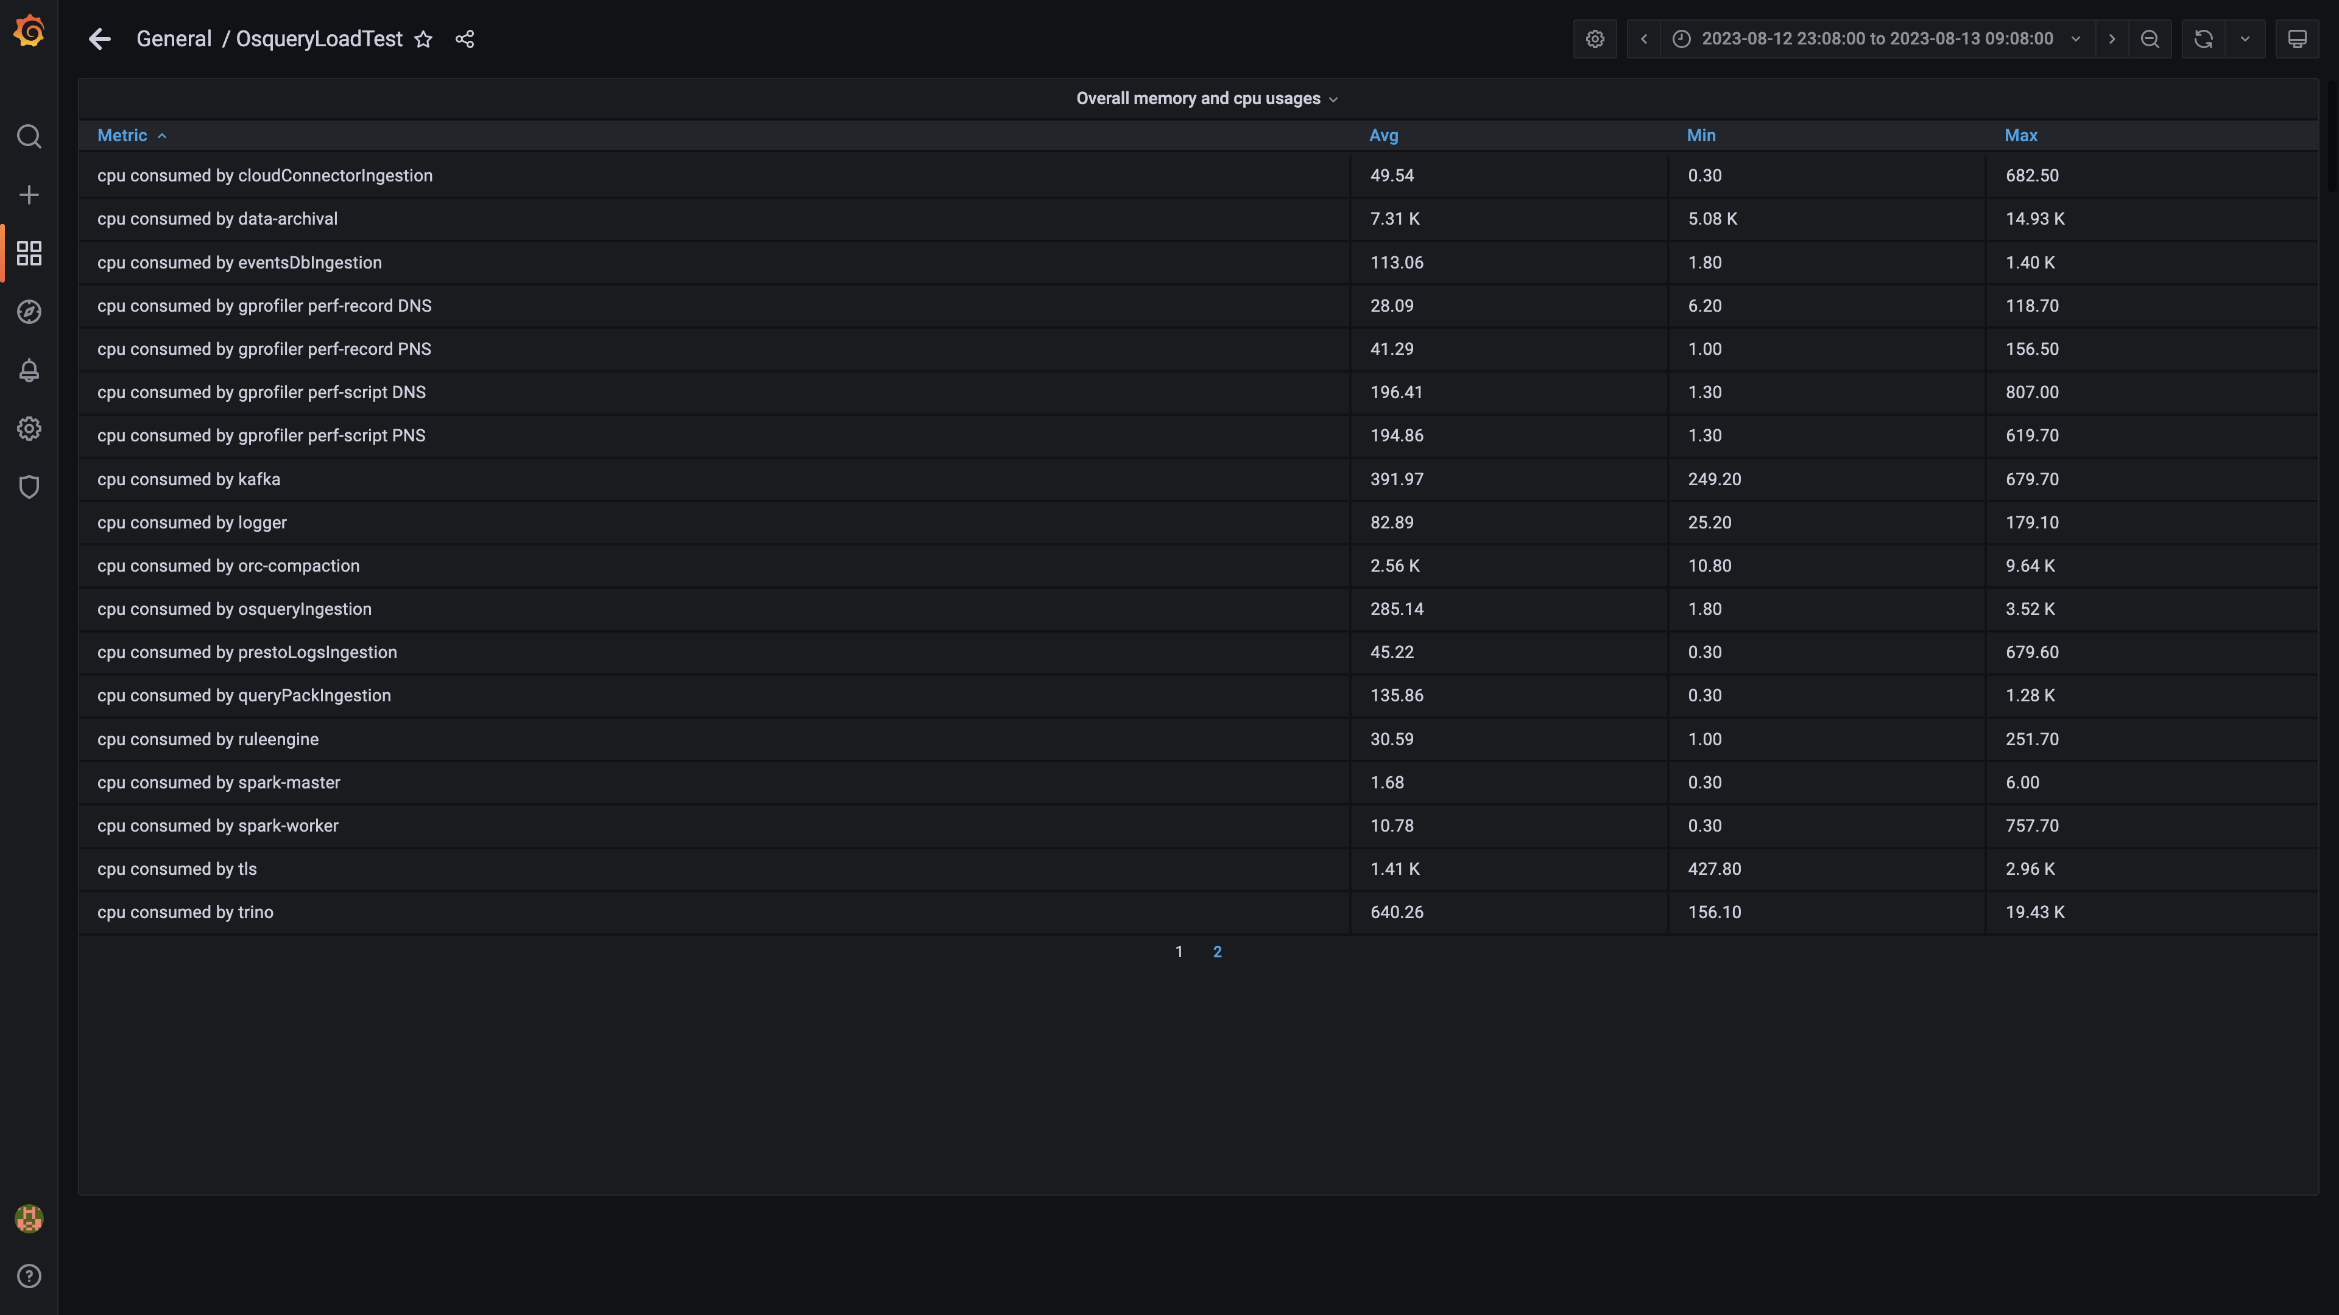

### Compaction status

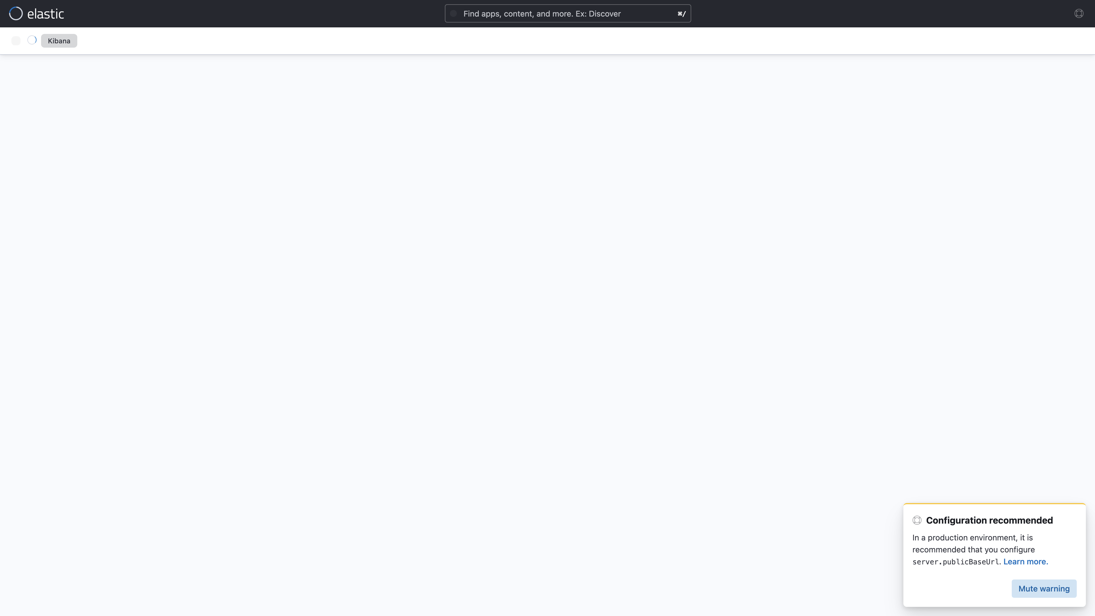

## Average Resource Utilization

### Comparision of Average Memory utilization

|  |  |  |  |  |
| --- | --- | --- | --- | --- |
| Metric | 137006 | 138888 | Absolute(%) | Relative(%) |
| Memory used by s1c1dn1 | 71.58% (179.67 GB) | 76.46% (191.91 GB) | 12.23 GB (4.87%) ⬆️ | 6.81 % ⬆️ |
| Memory used by s1c1dn2 | 73.64% (184.83 GB) | 75.37% (189.18 GB) | 4.34 GB (1.73%) ⬆️ | 2.35 % ⬆️ |
| Memory used by s1c1dn3 | 73.98% (185.69 GB) | 76.47% (191.93 GB) | 6.24 GB (2.49%) ⬆️ | 3.36 % ⬆️ |
| Memory used by s1c1dn4 | 80.06% (150.52 GB) | 81.16% (152.58 GB) | 2.07 GB (1.10%) ⬆️ | 1.37 % ⬆️ |
| Memory used by s1c1dn5 | 77.83% (146.31 GB) | 80.76% (151.82 GB) | 5.50 GB (2.93%) ⬆️ | 3.76 % ⬆️ |
| Memory used by s1c1dn6 | 80.18% (150.73 GB) | 82.17% (154.49 GB) | 3.75 GB (2.00%) ⬆️ | 2.49 % ⬆️ |
| Memory used by s1c1pn1 | 32.32% (60.77 GB) | 29.94% (56.28 GB) | 4.49 GB (2.39%) ⬇️ | 7.38 % ⬇️ |
| Memory used by s1c1pn2 | 31.61% (59.44 GB) | 29.41% (55.29 GB) | 4.14 GB (2.20%) ⬇️ | 6.97 % ⬇️ |
| Memory used by s1c1pn3 | 30.78% (57.87 GB) | 28.40% (53.40 GB) | 4.47 GB (2.38%) ⬇️ | 7.73 % ⬇️ |
| Memory used by s1c1pn4 | 32.06% (60.28 GB) | 29.62% (55.69 GB) | 4.59 GB (2.44%) ⬇️ | 7.61 % ⬇️ |
| Memory used by s1c1pn5 | 30.75% (57.80 GB) | 28.40% (53.40 GB) | 4.41 GB (2.34%) ⬇️ | 7.63 % ⬇️ |
| Memory used by s1c1pn6 | 29.96% (56.33 GB) | 27.61% (51.91 GB) | 4.42 GB (2.35%) ⬇️ | 7.85 % ⬇️ |
| Memory used by s1c2dn1 | 60.71% (152.37 GB) | 62.70% (157.37 GB) | 5.00 GB (1.99%) ⬆️ | 3.28 % ⬆️ |
| Memory used by s1c2dn2 | 64.01% (160.66 GB) | 66.16% (166.06 GB) | 5.40 GB (2.15%) ⬆️ | 3.36 % ⬆️ |
| Memory used by s1c2dn3 | 59.85% (150.22 GB) | 61.63% (154.70 GB) | 4.48 GB (1.79%) ⬆️ | 2.98 % ⬆️ |
| Memory used by s1c2dn4 | 73.66% (138.48 GB) | 76.56% (143.94 GB) | 5.46 GB (2.90%) ⬆️ | 3.94 % ⬆️ |
| Memory used by s1c2dn5 | 71.75% (134.89 GB) | 73.86% (138.85 GB) | 3.96 GB (2.11%) ⬆️ | 2.94 % ⬆️ |
| Memory used by s1c2dn6 | 72.76% (136.78 GB) | 75.58% (142.10 GB) | 5.32 GB (2.83%) ⬆️ | 3.89 % ⬆️ |
| Memory used by s1c2pn1 | 28.82% (54.19 GB) | 26.52% (49.86 GB) | 4.33 GB (2.30%) ⬇️ | 7.99 % ⬇️ |
| Memory used by s1c2pn2 | 28.58% (53.73 GB) | 26.37% (49.57 GB) | 4.16 GB (2.21%) ⬇️ | 7.74 % ⬇️ |
| Memory used by s1c2pn3 | 28.23% (53.07 GB) | 26.11% (49.08 GB) | 3.99 GB (2.12%) ⬇️ | 7.51 % ⬇️ |
| Memory used by s1c2pn4 | 28.59% (53.76 GB) | 26.22% (49.29 GB) | 4.46 GB (2.37%) ⬇️ | 8.30 % ⬇️ |
| Memory used by s1c2pn5 | 29.63% (55.71 GB) | 27.57% (51.84 GB) | 3.87 GB (2.06%) ⬇️ | 6.95 % ⬇️ |
| Memory used by s1c2pn6 | 30.84% (57.97 GB) | 28.54% (53.65 GB) | 4.32 GB (2.30%) ⬇️ | 7.46 % ⬇️ |
| Memory used by s1cloudquery | 2.39% | 2.41% | 0.02% ⬆️ | 0.93 % ⬆️ |
| Memory used by s1configdb1 | 11.73% (22.05 GB) | 11.88% (22.34 GB) | 0.29 GB (0.15%) ⬆️ | 1.30 % ⬆️ |
| Memory used by s1configdb2 | 1.21% (2.28 GB) | 1.19% (2.24 GB) | 0.04 GB (0.02%) ⬇️ | 1.84 % ⬇️ |
| Memory used by s1elasticsearch | 24.18% | 24.21% | 0.03% ⬆️ | 0.11 % ⬆️ |
| Memory used by s1kibana | 4.16% | 4.18% | 0.02% ⬆️ | 0.54 % ⬆️ |
| Memory used by s1logstash1 | 16.39% | 16.39% | 0.00% ⬆️ | 0.01 % ⬆️ |
| Memory used by s1logstash2 | 15.72% | 15.71% | 0.00% ⬇️ | 0.02 % ⬇️ |
| Memory used by s1mlnode1 | 9.01% | 9.03% | 0.02% ⬆️ | 0.17 % ⬆️ |
| Memory used by s1mlnode2 | 4.27% | 4.26% | 0.00% ⬇️ | 0.04 % ⬇️ |
| Memory used by s1monitor | 20.57% (12.76 GB) | 19.99% (12.39 GB) | 0.36 GB (0.59%) ⬇️ | 2.85 % ⬇️ |
| Memory used by s1stsnode1 | 12.15% | 12.44% | 0.29% ⬆️ | 2.41 % ⬆️ |
| Memory used by s1stsnode2 | 8.48% | 9.01% | 0.53% ⬆️ | 6.23 % ⬆️ |
| Memory used by s1stsnode3 | 8.56% | 9.17% | 0.60% ⬆️ | 7.04 % ⬆️ |
| Memory used by Rule Engine s1c1pn1 | 6.01% (11.29 GB) | 3.52% (6.61 GB) | 4.68 GB (2.49%) ⬇️ | 41.46 % ⬇️ |
| Memory used by Rule Engine s1c1pn2 | 5.87% (11.03 GB) | 3.51% (6.60 GB) | 4.43 GB (2.36%) ⬇️ | 40.19 % ⬇️ |
| Memory used by Rule Engine s1c1pn3 | 5.97% (11.23 GB) | 3.56% (6.69 GB) | 4.54 GB (2.42%) ⬇️ | 40.46 % ⬇️ |
| Memory used by Rule Engine s1c1pn4 | 5.86% (11.02 GB) | 3.57% (6.71 GB) | 4.31 GB (2.29%) ⬇️ | 39.12 % ⬇️ |
| Memory used by Rule Engine s1c1pn5 | 5.86% (11.02 GB) | 3.53% (6.64 GB) | 4.37 GB (2.33%) ⬇️ | 39.69 % ⬇️ |
| Memory used by Rule Engine s1c1pn6 | 5.81% (10.91 GB) | 3.52% (6.61 GB) | 4.30 GB (2.29%) ⬇️ | 39.42 % ⬇️ |
| Memory used by Rule Engine s1c2pn1 | 5.98% (11.23 GB) | 3.58% (6.74 GB) | 4.50 GB (2.39%) ⬇️ | 40.03 % ⬇️ |
| Memory used by Rule Engine s1c2pn2 | 5.99% (11.26 GB) | 3.63% (6.82 GB) | 4.44 GB (2.36%) ⬇️ | 39.40 % ⬇️ |
| Memory used by Rule Engine s1c2pn3 | 5.81% (10.93 GB) | 3.52% (6.61 GB) | 4.31 GB (2.29%) ⬇️ | 39.47 % ⬇️ |
| Memory used by Rule Engine s1c2pn4 | 5.93% (11.15 GB) | 3.40% (6.38 GB) | 4.77 GB (2.54%) ⬇️ | 42.74 % ⬇️ |
| Memory used by Rule Engine s1c2pn5 | 5.87% (11.03 GB) | 3.49% (6.55 GB) | 4.48 GB (2.38%) ⬇️ | 40.60 % ⬇️ |
| Memory used by Rule Engine s1c2pn6 | 6.13% (11.52 GB) | 3.51% (6.60 GB) | 4.92 GB (2.62%) ⬇️ | 42.72 % ⬇️ |
| Memory used by Osquery Ingestion s1c1dn1 | 7.64% (19.18 GB) | 5.85% (14.68 GB) | 4.50 GB (1.79%) ⬇️ | 23.46 % ⬇️ |
| Memory used by Osquery Ingestion s1c1dn2 | 7.71% (19.34 GB) | 5.80% (14.56 GB) | 4.78 GB (1.91%) ⬇️ | 24.73 % ⬇️ |
| Memory used by Osquery Ingestion s1c1dn3 | 7.74% (19.44 GB) | 4.81% (12.06 GB) | 7.37 GB (2.94%) ⬇️ | 37.93 % ⬇️ |
| Memory used by Osquery Ingestion s1c1dn4 | 10.21% (19.19 GB) | 7.84% (14.75 GB) | 4.45 GB (2.37%) ⬇️ | 23.17 % ⬇️ |
| Memory used by Osquery Ingestion s1c1dn5 | 10.30% (19.36 GB) | 7.86% (14.77 GB) | 4.59 GB (2.44%) ⬇️ | 23.70 % ⬇️ |
| Memory used by Osquery Ingestion s1c1dn6 | 10.32% (19.40 GB) | 7.83% (14.71 GB) | 4.68 GB (2.49%) ⬇️ | 24.15 % ⬇️ |
| Memory used by Osquery Ingestion s1c2dn1 | 7.67% (19.26 GB) | 5.79% (14.53 GB) | 4.73 GB (1.88%) ⬇️ | 24.56 % ⬇️ |
| Memory used by Osquery Ingestion s1c2dn2 | 7.92% (19.88 GB) | 4.68% (11.76 GB) | 8.13 GB (3.24%) ⬇️ | 40.87 % ⬇️ |
| Memory used by Osquery Ingestion s1c2dn3 | 7.86% (19.73 GB) | 5.53% (13.88 GB) | 5.85 GB (2.33%) ⬇️ | 29.66 % ⬇️ |
| Memory used by Osquery Ingestion s1c2dn4 | 10.31% (19.38 GB) | 7.58% (14.26 GB) | 5.12 GB (2.72%) ⬇️ | 26.40 % ⬇️ |
| Memory used by Osquery Ingestion s1c2dn5 | 10.19% (19.15 GB) | 7.98% (15.00 GB) | 4.15 GB (2.21%) ⬇️ | 21.66 % ⬇️ |
| Memory used by Osquery Ingestion s1c2dn6 | 10.17% (19.12 GB) | 7.85% (14.76 GB) | 4.36 GB (2.32%) ⬇️ | 22.79 % ⬇️ |
| Memory used by Kafka s1c1pn1 | 2.86% (5.37 GB) | 2.90% (5.44 GB) | 0.08 GB (0.04%) ⬆️ | 1.41 % ⬆️ |
| Memory used by Kafka s1c1pn2 | 3.51% (6.60 GB) | 3.50% (6.58 GB) | 0.02 GB (0.01%) ⬇️ | 0.28 % ⬇️ |
| Memory used by Kafka s1c1pn3 | 3.52% (6.61 GB) | 3.50% (6.58 GB) | 0.03 GB (0.02%) ⬇️ | 0.51 % ⬇️ |
| Memory used by Kafka s1c1pn4 | 3.53% (6.64 GB) | 3.50% (6.58 GB) | 0.06 GB (0.03%) ⬇️ | 0.85 % ⬇️ |
| Memory used by Kafka s1c1pn5 | 3.53% (6.63 GB) | 3.50% (6.58 GB) | 0.05 GB (0.03%) ⬇️ | 0.81 % ⬇️ |
| Memory used by Kafka s1c1pn6 | 3.52% (6.63 GB) | 3.50% (6.58 GB) | 0.05 GB (0.02%) ⬇️ | 0.69 % ⬇️ |
| Memory used by Kafka s1c2pn1 | 2.83% (5.33 GB) | 2.89% (5.44 GB) | 0.11 GB (0.06%) ⬆️ | 2.12 % ⬆️ |
| Memory used by Kafka s1c2pn2 | 3.52% (6.61 GB) | 3.50% (6.58 GB) | 0.03 GB (0.02%) ⬇️ | 0.47 % ⬇️ |
| Memory used by Kafka s1c2pn3 | 3.51% (6.60 GB) | 3.50% (6.58 GB) | 0.02 GB (0.01%) ⬇️ | 0.35 % ⬇️ |
| Memory used by Kafka s1c2pn4 | 3.45% (6.50 GB) | 3.40% (6.39 GB) | 0.10 GB (0.05%) ⬇️ | 1.59 % ⬇️ |
| Memory used by Kafka s1c2pn5 | 3.49% (6.57 GB) | 3.50% (6.58 GB) | 0.01 GB (0.01%) ⬆️ | 0.15 % ⬆️ |
| Memory used by Kafka s1c2pn6 | 3.50% (6.58 GB) | 3.50% (6.58 GB) | 0.00 GB (0.00%) ⬆️ | 0.03 % ⬆️ |
| Memory used by Trino s1c1dn1 | 21.73% (54.54 GB) | 27.14% (68.11 GB) | 13.57 GB (5.41%) ⬆️ | 24.89 % ⬆️ |
| Memory used by Trino s1c1dn2 | 24.97% (62.66 GB) | 27.41% (68.80 GB) | 6.14 GB (2.45%) ⬆️ | 9.79 % ⬆️ |
| Memory used by Trino s1c1dn3 | 23.37% (58.66 GB) | 26.45% (66.38 GB) | 7.72 GB (3.08%) ⬆️ | 13.17 % ⬆️ |
| Memory used by Trino s1c1dn4 | 25.02% (47.04 GB) | 27.91% (52.46 GB) | 5.42 GB (2.88%) ⬆️ | 11.53 % ⬆️ |
| Memory used by Trino s1c1dn5 | 24.78% (46.59 GB) | 27.28% (51.28 GB) | 4.69 GB (2.49%) ⬆️ | 10.06 % ⬆️ |
| Memory used by Trino s1c1dn6 | 25.31% (47.59 GB) | 28.84% (54.21 GB) | 6.63 GB (3.53%) ⬆️ | 13.93 % ⬆️ |
| Memory used by Trino s1c2dn1 | 24.09% (60.47 GB) | 26.30% (66.01 GB) | 5.54 GB (2.21%) ⬆️ | 9.17 % ⬆️ |
| Memory used by Trino s1c2dn2 | 24.02% (60.29 GB) | 26.29% (65.98 GB) | 5.69 GB (2.27%) ⬆️ | 9.44 % ⬆️ |
| Memory used by Trino s1c2dn3 | 23.41% (58.76 GB) | 25.94% (65.10 GB) | 6.34 GB (2.53%) ⬆️ | 10.79 % ⬆️ |
| Memory used by Trino s1c2dn4 | 25.76% (48.44 GB) | 28.65% (53.87 GB) | 5.43 GB (2.89%) ⬆️ | 11.21 % ⬆️ |
| Memory used by Trino s1c2dn5 | 24.30% (45.69 GB) | 26.90% (50.57 GB) | 4.88 GB (2.60%) ⬆️ | 10.69 % ⬆️ |
| Memory used by Trino s1c2dn6 | 24.88% (46.77 GB) | 28.14% (52.90 GB) | 6.13 GB (3.26%) ⬆️ | 13.10 % ⬆️ |
| Memory used by Tls s1c1pn1 | 0.20% (0.38 GB) | 0.20% (0.38 GB) | 0.00 GB (0.00%) ⬆️ | 0.00 % ⬆️ |
| Memory used by Tls s1c1pn2 | 0.20% (0.38 GB) | 0.20% (0.38 GB) | 0.00 GB (0.00%) ⬆️ | 0.00 % ⬆️ |
| Memory used by Tls s1c1pn3 | 0.20% (0.38 GB) | 0.20% (0.38 GB) | 0.00 GB (0.00%) ⬆️ | 0.00 % ⬆️ |
| Memory used by Tls s1c1pn4 | 0.20% (0.38 GB) | 0.20% (0.38 GB) | 0.00 GB (0.00%) ⬆️ | 0.00 % ⬆️ |
| Memory used by Tls s1c1pn5 | 0.20% (0.38 GB) | 0.20% (0.38 GB) | 0.00 GB (0.00%) ⬆️ | 0.00 % ⬆️ |
| Memory used by Tls s1c1pn6 | 0.20% (0.38 GB) | 0.20% (0.38 GB) | 0.00 GB (0.00%) ⬆️ | 0.00 % ⬆️ |
| Memory used by Tls s1c2pn1 | 0.20% (0.38 GB) | 0.20% (0.38 GB) | 0.00 GB (0.00%) ⬆️ | 0.00 % ⬆️ |
| Memory used by Tls s1c2pn2 | 0.20% (0.38 GB) | 0.20% (0.38 GB) | 0.00 GB (0.00%) ⬆️ | 0.00 % ⬆️ |
| Memory used by Tls s1c2pn3 | 0.20% (0.38 GB) | 0.20% (0.38 GB) | 0.00 GB (0.00%) ⬆️ | 0.00 % ⬆️ |
| Memory used by Tls s1c2pn4 | 0.20% (0.38 GB) | 0.20% (0.38 GB) | 0.00 GB (0.00%) ⬆️ | 0.00 % ⬆️ |
| Memory used by Tls s1c2pn5 | 0.20% (0.38 GB) | 0.20% (0.38 GB) | 0.00 GB (0.00%) ⬆️ | 0.00 % ⬆️ |
| Memory used by Tls s1c2pn6 | 0.20% (0.38 GB) | 0.20% (0.38 GB) | 0.00 GB (0.00%) ⬆️ | 0.00 % ⬆️ |
| Memory used by EventsDbIngestion s1c1dn1 | 3.13% (7.85 GB) | 2.76% (6.92 GB) | 0.93 GB (0.37%) ⬇️ | 11.85 % ⬇️ |
| Memory used by EventsDbIngestion s1c1dn2 | 3.14% (7.89 GB) | 2.73% (6.86 GB) | 1.03 GB (0.41%) ⬇️ | 13.05 % ⬇️ |
| Memory used by EventsDbIngestion s1c1dn3 | 1.55% (3.89 GB) | 1.43% (3.58 GB) | 0.32 GB (0.13%) ⬇️ | 8.11 % ⬇️ |
| Memory used by EventsDbIngestion s1c1dn4 | 4.12% (7.74 GB) | 3.54% (6.66 GB) | 1.08 GB (0.58%) ⬇️ | 13.97 % ⬇️ |
| Memory used by EventsDbIngestion s1c1dn5 | 4.12% (7.75 GB) | 3.65% (6.86 GB) | 0.89 GB (0.47%) ⬇️ | 11.44 % ⬇️ |
| Memory used by EventsDbIngestion s1c1dn6 | 4.20% (7.89 GB) | 3.56% (6.69 GB) | 1.20 GB (0.64%) ⬇️ | 15.21 % ⬇️ |
| Memory used by EventsDbIngestion s1c2dn1 | 3.22% (8.08 GB) | 2.76% (6.92 GB) | 1.16 GB (0.46%) ⬇️ | 14.31 % ⬇️ |
| Memory used by EventsDbIngestion s1c2dn2 | 1.68% (4.21 GB) | 1.40% (3.50 GB) | 0.71 GB (0.28%) ⬇️ | 16.79 % ⬇️ |
| Memory used by EventsDbIngestion s1c2dn3 | 3.10% (7.78 GB) | 2.57% (6.44 GB) | 1.33 GB (0.53%) ⬇️ | 17.13 % ⬇️ |
| Memory used by EventsDbIngestion s1c2dn4 | 4.12% (7.74 GB) | 3.69% (6.94 GB) | 0.80 GB (0.43%) ⬇️ | 10.34 % ⬇️ |
| Memory used by EventsDbIngestion s1c2dn5 | 3.98% (7.49 GB) | 3.28% (6.16 GB) | 1.33 GB (0.71%) ⬇️ | 17.73 % ⬇️ |
| Memory used by EventsDbIngestion s1c2dn6 | 4.10% (7.71 GB) | 3.41% (6.41 GB) | 1.30 GB (0.69%) ⬇️ | 16.82 % ⬇️ |
| Memory used by Logger s1c2pn2 | 1.20% (2.26 GB) | 0.37% (0.69 GB) | 1.56 GB (0.83%) ⬇️ | 69.36 % ⬇️ |
| Memory used by Logger s1c2pn4 | 1.20% (2.26 GB) | 0.41% (0.78 GB) | 1.48 GB (0.79%) ⬇️ | 65.51 % ⬇️ |

### Comparision of Average CPU utilization

|  |  |  |  |  |
| --- | --- | --- | --- | --- |
| Metric | 137006 | 138888 | Absolute(%) | Relative(%) |
| CPU used by s1c1dn1 | 60.03% (19.21 cores) | 40.13% (12.84 cores) | 6.37 cores (19.90%) ⬇️ | 33.15 % ⬇️ |
| CPU used by s1c1dn2 | 63.15% (20.21 cores) | 39.48% (12.63 cores) | 7.57 cores (23.67%) ⬇️ | 37.48 % ⬇️ |
| CPU used by s1c1dn3 | 63.91% (20.45 cores) | 40.41% (12.93 cores) | 7.52 cores (23.49%) ⬇️ | 36.76 % ⬇️ |
| CPU used by s1c1dn4 | 60.99% (19.52 cores) | 35.64% (11.40 cores) | 8.11 cores (25.35%) ⬇️ | 41.56 % ⬇️ |
| CPU used by s1c1dn5 | 61.94% (19.82 cores) | 36.64% (11.73 cores) | 8.09 cores (25.29%) ⬇️ | 40.84 % ⬇️ |
| CPU used by s1c1dn6 | 61.01% (19.52 cores) | 37.30% (11.94 cores) | 7.59 cores (23.71%) ⬇️ | 38.86 % ⬇️ |
| CPU used by s1c1pn1 | 60.85% (19.47 cores) | 22.92% (7.33 cores) | 12.14 cores (37.93%) ⬇️ | 62.34 % ⬇️ |
| CPU used by s1c1pn2 | 52.90% (16.93 cores) | 17.01% (5.44 cores) | 11.49 cores (35.89%) ⬇️ | 67.85 % ⬇️ |
| CPU used by s1c1pn3 | 53.40% (17.09 cores) | 16.99% (5.44 cores) | 11.65 cores (36.41%) ⬇️ | 68.19 % ⬇️ |
| CPU used by s1c1pn4 | 50.31% (16.10 cores) | 14.93% (4.78 cores) | 11.32 cores (35.38%) ⬇️ | 70.33 % ⬇️ |
| CPU used by s1c1pn5 | 53.64% (17.16 cores) | 18.84% (6.03 cores) | 11.14 cores (34.80%) ⬇️ | 64.88 % ⬇️ |
| CPU used by s1c1pn6 | 57.76% (18.48 cores) | 13.83% (4.43 cores) | 14.06 cores (43.93%) ⬇️ | 76.06 % ⬇️ |
| CPU used by s1c2dn1 | 57.70% (18.46 cores) | 34.96% (11.19 cores) | 7.28 cores (22.74%) ⬇️ | 39.42 % ⬇️ |
| CPU used by s1c2dn2 | 61.67% (19.73 cores) | 39.33% (12.59 cores) | 7.15 cores (22.33%) ⬇️ | 36.22 % ⬇️ |
| CPU used by s1c2dn3 | 58.41% (18.69 cores) | 34.66% (11.09 cores) | 7.60 cores (23.75%) ⬇️ | 40.66 % ⬇️ |
| CPU used by s1c2dn4 | 58.07% (18.58 cores) | 34.34% (10.99 cores) | 7.59 cores (23.73%) ⬇️ | 40.87 % ⬇️ |
| CPU used by s1c2dn5 | 58.44% (18.70 cores) | 34.72% (11.11 cores) | 7.59 cores (23.72%) ⬇️ | 40.59 % ⬇️ |
| CPU used by s1c2dn6 | 59.48% (19.03 cores) | 35.94% (11.50 cores) | 7.53 cores (23.54%) ⬇️ | 39.58 % ⬇️ |
| CPU used by s1c2pn1 | 53.97% (17.27 cores) | 17.80% (5.69 cores) | 11.58 cores (36.17%) ⬇️ | 67.03 % ⬇️ |
| CPU used by s1c2pn2 | 47.52% (15.21 cores) | 13.92% (4.46 cores) | 10.75 cores (33.59%) ⬇️ | 70.70 % ⬇️ |
| CPU used by s1c2pn3 | 49.88% (15.96 cores) | 13.61% (4.36 cores) | 11.60 cores (36.26%) ⬇️ | 72.71 % ⬇️ |
| CPU used by s1c2pn4 | 47.76% (15.28 cores) | 13.65% (4.37 cores) | 10.92 cores (34.12%) ⬇️ | 71.43 % ⬇️ |
| CPU used by s1c2pn5 | 43.55% (13.94 cores) | 14.25% (4.56 cores) | 9.38 cores (29.30%) ⬇️ | 67.28 % ⬇️ |
| CPU used by s1c2pn6 | 61.01% (19.52 cores) | 14.89% (4.76 cores) | 14.76 cores (46.12%) ⬇️ | 75.59 % ⬇️ |
| CPU used by s1cloudquery | 6.35% | 6.39% | 0.04% ⬆️ | 0.61 % ⬆️ |
| CPU used by s1configdb1 | 14.94% (4.78 cores) | 9.27% (2.97 cores) | 1.82 cores (5.67%) ⬇️ | 37.96 % ⬇️ |
| CPU used by s1configdb2 | 2.78% (0.89 cores) | 2.63% (0.84 cores) | 0.05 cores (0.15%) ⬇️ | 5.25 % ⬇️ |
| CPU used by s1elasticsearch | 64.18% | 64.77% | 0.59% ⬆️ | 0.92 % ⬆️ |
| CPU used by s1kibana | 7.56% | 7.31% | 0.25% ⬇️ | 3.34 % ⬇️ |
| CPU used by s1logstash1 | 21.47% | 20.89% | 0.57% ⬇️ | 2.68 % ⬇️ |
| CPU used by s1logstash2 | 22.06% | 21.80% | 0.26% ⬇️ | 1.16 % ⬇️ |
| CPU used by s1mlnode1 | 4.18% | 4.32% | 0.14% ⬆️ | 3.43 % ⬆️ |
| CPU used by s1mlnode2 | 1.56% | 1.62% | 0.06% ⬆️ | 3.91 % ⬆️ |
| CPU used by s1monitor | 4.18% (0.67 cores) | 3.38% (0.54 cores) | 0.13 cores (0.80%) ⬇️ | 19.18 % ⬇️ |
| CPU used by s1stsnode1 | 3.12% | 3.23% | 0.11% ⬆️ | 3.48 % ⬆️ |
| CPU used by s1stsnode2 | 8.20% | 8.32% | 0.12% ⬆️ | 1.49 % ⬆️ |
| CPU used by s1stsnode3 | 8.27% | 8.58% | 0.31% ⬆️ | 3.75 % ⬆️ |
| CPU used by Rule Engine s1c1pn1 | 94.10% (0.94 cores) | 24.25% (0.24 cores) | 0.70 cores (69.85%) ⬇️ | 74.23 % ⬇️ |
| CPU used by Rule Engine s1c1pn2 | 96.27% (0.96 cores) | 9.75% (0.10 cores) | 0.87 cores (86.52%) ⬇️ | 89.87 % ⬇️ |
| CPU used by Rule Engine s1c1pn3 | 96.36% (0.96 cores) | 20.52% (0.21 cores) | 0.76 cores (75.84%) ⬇️ | 78.70 % ⬇️ |
| CPU used by Rule Engine s1c1pn4 | 94.70% (0.95 cores) | 8.67% (0.09 cores) | 0.86 cores (86.04%) ⬇️ | 90.85 % ⬇️ |
| CPU used by Rule Engine s1c1pn5 | 98.57% (0.99 cores) | 12.61% (0.13 cores) | 0.86 cores (85.96%) ⬇️ | 87.21 % ⬇️ |
| CPU used by Rule Engine s1c1pn6 | 90.22% (0.90 cores) | 11.23% (0.11 cores) | 0.79 cores (78.99%) ⬇️ | 87.55 % ⬇️ |
| CPU used by Rule Engine s1c2pn1 | 93.82% (0.94 cores) | 8.05% (0.08 cores) | 0.86 cores (85.77%) ⬇️ | 91.42 % ⬇️ |
| CPU used by Rule Engine s1c2pn2 | 101.25% (1.01 cores) | 11.93% (0.12 cores) | 0.89 cores (89.31%) ⬇️ | 88.21 % ⬇️ |
| CPU used by Rule Engine s1c2pn3 | 101.29% (1.01 cores) | 6.48% (0.06 cores) | 0.95 cores (94.82%) ⬇️ | 93.61 % ⬇️ |
| CPU used by Rule Engine s1c2pn4 | 102.29% (1.02 cores) | 6.81% (0.07 cores) | 0.95 cores (95.48%) ⬇️ | 93.35 % ⬇️ |
| CPU used by Rule Engine s1c2pn5 | 91.86% (0.92 cores) | 7.01% (0.07 cores) | 0.85 cores (84.85%) ⬇️ | 92.37 % ⬇️ |
| CPU used by Rule Engine s1c2pn6 | 96.78% (0.97 cores) | 4.63% (0.05 cores) | 0.92 cores (92.15%) ⬇️ | 95.22 % ⬇️ |
| CPU used by Osquery Ingestion s1c1dn1 | 324.40% (3.24 cores) | 17.26% (0.17 cores) | 3.07 cores (307.14%) ⬇️ | 94.68 % ⬇️ |
| CPU used by Osquery Ingestion s1c1dn2 | 309.30% (3.09 cores) | 14.38% (0.14 cores) | 2.95 cores (294.92%) ⬇️ | 95.35 % ⬇️ |
| CPU used by Osquery Ingestion s1c1dn3 | 177.64% (1.78 cores) | 14.47% (0.14 cores) | 1.63 cores (163.17%) ⬇️ | 91.86 % ⬇️ |
| CPU used by Osquery Ingestion s1c1dn4 | 289.14% (2.89 cores) | 12.67% (0.13 cores) | 2.76 cores (276.47%) ⬇️ | 95.62 % ⬇️ |
| CPU used by Osquery Ingestion s1c1dn5 | 301.06% (3.01 cores) | 14.36% (0.14 cores) | 2.87 cores (286.70%) ⬇️ | 95.23 % ⬇️ |
| CPU used by Osquery Ingestion s1c1dn6 | 316.73% (3.17 cores) | 18.26% (0.18 cores) | 2.98 cores (298.47%) ⬇️ | 94.23 % ⬇️ |
| CPU used by Osquery Ingestion s1c2dn1 | 304.17% (3.04 cores) | 14.77% (0.15 cores) | 2.89 cores (289.40%) ⬇️ | 95.14 % ⬇️ |
| CPU used by Osquery Ingestion s1c2dn2 | 182.17% (1.82 cores) | 10.52% (0.11 cores) | 1.72 cores (171.65%) ⬇️ | 94.23 % ⬇️ |
| CPU used by Osquery Ingestion s1c2dn3 | 301.80% (3.02 cores) | 15.39% (0.15 cores) | 2.86 cores (286.42%) ⬇️ | 94.90 % ⬇️ |
| CPU used by Osquery Ingestion s1c2dn4 | 300.73% (3.01 cores) | 12.50% (0.13 cores) | 2.88 cores (288.22%) ⬇️ | 95.84 % ⬇️ |
| CPU used by Osquery Ingestion s1c2dn5 | 317.73% (3.18 cores) | 14.64% (0.15 cores) | 3.03 cores (303.10%) ⬇️ | 95.39 % ⬇️ |
| CPU used by Osquery Ingestion s1c2dn6 | 300.83% (3.01 cores) | 17.99% (0.18 cores) | 2.83 cores (282.84%) ⬇️ | 94.02 % ⬇️ |
| CPU used by Kafka s1c1pn1 | 194.31% (1.94 cores) | 26.19% (0.26 cores) | 1.68 cores (168.12%) ⬇️ | 86.52 % ⬇️ |
| CPU used by Kafka s1c1pn2 | 277.34% (2.77 cores) | 14.61% (0.15 cores) | 2.63 cores (262.73%) ⬇️ | 94.73 % ⬇️ |
| CPU used by Kafka s1c1pn3 | 286.34% (2.86 cores) | 24.62% (0.25 cores) | 2.62 cores (261.72%) ⬇️ | 91.40 % ⬇️ |
| CPU used by Kafka s1c1pn4 | 319.59% (3.20 cores) | 27.20% (0.27 cores) | 2.92 cores (292.39%) ⬇️ | 91.49 % ⬇️ |
| CPU used by Kafka s1c1pn5 | 385.85% (3.86 cores) | 120.89% (1.21 cores) | 2.65 cores (264.96%) ⬇️ | 68.67 % ⬇️ |
| CPU used by Kafka s1c1pn6 | 554.97% (5.55 cores) | 25.21% (0.25 cores) | 5.30 cores (529.76%) ⬇️ | 95.46 % ⬇️ |
| CPU used by Kafka s1c2pn1 | 247.68% (2.48 cores) | 25.56% (0.26 cores) | 2.22 cores (222.11%) ⬇️ | 89.68 % ⬇️ |
| CPU used by Kafka s1c2pn2 | 253.35% (2.53 cores) | 14.46% (0.14 cores) | 2.39 cores (238.90%) ⬇️ | 94.29 % ⬇️ |
| CPU used by Kafka s1c2pn3 | 329.30% (3.29 cores) | 15.54% (0.16 cores) | 3.14 cores (313.76%) ⬇️ | 95.28 % ⬇️ |
| CPU used by Kafka s1c2pn4 | 210.39% (2.10 cores) | 14.27% (0.14 cores) | 1.96 cores (196.12%) ⬇️ | 93.22 % ⬇️ |
| CPU used by Kafka s1c2pn5 | 193.39% (1.93 cores) | 15.31% (0.15 cores) | 1.78 cores (178.07%) ⬇️ | 92.08 % ⬇️ |
| CPU used by Kafka s1c2pn6 | 565.41% (5.65 cores) | 26.61% (0.27 cores) | 5.39 cores (538.80%) ⬇️ | 95.29 % ⬇️ |
| CPU used by Trino s1c1dn1 | 43.93% (0.44 cores) | 118.71% (1.19 cores) | 0.75 cores (74.78%) ⬆️ | 170.20 % ⬆️ |
| CPU used by Trino s1c1dn2 | 95.11% (0.95 cores) | 42.80% (0.43 cores) | 0.52 cores (52.31%) ⬇️ | 55.00 % ⬇️ |
| CPU used by Trino s1c1dn3 | 95.61% (0.96 cores) | 47.20% (0.47 cores) | 0.48 cores (48.41%) ⬇️ | 50.63 % ⬇️ |
| CPU used by Trino s1c1dn4 | 100.95% (1.01 cores) | 49.36% (0.49 cores) | 0.52 cores (51.59%) ⬇️ | 51.10 % ⬇️ |
| CPU used by Trino s1c1dn5 | 109.76% (1.10 cores) | 48.80% (0.49 cores) | 0.61 cores (60.96%) ⬇️ | 55.54 % ⬇️ |
| CPU used by Trino s1c1dn6 | 103.04% (1.03 cores) | 49.50% (0.49 cores) | 0.54 cores (53.54%) ⬇️ | 51.96 % ⬇️ |
| CPU used by Trino s1c2dn1 | 100.56% (1.01 cores) | 48.18% (0.48 cores) | 0.52 cores (52.38%) ⬇️ | 52.09 % ⬇️ |
| CPU used by Trino s1c2dn2 | 101.46% (1.01 cores) | 51.11% (0.51 cores) | 0.50 cores (50.35%) ⬇️ | 49.63 % ⬇️ |
| CPU used by Trino s1c2dn3 | 108.08% (1.08 cores) | 43.45% (0.43 cores) | 0.65 cores (64.64%) ⬇️ | 59.80 % ⬇️ |
| CPU used by Trino s1c2dn4 | 103.85% (1.04 cores) | 48.00% (0.48 cores) | 0.56 cores (55.85%) ⬇️ | 53.78 % ⬇️ |
| CPU used by Trino s1c2dn5 | 102.62% (1.03 cores) | 44.96% (0.45 cores) | 0.58 cores (57.67%) ⬇️ | 56.19 % ⬇️ |
| CPU used by Trino s1c2dn6 | 111.75% (1.12 cores) | 43.66% (0.44 cores) | 0.68 cores (68.09%) ⬇️ | 60.93 % ⬇️ |
| CPU used by Tls s1c1pn1 | 16.99% (0.17 cores) | 14.51% (0.15 cores) | 0.02 cores (2.48%) ⬇️ | 14.61 % ⬇️ |
| CPU used by Tls s1c1pn2 | 15.95% (0.16 cores) | 14.30% (0.14 cores) | 0.02 cores (1.65%) ⬇️ | 10.37 % ⬇️ |
| CPU used by Tls s1c1pn3 | 17.25% (0.17 cores) | 15.08% (0.15 cores) | 0.02 cores (2.16%) ⬇️ | 12.53 % ⬇️ |
| CPU used by Tls s1c1pn4 | 15.94% (0.16 cores) | 14.76% (0.15 cores) | 0.01 cores (1.19%) ⬇️ | 7.44 % ⬇️ |
| CPU used by Tls s1c1pn5 | 16.69% (0.17 cores) | 14.21% (0.14 cores) | 0.02 cores (2.48%) ⬇️ | 14.84 % ⬇️ |
| CPU used by Tls s1c1pn6 | 15.72% (0.16 cores) | 14.26% (0.14 cores) | 0.01 cores (1.45%) ⬇️ | 9.23 % ⬇️ |
| CPU used by Tls s1c2pn1 | 16.32% (0.16 cores) | 14.95% (0.15 cores) | 0.01 cores (1.37%) ⬇️ | 8.42 % ⬇️ |
| CPU used by Tls s1c2pn2 | 16.08% (0.16 cores) | 14.83% (0.15 cores) | 0.01 cores (1.25%) ⬇️ | 7.75 % ⬇️ |
| CPU used by Tls s1c2pn3 | 15.58% (0.16 cores) | 14.73% (0.15 cores) | 0.01 cores (0.85%) ⬇️ | 5.46 % ⬇️ |
| CPU used by Tls s1c2pn4 | 16.12% (0.16 cores) | 15.20% (0.15 cores) | 0.01 cores (0.92%) ⬇️ | 5.69 % ⬇️ |
| CPU used by Tls s1c2pn5 | 15.72% (0.16 cores) | 14.76% (0.15 cores) | 0.01 cores (0.95%) ⬇️ | 6.06 % ⬇️ |
| CPU used by Tls s1c2pn6 | 17.08% (0.17 cores) | 15.21% (0.15 cores) | 0.02 cores (1.87%) ⬇️ | 10.95 % ⬇️ |
| CPU used by EventsDbIngestion s1c1dn1 | 29.51% (0.30 cores) | 7.07% (0.07 cores) | 0.22 cores (22.44%) ⬇️ | 76.05 % ⬇️ |
| CPU used by EventsDbIngestion s1c1dn2 | 28.16% (0.28 cores) | 5.70% (0.06 cores) | 0.22 cores (22.46%) ⬇️ | 79.76 % ⬇️ |
| CPU used by EventsDbIngestion s1c1dn3 | 13.64% (0.14 cores) | 6.05% (0.06 cores) | 0.08 cores (7.59%) ⬇️ | 55.64 % ⬇️ |
| CPU used by EventsDbIngestion s1c1dn4 | 21.63% (0.22 cores) | 5.41% (0.05 cores) | 0.16 cores (16.22%) ⬇️ | 74.98 % ⬇️ |
| CPU used by EventsDbIngestion s1c1dn5 | 24.90% (0.25 cores) | 5.92% (0.06 cores) | 0.19 cores (18.98%) ⬇️ | 76.23 % ⬇️ |
| CPU used by EventsDbIngestion s1c1dn6 | 25.26% (0.25 cores) | 5.56% (0.06 cores) | 0.20 cores (19.70%) ⬇️ | 78.00 % ⬇️ |
| CPU used by EventsDbIngestion s1c2dn1 | 24.38% (0.24 cores) | 7.89% (0.08 cores) | 0.16 cores (16.49%) ⬇️ | 67.65 % ⬇️ |
| CPU used by EventsDbIngestion s1c2dn2 | 15.50% (0.15 cores) | 4.01% (0.04 cores) | 0.11 cores (11.48%) ⬇️ | 74.10 % ⬇️ |
| CPU used by EventsDbIngestion s1c2dn3 | 21.55% (0.22 cores) | 5.26% (0.05 cores) | 0.16 cores (16.29%) ⬇️ | 75.58 % ⬇️ |
| CPU used by EventsDbIngestion s1c2dn4 | 21.52% (0.22 cores) | 5.02% (0.05 cores) | 0.16 cores (16.50%) ⬇️ | 76.68 % ⬇️ |
| CPU used by EventsDbIngestion s1c2dn5 | 28.77% (0.29 cores) | 7.60% (0.08 cores) | 0.21 cores (21.16%) ⬇️ | 73.57 % ⬇️ |
| CPU used by EventsDbIngestion s1c2dn6 | 22.93% (0.23 cores) | 5.62% (0.06 cores) | 0.17 cores (17.31%) ⬇️ | 75.51 % ⬇️ |
| CPU used by Logger s1c1pn1 | 376.72% (3.77 cores) | 4.31% (0.04 cores) | 3.72 cores (372.41%) ⬇️ | 98.86 % ⬇️ |
| CPU used by Logger s1c1pn2 | 440.37% (4.40 cores) | 5.79% (0.06 cores) | 4.35 cores (434.58%) ⬇️ | 98.69 % ⬇️ |
| CPU used by Logger s1c1pn3 | 438.25% (4.38 cores) | 5.26% (0.05 cores) | 4.33 cores (432.99%) ⬇️ | 98.80 % ⬇️ |
| CPU used by Logger s1c1pn4 | 451.86% (4.52 cores) | 9.40% (0.09 cores) | 4.42 cores (442.46%) ⬇️ | 97.92 % ⬇️ |
| CPU used by Logger s1c1pn5 | 443.90% (4.44 cores) | 7.25% (0.07 cores) | 4.37 cores (436.65%) ⬇️ | 98.37 % ⬇️ |
| CPU used by Logger s1c1pn6 | 460.43% (4.60 cores) | 10.17% (0.10 cores) | 4.50 cores (450.26%) ⬇️ | 97.79 % ⬇️ |
| CPU used by Logger s1c2pn1 | 435.67% (4.36 cores) | 7.15% (0.07 cores) | 4.29 cores (428.52%) ⬇️ | 98.36 % ⬇️ |
| CPU used by Logger s1c2pn2 | 441.43% (4.41 cores) | 9.49% (0.09 cores) | 4.32 cores (431.95%) ⬇️ | 97.85 % ⬇️ |
| CPU used by Logger s1c2pn3 | 433.96% (4.34 cores) | 8.92% (0.09 cores) | 4.25 cores (425.04%) ⬇️ | 97.94 % ⬇️ |
| CPU used by Logger s1c2pn4 | 483.70% (4.84 cores) | 9.29% (0.09 cores) | 4.74 cores (474.40%) ⬇️ | 98.08 % ⬇️ |
| CPU used by Logger s1c2pn5 | 397.07% (3.97 cores) | 10.36% (0.10 cores) | 3.87 cores (386.71%) ⬇️ | 97.39 % ⬇️ |
| CPU used by Logger s1c2pn6 | 419.47% (4.19 cores) | 11.27% (0.11 cores) | 4.08 cores (408.20%) ⬇️ | 97.31 % ⬇️ |

## Overall Usages

### Comparision of Overall Memory utilization

|  |  |  |  |
| --- | --- | --- | --- |
| Metric | 137006 | 138888 | Delta |
| Average Memory used by pnodes | 680.90 GB | 629.25 GB | 7.59% (51.65 GB) ⬇️ |
| Average Memory used by dnodes | 1871.16 GB | 1934.92 GB | 3.41% (63.76 GB) ⬆️ |
| Average Memory used by pgnodes | 24.33 GB | 24.57 GB | 1.01% (0.24 GB) ⬆️ |

### Comparision of Overall CPU utilization

|  |  |  |  |
| --- | --- | --- | --- |
| Metric | 137006 | 138888 | Delta |
| Average CPU used by pnodes | 202.42 cores | 61.64 cores | 69.55% (140.78 cores) ⬇️ |
| Average CPU used by dnodes | 231.93 cores | 141.93 cores | 38.80% (90.00 cores) ⬇️ |
| Average CPU used by pgnodes | 5.67 cores | 3.81 cores | 32.83% (1.86 cores) ⬇️ |